Mothers’ Union
FOR IMMEDIATE RELEASE
NOVEMBER 19 2021

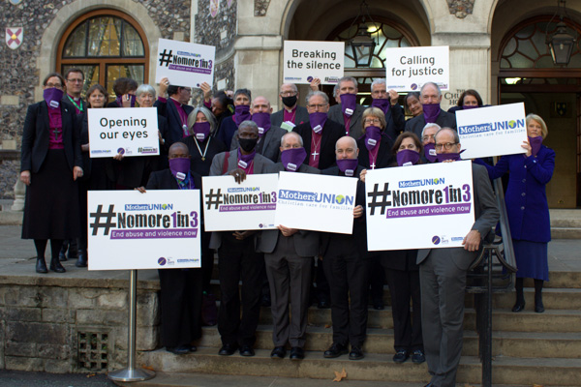

Bishops support Mothers’ Union’s #nomore1in3 campaign to end violence against women and girls
One in three women world-wide has experienced domestic and sexual violence – a shocking statistic that soared following mandatory lockdowns due to the coronavirus pandemic.
Mothers’ Union is calling for an end to abuse and violence now, with #nomore1in3, a campaign which is part of its Global Day of Action, on Saturday November 27th.
On this day, the friends and members of Mothers’ Union will be coming together for three minutes of silence at 1.03pm, to make more people aware of the work that still needs to be done.
The Global Day of Action is the organisation’s response to the call for 16 days of global activism against gender based violence, a UN women’s initiative, launched in 1991. The Global 16 Days campaign runs annually from November 25 (International Day Against Violence Against Women) to December 10 (International Human Rights Day).
Bev Jullien, the CEO of Mothers’ Union, said: “Our members will be meeting in venues across Britain and Ireland - from cathedrals to shopping centres and churches to their own living rooms, uniting to call for action against the abuse suffered by so many women and girls.
“Lockdown and the recent media coverage around the shocking deaths of Sarah Everard, Sabina Nessa, Bibaa Henry and Nicole Smallman, only serve to confirm why more must be done on this issue now.”

Please add details of your own local activities focused on the Global Day of Action here
Alternatively, add them just above the quote from the CEO of the Mothers’ Union - so just before the words Bev Jullien, the CEO…..

Bishops from the Church of England were joined by the Archbishops of both York and Canterbury in calling for the church and wider community to support Mothers’ Union’s 1in3 campaign, recognising the importance of working in partnership with the Church to effect change.
Archbishop of York, Stephen Cottrell, said: “Mothers’ Union is not just doing a great job in raising awareness of violence against women, but also confronting it. The whole church needs to be involved in this campaign, and men and boys must step up and recognise the change that is needed to truly combat this issue.”
Bishop of Gloucester, Rachel Treweek, said: “So often abuse is hidden and so it’s fantastic that Mothers’ Union is bringing this to light by highlighting the dreadful statistic, that one in three women suffer abuse and violence.
“Despite our best efforts, I, along with Mothers’ Union, were very disappointed by one of the outcomes of the Domestic Abuse Bill, now Act, because we didn’t manage to achieve what we wanted in relation to migrant women. So, despite progress, more must be done and that will only happen if people are aware of statistics like this. Domestic abuse happens in homes and communities, including members of church communities and people are often not aware – that is why this campaign is so important.”
Being at the heart of communities means Mothers’ Union campaigns such as #nomore1in3 are driven by the experience and practical action that its members are a part of every single day.
Across Britain and Ireland its practical support includes providing essential items for refuges, training and support workshops on gender based issues in schools and prisons as well as supporting the families of survivors to heal and rebuild important family bonds through its ‘Away from it all’ breaks.
“Members of Mothers’ Union are able to make a practical difference locally, but also unite to call for change and action regionally, nationally and internationally, thanks to our links with the UN,” said Mrs Jullien.
“We are always looking for more people to join our movement and won’t rest until the abuse of and violence against women is eliminated.”
For more information about the Global Day of Action and Mothers’ Union’s work with gender based violence, please go to: Global Day 2021 (Mothers' Union Responds to 16 Days of Activism) | Mothers' Union (mothersunion.org)
For more general information, photographs or interviews, please contact Adeline Iziren on 07950 255 389
For a brief video clip summer please see: https://youtu.be/8EvT01wvZvQ

ENDS

NOTES FOR EDITORS
ABOUT MOTHERS UNION
Mothers’ Union is a movement of 4 million Christians in 84 countries world-wide. Founded 145 years ago, by Mary Sumner, Mothers’ Union is unique because our members work as volunteers in local communities, putting their faith into action by acts great and small, giving individuals in need a helping hand and engaging communities (of all faiths and none) to have the confidence and skills to transform their lives in a sustainable way. Thanks to donations, subscriptions and volunteer members, the organisation is transforming communities and the lives of families, women and men, through practical grassroots support, empowerment, and by challenging systems that perpetuate injustice at the local, national and international level.

