Violence against women and girls: how does our Christian faith guide our understanding?

The reasons for campaigning against violence against women and girls are many; any number of individuals and groups will find themselves drawn together to champion such a cause. For us as Mothers’ Union, however, we need a distinctive voice as we join with others to support 16 Days of Activism and our Global Day of Action. We find this distinctiveness at the heart of our vision: that of a world where God's love is shown through loving, respectful, and flourishing relationships.

God exists in, and created, equality of relationship. The relationship of the Trinity powerfully illustrates this; each distinct from but equal to the other; relating together in loving agreement. The equality of human relationships is established at the beginning of creation:

‘God created human beings in his own image. In the image of God, he created them;
male and female he created them.’
Genesis 1:27

All are created in the likeness of God, whatever our gender; as such all are entitled to be treated as God’s precious children, whose image we reflect.

‘There is neither Jew nor Gentile, neither slave nor free, nor is there male and female, for you are all one in Christ Jesus.’
Galatians 3:28

Any culture of violence against one another, whether physical or emotional, is a distortion of relationships as originally intended: equality and respect in the sight of God.

Throughout the Old Testament, God’s attitude to women is positive and pastoral. There are many instances of women in positions of influence and leadership; also provision is made for those in positions of vulnerability, as in Deuteronomy 26:12. A woman’s choice in marriage is highlighted in Genesis 24:57 and other examples, whilst in Proverbs ‘wisdom’ is personified as a woman.

Where instances of violence against women are recorded, they are described as a wrongful action with negative consequences, for example, the rape of Tamar by her half brother in 2 Samuel 13, which led to serious family conflict and bloodshed. God’s position remains constant.

Within Jewish society, attitudes began to change towards women through the times of exile and intermingling with other cultures. The religious leaders attempted to protect the purity of their race through more restrictive laws, many of which had a negative effect on the lives of women. Hence, by the time of Jesus’ birth, Jewish men would pray every morning and thank God that he had not made them a Gentile, a slave, or a woman.

However, Jesus radically challenged this culture through his actions and teaching. He treated women as completely equal to men calling them ‘Daughters of Abraham’ (Luke 13:16).

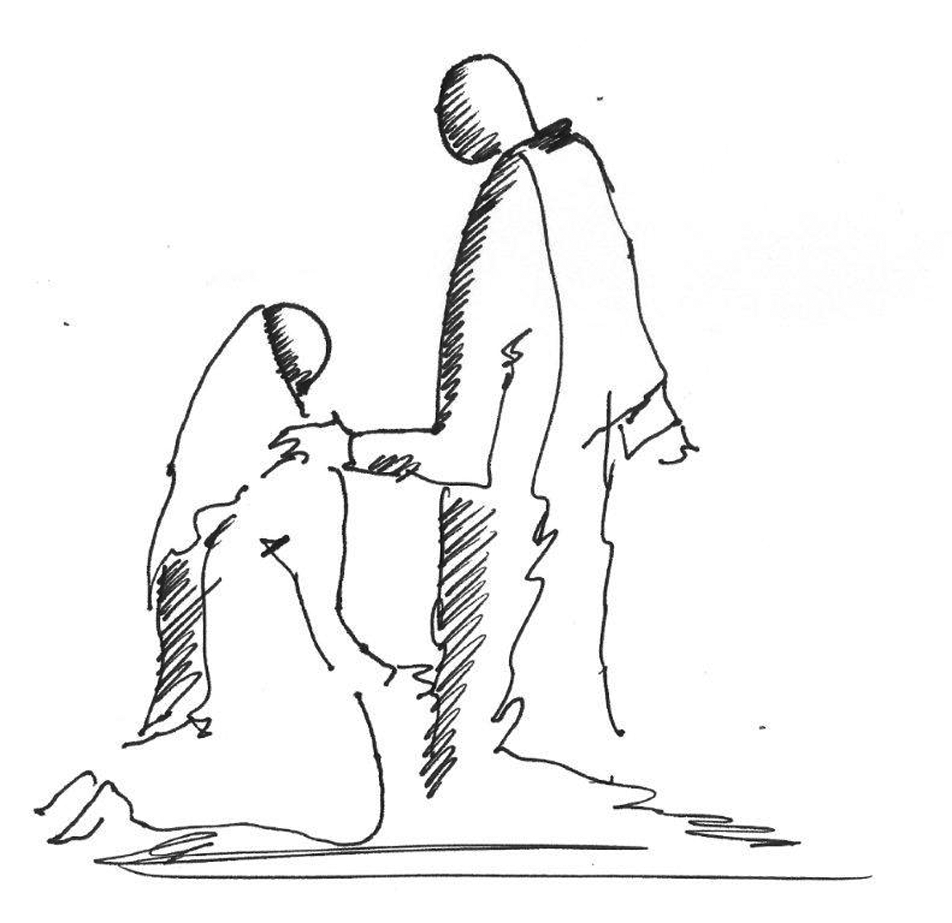
He openly conversed with women, met their needs and included them amongst his followers and supporters. He disregarded Jewish edicts when he healed the woman suffering from a hemorrhage for twelve years, choosing compassion over the letter of the law. He revealed his divinity to Martha (John 11:25-26), and chose to appear first to Mary Magdalene after his resurrection (John 20:10-18).

In a situation where violence against a woman was allowed under Jewish law – that of the woman caught in adultery – Jesus averted the aggression with wisdom and compassion, using the situation to challenge her accusers without condoning her wrongdoing.

Thus, the arrival of Christianity transformed life for women. The New Testament indicates that they played a significant role in the life of the early church. They were involved in leadership roles alongside Paul and others; they used their homes for gatherings of believers and had important input into the missionary growth of the church. Relationships between Christian men and women were surely ones of equality and mutual respect.

Within the marriage relationship, the sometimes-controversial edict by Paul for wives to submit to their husbands (Ephesians 5:22), becomes less so when seen in the context of the previous verse, submit to one another out of reverence for Christ, and the instruction to husbands to love their wives as Christ loved the church (v.25), that is, to be prepared to lay down their lives for them. With this perspective there is no room for violence or abuse of any sort: whether psychological, physical, sexual, financial, or emotional.

However, history has unfolded since New Testament times, both in the church and the world: there can never be any justification for violence against women. In our campaigning against it, we seek to follow the example of God. We look for inner change within perpetrators as they are enabled to conduct equal loving relationships, respecting women as made in the image of God.

We build our campaign on God’s command: to love our neighbour as ourselves. Where this is followed, there will be no place for violence against anyone.
The Church's response to violence against women and girls (VAWG)

We have examined the truth of God’s equal respect and love for all made in his image, lived out through the example of Christ and the early church. But the reality is that, throughout history and still in recent times, the Church has not always handled the issue of VAWG well.

There are a variety of reasons for this, including:
- The Church has sometimes been slow to accept that this can happen within Christian relationships, and when a church leader is involved.

- The nature of the issue is such that it is very often hidden behind closed doors, protected by a veneer of respectability which has covered up the truth.

- The question of forgiveness has been a stumbling block to the need for justice.

- Within some church traditions a distorted view of the nature of submission within a marriage relationship and gender roles within a relationship led to allegations of abuse not being taken seriously.

The Church of England guidelines Responding to domestic abuse (2006) states:

‘It is particularly disturbing that not only has the Church failed at many points to protect the vulnerable and to address the processes that lead to domestic abuse, but has also (intentionally or unintentionally) reinforced abuse, failed to challenge abusers and intensified the suffering of survivors.’

However, there is now a much greater acknowledgement of the prevalence of VAWG both within and outside the Church, and recognition of the Church’s responsibility in dealing with it.

‘Gender-based violence is one of the greatest injustices in our world today… The Church is already supporting and caring for those affected; it must continue in that work and must condemn the notion that such violence is ever acceptable. The Church must be an advocate for restored relationships of mutual respect and love, modelling the reconciling love shown by Christ to all people.’

Justin Welby, Archbishop of Canterbury

