16 Days of Activism and Global Day of Action 2020 Downloadable Bookmark

This prayer bookmark can be printed out, cut out, folded and stuck to make a double sided bookmark. Use it to reflect on how you want to respond to our 16 Days of Activism campaign this year.
With thanks to Mothers’ Union in All-Ireland for this wonderful resource.

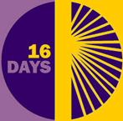

We pray for all to follow Christ’s example of treating children, women and men with equality and respect.

We pray for all who live
in fear of violence and despair that life will ever change.
Bring to an end their suffering,
restore their sense of worth.
We pray for those who perpetrate abuse with no sense
of guilt or shame.
Bring to justice their actions,
change their inner hearts.
We pray against regimes
that endorse violence.
Shatter their influence,
initiate peace.

Loving Lord,
we pray for a better world
where love, justice and peace
may flourish.
Amen
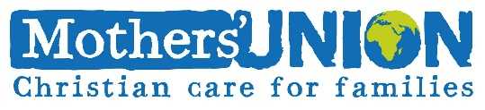
Reflect…..

Pray…..

Plan…..

Act…..

16 Days of Activism: 25th November – 10th December 2020
Mothers Union Global Day of Action: 5th December

For resources and information on our calendar of events: https://www.mothersunion.org/16-days-activism-and-global-day-resources-2020

