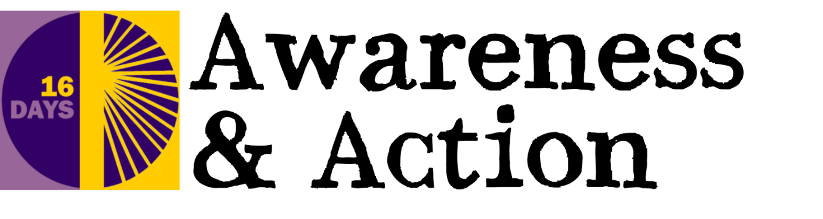

Service Outline For 16 Days of Activism Against Gender-Based Violence 2019

This service outline may be used and adapted for a variety of contexts. Please add hymns and other material as required.

Welcome
Welcome to our service, which is part of our 16 Days of Activism Against Gender-Based Violence. As members of the body of Christ we draw near in faith to commit ourselves to be Christ’s hands and feet in the world. Hands to raise awareness by pointing out injustice and unrighteousness and feet to march for change, and to run to those in need of help.

Opening hymn

Opening prayers and confession

Loving Lord,
who has called us to be the body of Christ,
make us ready to act as his hands and feet in the world;
to raise awareness of what must be challenged,
and to address the plight of the vulnerable. Amen

Forgive us, Lord,
who call ourselves your own
but daily cause you pain,
who see someone in need
and walk across the road,
hear about injustice
and fail to say a word.
Forgive us, Lord,
who call ourselves your own.

Renew our hearts,
our souls and minds;
Strengthen our faith
and make us a people
who are your hands,
your feet and voice
within this world. Amen
©John Birch

Bible Readings:

O people, the Lord has told you what is good,
and this is what he requires of you:
to do what is right, to love mercy,
and to walk humbly with your God.
Micah 6:8 (NLT)

Just as a body, though one, has many parts, but all its many parts form one body, so it is with Christ.
God has put the body together, giving greater honour to the parts that lacked it, so that there should be no division in the body, but that its parts should have equal concern for each other. ²⁶ If one part suffers, every part suffers with it; if one part is honoured, every part rejoices with it.
Now you are the body of Christ, and each one of you is a part of it.
1 Corinthians 12:12, 24-27

Homily
The information sheets included in the 16 Day resources on the website may be helpful in preparing this.

Hymn

Intercessions
These are suggestions for appropriate actions to accompany these prayers:
- Reaching out of hands
- Marching on the spot
- Holding hands together
If you are involved in specific local initiatives then include your own intercessions for these here.

Lord of justice and mercy,
draw us close to those who hurt.
Let us reach out our hands in your name
to share the sorrow and lessen the pain.

Lord of justice and mercy
lengthen our strides to march for good.
Clothe our feet with your living Word
to trample the works of unrighteousness.

Lord of justice and mercy
knit us together as the body of Christ
that we may speak out with one accord
for the kingdom of God to prevail. Amen

Symbolic Prayer offering
You may like to use the hands and feet templates provided to write prayers on
either before or as part of the service. Display a prayer tree or other holder at the front and bring the prayers up now to be attached and offered to God.

Lord of justice and mercy,
who has called us to be the body of Christ,
we offer up our prayers for those who
are affected by gender-based violence
and as a sign of our unity with all who
campaign for justice across the world. Amen

Closing hymn

Final blessing

Christ has no body now on earth but ours,
no hands but ours, no feet but ours.
Ours are the eyes through which
Christ's compassion is to look out to the earth.
Ours are the feet by which
he is to go about doing good
and ours are the hands by which
he is to bless us now.
St Teresa of Avila

Now may the God of peace equip you
with all you need for doing his will.
May he produce in you,
through the power of Jesus Christ,
every good thing that is pleasing to him.
All glory to him forever and ever! Amen

We say The Grace together

Hands and Feet templates 2019
You may like to use the hands and feet templates provided to write prayers on
either before or as part of a service. Display a prayer tree or other holder and bring the prayers up to be attached and offered to God.

