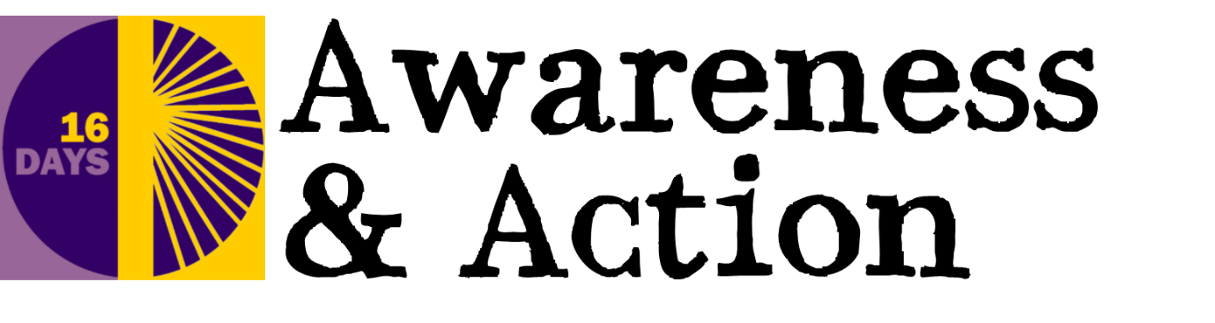

16 Days of Bible Verses and Prayers

Day 1
God created human beings in his own image.
In the image of God he created them;
male and female he created them.
Then God looked over all he had made,
and he saw that it was very good!
Genesis 1:27, 31 (NLT)

Creator God, thank you that we are all made in your image, and equally loved by you. Open our eyes to see your face in those of our sisters and brothers. Amen

Day 2
He has sent me to proclaim that captives will be released,
that the blind will see, that the oppressed will be set free,
and that the time of the Lord’s favour has come.
Luke 4:18-19 (NLT)

Compassionate God, may those experiencing all forms of violence be given courage, hope and practical help to break free from their abuse. Amen

Day 3
Let us not become weary in doing good,
for at the proper time we will reap a harvest
if we do not give up.
Galatians 6:9

Steadfast God, give us resolve to work tirelessly to change attitudes that promote, accept and perpetuate all forms of violence and abuse. Amen

Day 4
The Lord God has told us what is right and what he demands:
“See that justice is done, let mercy be your first concern,
and humbly obey your God.”
Micah 6:8 (CEV)

Righteous God, help those who administer justice for victims and survivors of gender-based violence to make decisions with integrity and compassion. Amen

Day 5
Remember those in prison as if you were together with them in prison,
and those who are ill-treated as if you yourselves were suffering.
Hebrews 13:3

Righteous Saviour, who came to free the oppressed, use us to challenge social injustice with a clear voice, in a world where the vulnerable strive to be heard. Amen

Day 6
The thief comes only in order to steal, kill, and destroy.
I have come in order that you might have life
— life in all its fullness.
John 10:10

Lord of life, thank you that many women and girls are now free from abuse and violence. Thank you for your healing power which brings hope to survivors. Amen

Day 7
Love the Lord your God with all your heart and with all your soul
and with all your mind and with all your strength
and love your neighbour as yourself.
There is no commandment greater than these.
Mark 12:30-31

Loving Lord, you have called us to love our neighbour as ourselves. Help us to treat all with dignity and respect as we follow Christ’s example of selfless love. Amen

Day 8
Do not fear, for I am with you;
do not be dismayed, for I am your God.
I will strengthen you and help you;
I will uphold you with my righteous right hand.
Isaiah 41:10

God of righteousness, we pray against regimes that endorse violence against women and girls. Replace their evil influence with a rule of justice and decency. Amen

Day 9
God will give a crown of beauty for ashes,
a joyous blessing instead of mourning,
festive praise instead of despair.
Isaiah 61:3 (NLT)

Transforming God, we pray for all who live in fear of violence and despair that life will ever change. Bring to an end their suffering; restore their sense of worth. Amen

Day 10
Then I heard the voice of the Lord saying,
‘Whom shall I send? And who will go for us?’
And I said, ‘Here am I. Send me!’
Isaiah 6:8

Holy Spirit, fill us with new resolve to challenge unacceptable mindsets and actions and to champion the cause of righteousness in the name of Christ. Amen

Day 11
Then the king will answer,
“The truth is, anything you did for any of my people here,
you also did for me.”
Matthew 25:40 (ERV)

Lord Jesus, be with those who work with survivors of gender-based violence. May they be given the resources they need to offer long lasting support. Amen

Day 12
Jesus said: Truly I tell you, unless you change and become like little children, you will never enter the kingdom of heaven. Therefore, whoever takes the lowly position of this child is the greatest in the kingdom of heaven. And whoever welcomes one such child in my name welcomes me.
Matthew 18:3-5

Heavenly Father, protect children who witness violence in the home. May they be given support to enable them to lead positive lives, in freedom from fear. Amen

Day 13
Don’t copy the behaviour and customs of this world,
but let God transform you into a new person by changing the way you think. Romans 12:2 (NLT)

All-powerful God, break the patterns of abuse committed down the generations. Transform attitudes and behaviour for current and future relationships. Amen

Day 14
Endow the king with your justice, O God,
the royal son with your righteousness.
May he judge your people in righteousness,
your afflicted ones with justice.
Psalm 72:1-2

Lord of the nations, we pray for governments as they deal with gender-based violence. May they make policy and law with wisdom and discernment. Amen

Day 15
Don’t take part in doing those worthless things that are done
in the dark. Instead, show how wrong they are.
The light will show what these things are really like.
Ephesians 5:11, 13

Merciful God, bless those working with perpetrators of gender-based violence. Give them your resources to bring about lasting transformation of lives. Amen

Day 16
There is neither Jew nor Gentile, neither slave nor free,
nor is there male and female, for you are all one in Christ Jesus.
Galatians 3:28

Lord of heaven and earth, we pray for all to follow Christ’s example of treating women with equality and respect. We pray for the dawn of a better world where justice and peace may flourish. Amen

