Transformation – Now!

Steps to transformation

When we start to think about transformation- whether for ourselves, our churches and communities or Mothers' Union – we tend to approach this from past experiences and the way we have done things in the past.

Use one of these light-hearted activities to help your group open their minds to wider possibilities.

Thinking outside the box

This familiar saying originated from a “nine dots puzzle” found in a 1914 book by Sam Lloyd called the Cyclopedia of Puzzles.

Give everyone a nine dot puzzle – you can draw your own, or use the sample included in this resource. The challenge is to connect the dots by drawing four straight continuous lines, not lifting the pen from the paper and without tracing the same line more than once.

Most people may say that this is impossible – but it’s not. When we look at the field of dots, we imagine a boundary round the edge and limit ourselves to think of a solution that links the dots inside that boundary.
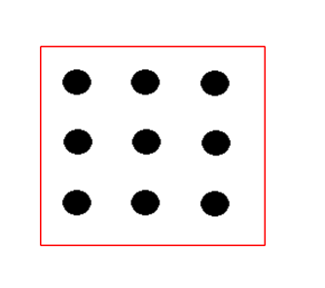

You can solve the puzzle if we realise that there isn’t a border and we can draw lines outside the box to connect the dots – by thinking outside the box.

The solution to the puzzle is then quite straightforward:
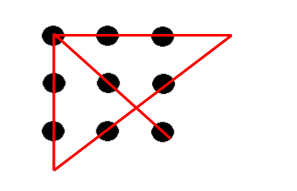

Nine Dots Puzzle

A journey to Southampton

In groups of three or four, consider the following:

There are three people in a car going from Edinburgh to Bournemouth. What’s the fastest way to get there?

Ask each group to come up with their response and why they decided on it.

Answers may include:
- Map out the most efficient route using a Road Atlas
- Look up the route on a Sat Nav system and choose the quickest option
- Use a real time navigation system, which shows current road works/accidents

Some groups might factor in the best time of day to be travelling in the vicinity of major conurbations. Or rotating drivers so there is no need for prolonged rest stops.

All of these are good ideas, but the starting point – the fact that the three people are in a car – limits the responses by creating an assumption that the travel has to be by car. There are other ways of travelling from Edinburgh to Bournemouth – not just by car.

The fastest way is to drive to Edinburgh Airport and get a flight to Bournemouth – it’s a 90 minute flight.
Or drive to Edinburgh Waverley station and get a train, which will take 7 hours 20 minutes (including connection times and the journey across London from Kings Cross to Waterloo).
A non-stop drive from Edinburgh to Southampton will take around 8 hours.

Getting your head round it (or through it)

Sometimes we are faced with situations that seem impossible, but it is just how you approach it.

Give everyone an A6 side piece of paper (15cm x 10.5 cm approx.) and a pair of scissors – and ask them to get their heads through it.

Impossible? No, it just depends on the way you cut the paper.

Fold in half along the long edge to get a piece of paper about 7.5cm x 10.5cm.

Folded edge

Make six cuts from the folded edge, stopping about 1cm from the open edge (as shown by blue lines)

Then make five cuts from the cut edge, stopping about 1cm from the folded edge (as shown by the red lines)

Cut through the five centre folded edges – to make a large enough paper chain to go over a head.

What can we learn from any of these activities?

All too often, we make assumptions about the way that things should be done, or put boundaries on our approach to things. We need to break free from imaginary restraints, because “we’ve always done it that way” and allow ourselves to re-imagine what we do and how we do it. If something is worth doing then let’s learn from what didn’t turn out right and try again with a different approach

If we want to transform our communities, or to make Mothers' Union relevant to the 21st century, we need to avoid assumptions and break out of the box. It might be comfortable in the box, because it’s easy, safe and comfortable but it won’t help us to see different possibilities and approaches.

For with God nothing shall be impossible (Luke 1.37 NIV)

