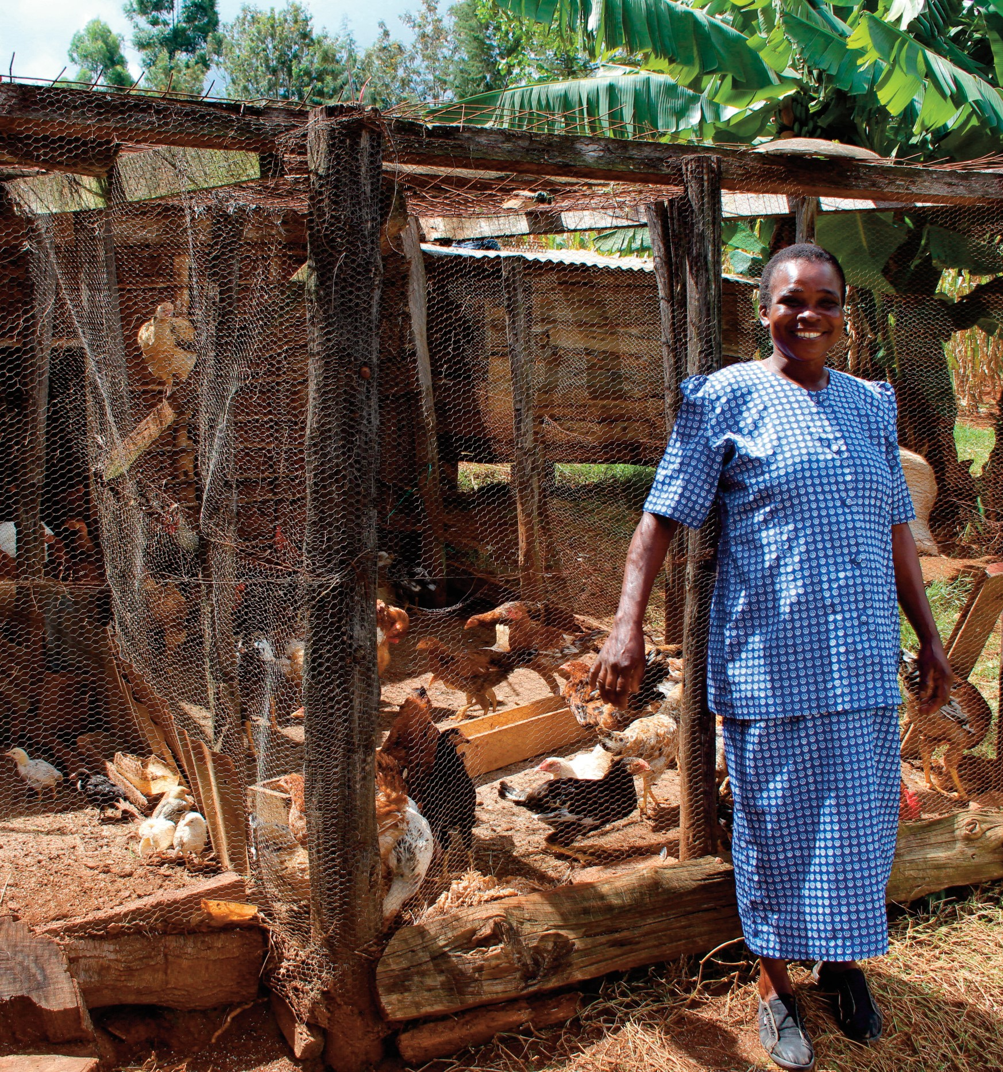

2019
Harvest

A Mothers’ Union Family Service for Harvest

This service can be adapted to suit your particular setting.
If a more formal service is required then use whichever elements are appropriate

2019
Harvest
Welcome
Welcome to our Harvest Family Service.
Harvest is a time to thank God for all he provides for us so we can live well and enjoy his world. God also asks us to be part of his work providing for others so everyone is able to live well, and we’ll be thinking how we can do this during the service. But first, and most importantly, we want to start by thanking God for all his wonderful gifts to us.

The land yields its harvest; God, our God, blesses us.

God has blessed us with all that is good! We bring him our thanks today.

Let us pray: (a child/children could read this prayer) Father God,
thank you for all the good things you provide for us
so we can live well, be healthy and enjoy your wonderful world.

Help us all to share these good things with those who find life hard
so they can also live well, be healthy and enjoy your wonderful world.

Most of all, thank you, God, for giving all of us your love
and helping us to follow your ways to enjoy your wonderful world. Amen

1 2

Hymn
Here we are giving, out of our plenty fruit of thanksgiving, tribute of love.
Hearts overflowing cannot stand empty, constantly growing grace from above.

Gathered as one, and thankfully bringing all that we are, and all that we do.
Serving and caring, praying and singing, building and sharing, offered to you.

Love beyond measure, total compassion,
We are your treasure: wondrously giv’n.
Made in your likeness, imaged and fashioned, life that is priceless, valued in heaven.

©Ally Barrett. Tune: Bunessan (Morning has broken)

Readings
(Two children / young people could read these)

God gives us what we need to help others:
2 Corinthians 9: 8, 10-11 (ICB)
God can give you more blessings than you need. Then you will always have plenty of everything. You will have enough to give to every good work.

10 God is the One who gives seed to the farmer. And he gives bread for food. And God will give you all the seed you need and make it grow. He will make a great harvest from your goodness. 11 God will make you rich in every way so that you can always give freely. And your giving through us will cause many to give thanks to God.

God uses what we give to him:
John 6:5-13 (ICB)
Jesus looked up and saw a large crowd coming toward him. He said to Philip, “Where can we buy bread for all these people to eat?”
6 (Jesus asked Philip this question to test him. Jesus already knew what he planned to do.)

7 Philip answered, “Someone would have to work almost a year to buy enough bread for each person here to have only a little piece.” 8 Another follower there was Andrew. He was Simon Peter’s brother.

Andrew said, 9 “Here is a boy with five loaves of barley bread and two little fish. But that is not enough for so many people.”

10 Jesus said, “Tell the people to sit down.” This was a very grassy place. There were about 5,000 men who sat down there. 11 Then Jesus took the loaves of bread. He thanked God for the bread and

3 4

gave it to the people who were sitting there. He did the same with the fish. He gave them as much as they wanted.

12 They all had enough to eat. When they had finished, Jesus said to his followers, “Gather the pieces of fish and bread that were not eaten. Don’t waste anything.”

13 So they gathered up the pieces that were left. They filled 12 large baskets with the pieces that were left of the five barley loaves.

Talk: ideas
Invite the children to come up to the front for the talk.
You may like to have a picnic basket with bread and examples of sandwich fillings in; also paper outlines of fishes and loaves with some crayons for children to write or draw their favourite food on

Ask what are their favourite sandwiches?
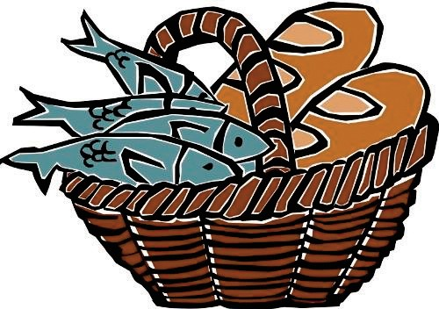Mine is…. fish finger sandwich – I think the boy who shared his lunch in the reading might have liked fish finger sandwiches!

Points arising from the story:
l God provides the ingredients for the sandwich (the food)
l We enjoy what God’s given us
l God can do a miracle when we share with others what he’s given us
l We don’t have to work out how he’s going to do the miracle we just have to give
l God creates enough for all so when we share what God’s given to us we don’t miss out, go hungry. But it’s good to be part of making things fair so no-one misses out

Suggestions for “wondering questions”
l I wonder why the boy decided to share his food?
l I wonder what his family said when he offered his picnic to Jesus?
l I wonder how the boy felt when the miracle happened?
l I wonder what you would have done if you had been there?

A story about Mothers’ Union work
Now we have a story about someone not from the Bible but from
now. Her name is Cherise and she lives in Kenya. Just as Jesus used the little food the boy gave him to provide for many, Cherise has learnt, with help, to use the little that they have to provide for her family

Cherise is a mother and grandmother. She has suffered the effects of drought and in turn struggled to provide for her family.

We need to adapt, to prepare for seasons with little water but also to look for ways to earn incomes in different ways – we have to

5 6

change to survive.
Mothers’ Union in Kenya supported the community to respond to this challenge. The solution was not to provide help in the form of seeds or food but to empower and shift the power to the community and in this case, to Irene.

We started a savings and credit group; this saving means we are able to plan to buy better seeds, livestock and grow cash crops to earn income. Alone we could not do this but together we can.

These savings and credit groups, which have benefitted Cherise and her wider community, work by all the members of the group paying a small amount at the start of the year. This pooled money is then used to provide small loans, such as to start a small business, as well as growing with interest. This, coupled with literacy and numeracy education, gives the women financial security and means by the end of the year their communities are stronger due to investments within them. For the first time many of these women have their own financial freedom, meaning families are not relying on just one wage to survive.

Thanks to this project, Cherise has started a small poultry business; she is able to sell eggs when her crops fail. As a group, they have also been able to give back to the local community, setting up a small market linked to their church where people can sell produce or goods. It has helped her break the cycle of poverty and adapt to the challenges faced by the effects of climate change.

We also need to look to the future, we must prepare for changes that seem to be here to stay. Without the rains when we expect them, we need to change our crops or save our water – but with God, all is possible.

Hymn
For the fruits of his creation, thanks be to God.
For his gifts to every nation, thanks be to God.
For the ploughing, sowing, reaping, silent growth while we are sleeping, future needs in earth's safekeeping, thanks be to God.

In the just reward of labour, God's will be done.
In the help we give our neighbour, God's will be done.
In our worldwide task of caring for the hungry and despairing, in the harvests we are sharing, God's will be done.

For the harvests of his Spirit, thanks be to God.
For the good we all inherit, thanks be to God.
For the wonders that astound us, for the truths that still confound us, most of all that love has found us, thanks be to God.
Fred Pratt Green:

© 1970 Hope Publishing Company. Tune: East Acklam

7 8

Offering
If the service includes an offering of foodstuffs / harvest baskets etc. and these have not already been displayed then they may be brought up as part of the offering.

Thank you Lord, that you love us unconditionally; that we can do nothing to earn your love.
In that security we gladly open our hearts and resources to those in need;
as an outflowing of our love for God and our neighbour. Thank you for your ultimate example of generosity,
by sending Jesus to die in our place. Thanks indeed be to God. Amen

Generous God, our provider, accept and use the gifts we bring
out of the wealth we have received; that we may work with you
to build your kingdom on earth. Amen
Prayers of thanksgiving and intercession
Firstly, prayers of thanks for the variety of food God provides for us: Ask everyone to think of a favourite food (these could be what the children have written on their loaves and fishes) then all say together - adding their favourite food. You may like to repeat a few times to include different favourite foods!

God made…, and it is very good. Thank you God!

We’ve thanked God for the food we enjoy, now we’re going to ask him to help people who haven’t enough food and other things to help them live well, be healthy and enjoy God’s wonderful world.

Display at the front a piece of bread, cup of water, packet of seeds, coins.
Children may hold up each in turn, as the prayer is said:

Loving God, bread of life,
we pray for those who are starving for lack of food whilst we have so much.

Turn our pity into action;
may our actions be the answer to our prayers.

Loving God, water of life,
we pray for those who are thirsting from lack of water whilst we overflow with all that we need.

Turn our pity into action;
may our actions be the answer to our prayers.

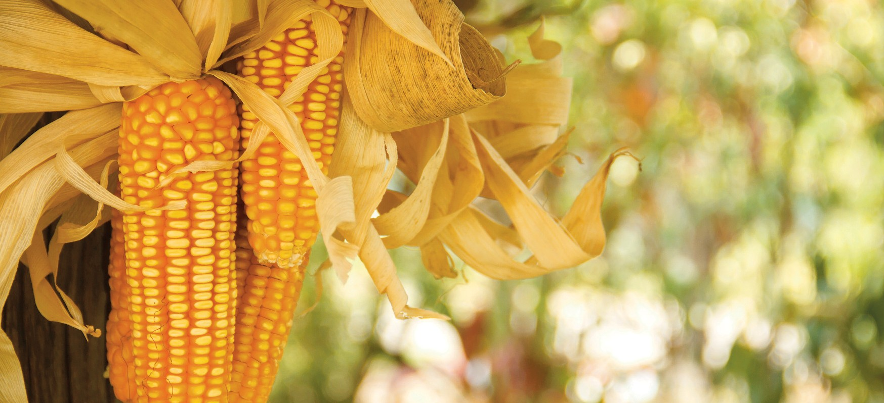

9 10

Loving God, lord of the harvest,
we pray for those who are dying from lack of seeds whilst we are surrounded by abundance.

Turn our pity into action;
may our actions be the answer to our prayers.

Loving God, generous giver,
we pray for those struggling in dire poverty, whilst we know riches beyond their imagination. Turn our pity into action;

may our actions be the answer to our prayers. Amen
Final hymn
Now thank we all our God,
with hearts and hands and voices, who wondrous things has done, in whom this world rejoices; who from our mothers' arms
has blessed us on our way with countless gifts of love, and still is ours today.

O may this bounteous God through all our life be near us, with ever-joyful hearts
and blessed peace to cheer us; and keep us still in grace, and guide us when perplexed; and free us from all ills,
in this world and the next.

All praise and thanks to God the Father now be given; the Son, and him who reigns with them in highest heaven; the one eternal God,
whom earth and heaven adore; for thus it was, is now,
and shall be evermore. Martin Rinkart:

1586-1649. Tune: Gracias

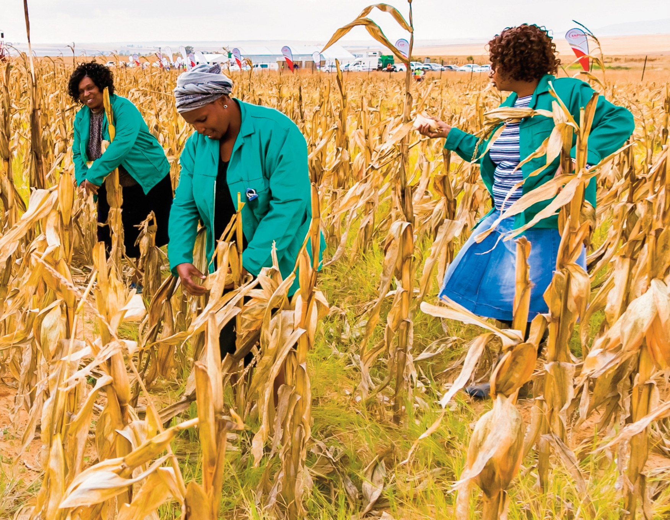

11 12

OR

You shall go out with joy and be led forth with peace
and the mountains and the hills will break forth before you: there’ll be shouts of joy
and all the trees of the fields will clap, will clap their hands.

And the trees of the fields will clap their hands,
all the trees of the fields will clap their hands.
The trees of the fields will clap their hands while you go out with joy.

Stuart Dauermann © 1975 Lillenas Publishing Company

Final blessing
We go rejoicing in God’s provision. We go to sow his love in the world that it may yield a harvest of blessing and no-one may be in want. Amen

And the blessing of God almighty, the Father, the Son and the Holy Spirit,
be among you, and remain with you, this harvest time and always. Amen

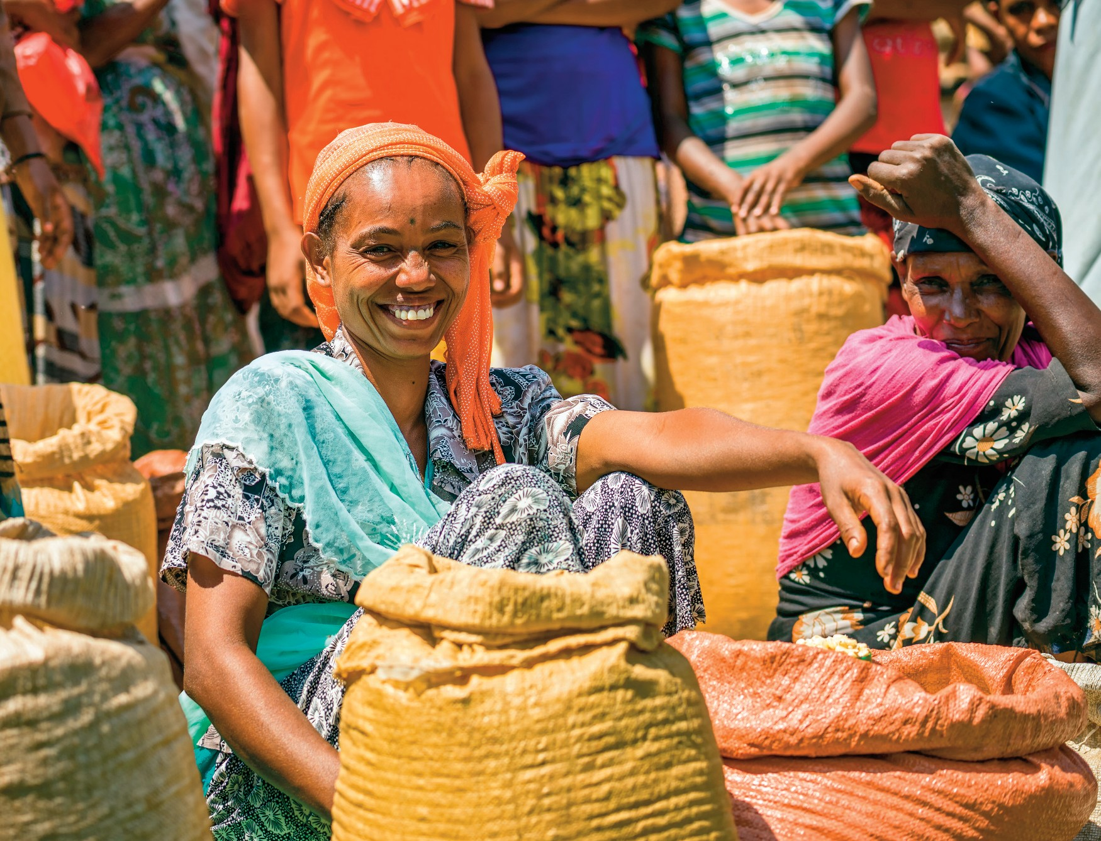

13 14

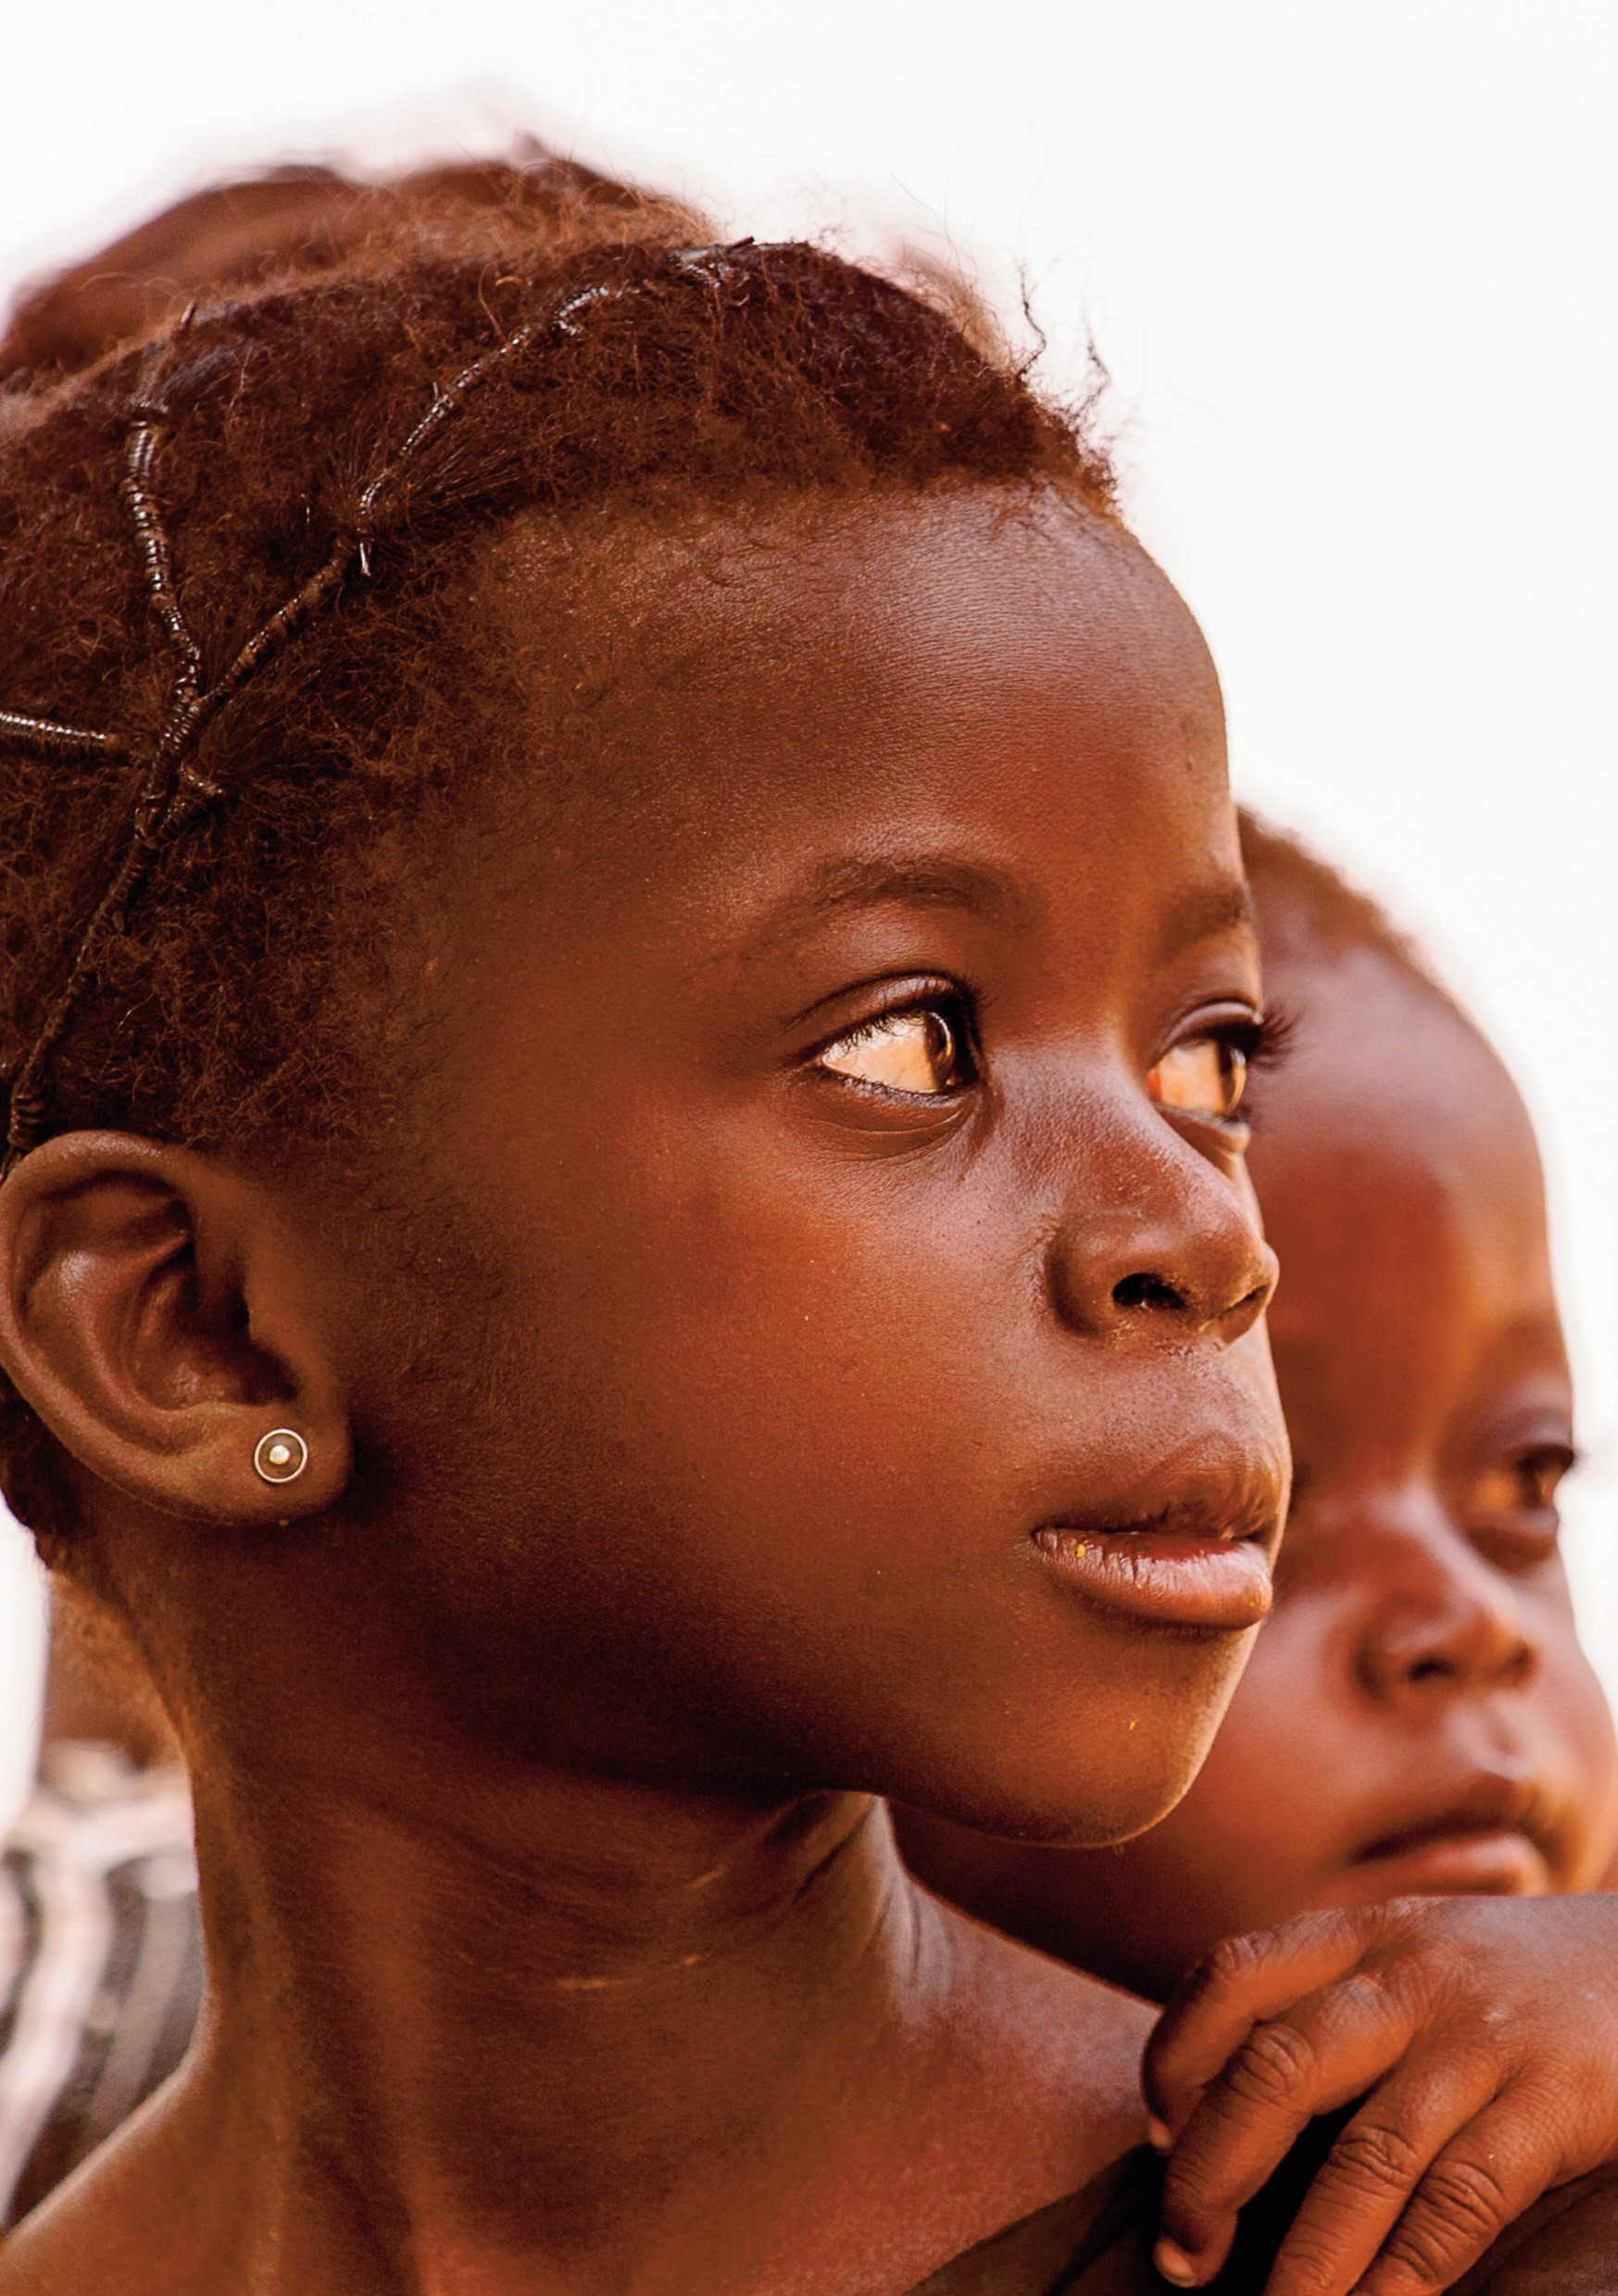

2019
Harvest

