Mothers’ Union 5k Big Run
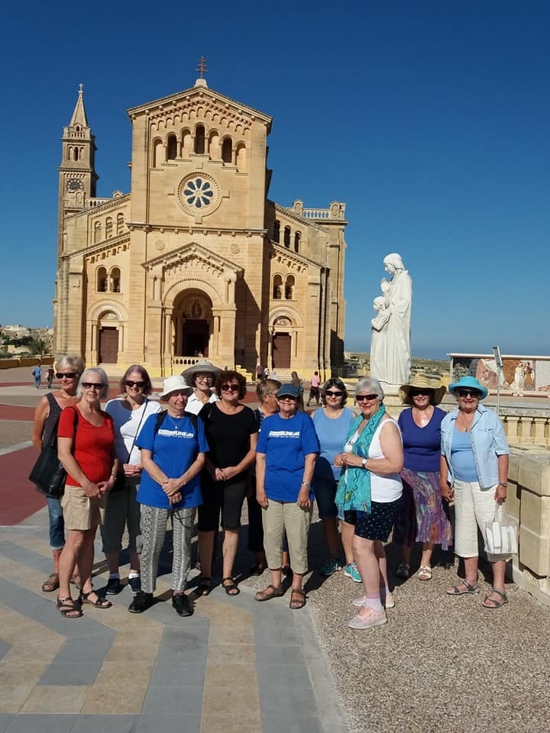
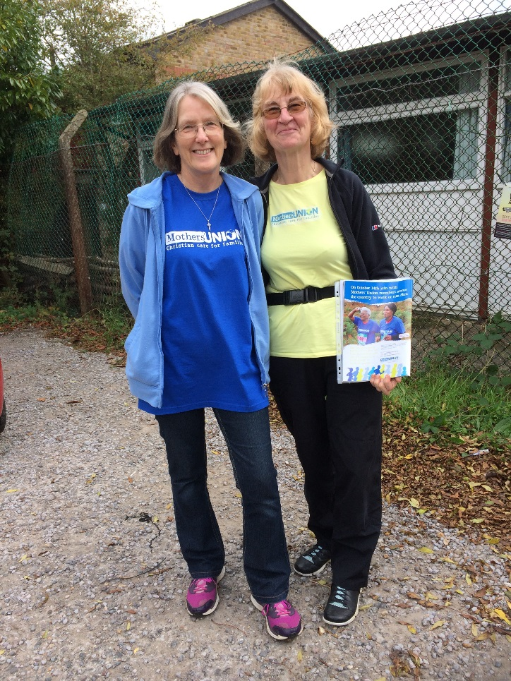
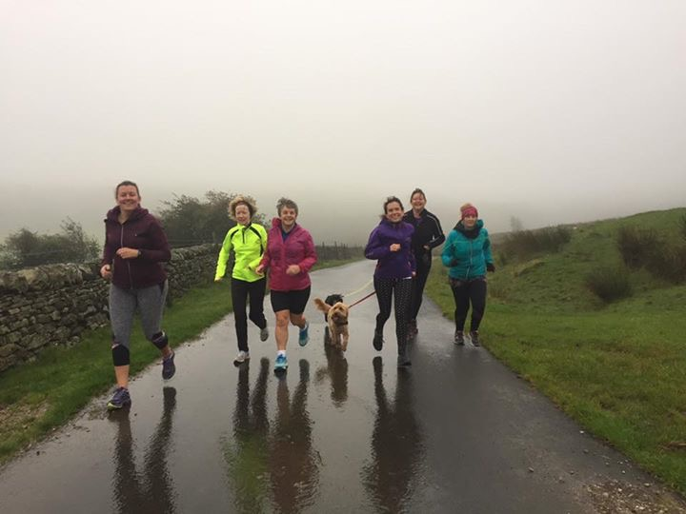

Information Pack 2020
Organise your very own Mothers’ Union 5k Big Run and help support our work around the world!

Dear Friend of Mothers’ Union,

Thank you so much for considering organising your very own 5k Big Run for Mothers’ Union!
This year we would love members to organise their event for Saturday 10th October – but if you cannot make this date – don’t worry any time at the beginning of October will be fine.
Organising your own run / walk can be lots of fun and a great way to engage friends and family with the work of Mothers’ Union whilst coming together with your branch and diocese to support one another as you take on this challenge. Don’t forget you can do a 2.5k event if you think that is more manageable or participants can take part as a relay.
We want to do some of the hard work for you so we have produced this pack and a range of resources to help support your event. It does not matter if it’s just you and a friend doing this or five branches joining together to create a large event at a local park – it all makes a difference! Do not forget it does not just have to be members who join in – we have loved seeing over the past few years how families, friends and pets have joined with members to make their events a success!
The following pack aims to give you information and advice on setting up your event and make sure you get in touch with us at fundraising@mothersunion.org to let us know about your event and so we can support you.

We cannot wait to hear more about your Big 5k Run – do not forget to enjoy your event!

The Mothers’ Union Fundraising Team
Planning your 5k Run / Walk

When you start planning the route, it is worth thinking about the following:
- Aim for a circular route. Your route should start and end in the same place, which should be off road.
- Stay off roads as much as possible. If your route does go along any roads, ensure there are pavements and avoid dangerous junctions. It is helpful to minimise the number of roads that need to be crossed.
- Think about facilities. Aim to find somewhere with toilets and possibly a refreshment venue. Large parks are the best places.
- Measuring the distance to make sure its 5km. One of the easiest way7s of doing this is via a website or app like MapMyRun (https://www.mapmyrun.com/gb/)
- Once you have planned your run you need to register, it with Mothers’ Union (via fundraising@mothersunion.org ) so we know when your event is taking place and can help support you.

Permissions and licences
If there are, just a few of you taking part you should not need to gain permission to use somewhere like a park. However if you are a larger group then this event will need more organisation and possibly require a license to run. Do not let this put you off – just contact Mary Sumner House for more information and we can support you on this
Tel: 020 7222 5533 email: rachael.anderson@mothersunion.org

Health and Safety
When planning your event please make sure you consider the following:
- Consider the abilities of participants - could your route pose any problems for younger, older or disabled people?
- First Aid - It is advisable to have someone who is First Aid trained present at the event. Larger events may need to consider St Johns Ambulance – this is something that will be discussed when you speak to Rachael about organising an event.
- Any participants aged under 18 must provide a signed guardian consent form and the guardian should be encouraged to attend the event. These forms are available to download from our website
- You may wish to provide a disclaimer to all participants so that they know they are taking part at their own risk. Please contact Mary Sumner House for suggested wording
- Risk Assessments – all events should complete the basic risk assessment form included in this pack. A copy of the completed form must be sent to fundraising@mothersunion.org and the event organiser should have a printed out copy with them on the day of the event.

Communicating your run!
- Use the posters in this pack to advertise and promote your event and get other people to join you and sponsor you / your group. The posters will also help raise awareness of Mothers’ Union.
- It is a good idea to contact local churches and businesses and ask them to support your event. If they promote your event this may get more people involved. Businesses may be able to provide things like refreshments.
- Contact the local press to see if they may be interested in covering your event. It is useful to have some sort of hook for this – perhaps an anniversary being celebrated by the branch, a member’s personal story or the reason you are fundraising. Please contact us if you would like more support on this.

Fundraising

Fundraising can sometimes feel a bit daunting so here are a few top tips on how to encourage fundraising for your event:
- Set up a Just Giving page - make sure it is compelling, explains your motivation and includes a link to the Mothers’ Union website: https://www.mothersunion.org. There are instructions on setting up a page on page X of this pack.
- Tell people what your fundraising target is and what their contribution will help to achieve – it’s great to mention specific MU projects. For example:

£27 can help someone in Ethiopia complete a two-year course to learn to read and write, providing them with a basic skill that completely changes their life.

£65 can start a savings and credit association in Rwanda, allowing group members to save collectively and provide each other with loans to buy household items, start businesses, care for others in the community and build a secure future for their families.

- Time your donation request - people are more likely to donate after payday.
- Don’t forget to ask for Gift Aid as it means Mothers’ Union will receive an extra 25p for every £1 sponsored.
- Ask close friends and family to donate and you can ask them to spread the word about your fundraising too – they will be keen to help you get more sponsors!
- Help people put their donation into perspective. For example, £10 might mean giving up just one takeaway dinner.
- Continue to keep asking for sponsorship after the event - as much as 20% of donations can come in at this time!
- Mention your fundraising event at every opportunity – on social media, in your answer phone messages, email signatures, notice boards.
- You can download a Mothers’ Union sponsorship form here. This can be used for all off line donations

Raise money at work / church
As well as passing a sponsorship form around, here are some other options to increase donations:
- Email round a link to your Just Giving page to your contacts
- Stick up the poster included in this pack on your noticeboard at work and church
- Get some information in a staff / church newsletter
- If your employer / church has a matched giving scheme, make sure to apply. If they won’t match the total amount you raise, perhaps you could still ask for a donation.

Additional ways to fundraise
- Ask your employer if you can charge everyone £1 to dress casually for the day. You could collect this in person, or send a link to your Just Giving page – people may donate more that way.
- Run a bake sale at lunchtime / end of church service
- Car boot / eBay sale - take the opportunity to have a good clear out and sell the items you don’t want anymore.
- Pub quiz - perhaps your local pub would be happy to sponsor you through the proceeds of their own quiz one week. Alternatively, you could hold your own quiz somewhere else, like the local church hall.
- Offer to do odd jobs - Wash cars, walk dogs, babysit, iron clothes - all for a donation of course!
- Prizes - Some businesses may be willing to donate items, such as gift vouchers, a bottle of wine or discounts, which you could raffle off at another event you hold.

Get the message out there
Use social media: Facebook, Twitter, Instagram – make sure you ‘tag’ Mothers’ Union in any posts so that we can see and share them too e.g. @MothersUnion.
It may also be good to use the hashtag of the event you are participating in e.g. #TeamMothersUnion #MothersUnion5kmChallenge
The following may be useful when creating social media posts:
- Mothers’ Union Facebook page: https://www.facebook.com/MothersUnion/
- Mothers’ Union Twitter: https://twitter.com/MothersUnion
- Mothers’ Union Instagram: https://www.instagram.com/officialmothersunion/
- Mothers’ Union YouTube: https://www.youtube.com/channel/UCz4qiyQqyv3u9DnGTpkryzQ

Setting up a JustGiving Fundraising Page

- Go to www.justgiving.com
- In the top right hand side of the screen, either click on ‘Log in’ - if you already have a JustGiving account - or ‘Sign up’ - to set up an account.
- Once your account is set up and you have logged in, click “start fundraising” in the top left hand corner of the page.
- Then click on the button that says you want the money to go to a charity:
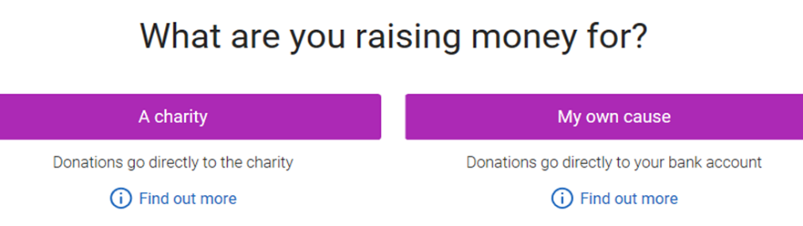

- Search for Mothers’ Union as the cause you want to support, choosing ‘United Kingdom’ on from the drop down list on the right hand side. Make sure you choose the option that has our current logo (see below).
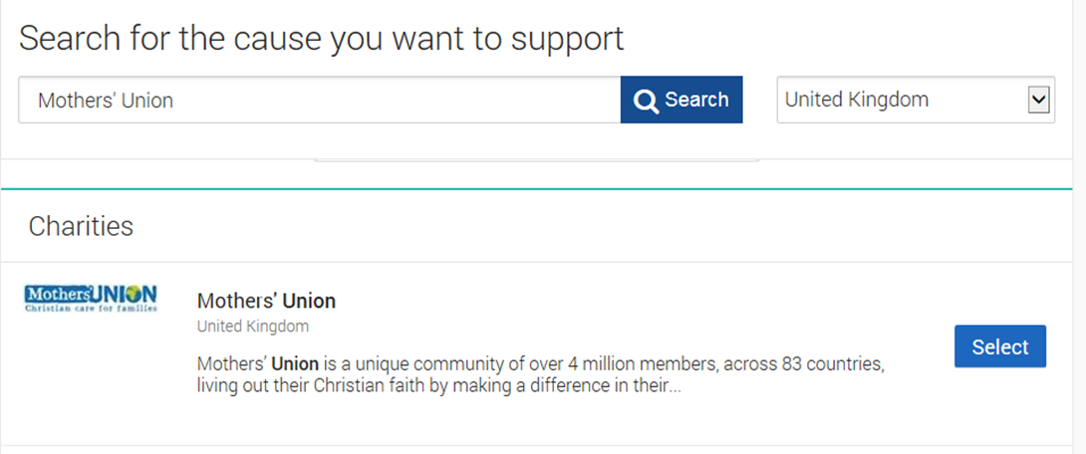
- You will then be asked ‘What are you doing?’ Click on ‘Doing your own thing’
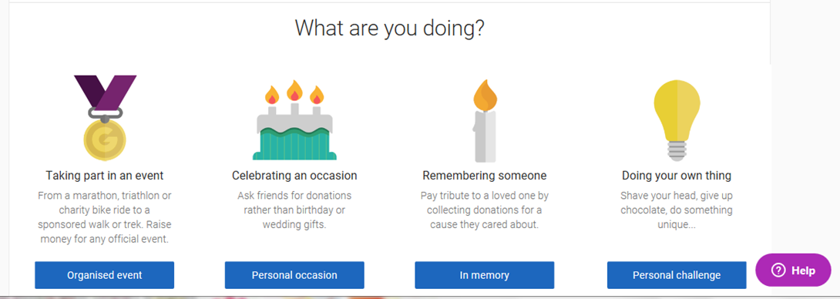

- On the ‘Tell us about your event page’:
  - Choose either ‘a personal run / marathon’ or ‘a personal walk’ as your event type, depending on which you have chosen to do.
  - Type in Mothers’ Union’s 5km Challenge as the Event name.
  - Set your event date
  - Leave the two check boxes marked as ‘No’ (see below)
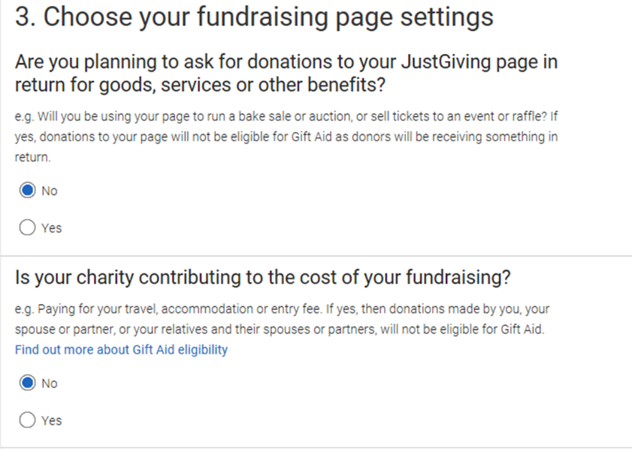
  - Choose whether you would like to receive fundraising information in future from Mothers’ Union.
  - Click “Create your page” - You have now created a fundraising page!
  - You can click on “edit your page” at the top of the page to add more information.

- Under ‘Donations made to your page’ on the right hand side you can edit your fundraising target and keep your total up to date by saying how much money you have raised offline.

- Under’ Edit and personalise your page’ on the left hand side, click on ‘Edit your page title, summary and story’ then say a bit about why you have chosen to take part in this event. It would be great if you could add something along the lines of:
  - Your connection with Mothers’ Union…
  - Why people should donate e.g. By supporting and working with people in need all over the world, Mothers’ Union are enabling real change and improvement to the lives of a great many people and their families.
  - Add a link to our website and video to provide more information about Mothers’ Union and our work: e.g. You'll see a lot more detail on their website: https://www.mothersunion.org/ and I also recommend this video for a succinct summary: https://www.youtube.com/watch?v=kERCG7y52mc
  - A line or two about your motivation…
  - A sentence to encourage people to donate e.g. please give generously!
- Click on ‘Add photos’ to add a picture of yourself. You can then add more photos later – of you training, taking part in and completing the event etc. You can also add updates during your training and after the event.
- Click on “Visit your page” to see how it now looks. Once you are happy with your page, share it on social media or email it to friends and family and watch the donations roll in!

We wish you the best of luck with your run! Don’t forget if you want any help or support, you can email fundraising@mothersunion.org or call us on 020 7222 5533 and we can help answer any questions that you may have!

