Paint a Rainbow and Connect with your Community
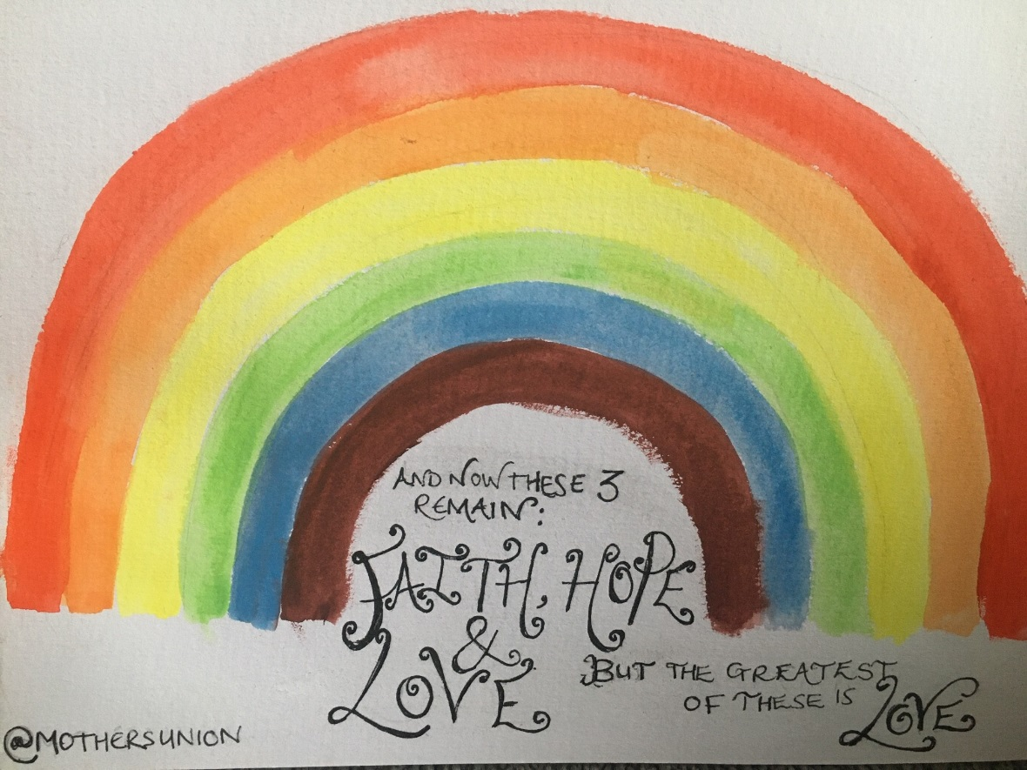
You may have seen, on social media, that people are putting pictures in their windows so when children and those feeling lonely leave their homes for their daily walks they can hunt for the rainbows and hopefully it will bring them a smile.
We loved the idea here at Mothers’ Union and thought it would be great to include an encouraging Bible verse as well!
This is a simple but engaging craft for you to do with children or by yourself – you can then go for walks to see who else has put a rainbow up in their window.
What you need:
- Paints / colouring pencils / pens – you could even do a rainbow collage with coloured tissue paper or torn up magazines
- Paper
- Sellotape or Blu Tack
What to do:
Outline the rainbow in pencil – search online for a picture of a rainbow if you need to check on the colours! Or just freestyle and put as many colours as you want!
Use paints, encils or pens to colour the rainbow in – or fill the sections with coloured tissue paper – be as creative as you like.
Once the picture has dried add in your favourite Bible verse or an encouraging verse that people may read as they walk past.
Don’t forget to add @MothersUnion in one of the corners
Stick up in your window!
If you can, take a picture and share on our members Facebook group!
