Calling all birdwatchers amongst us!
As we see the world slow down around us, nature takes its chance to make a comeback. While you look out through your windows, or enjoy some time in your gardens, take note of the birds fluttering past. Are there some familiar faces, often hiding away from the sounds of cars and planes, but rejoicing in the calm skies they find themselves in?
Why not reflect on this Bible verse as you take some time to birdwatch?
Matthew 6:26-27
“Look at the birds of the air; they do not sow or reap or store away in barns, and yet your heavenly Father feeds them. Are you not much more valuable than they? Can any one of you by worrying add a single hour to your life?”
We would love to see your pictures of the wildlife in your area, and you can keep in touch with us by uploading them to social media and tagging us @mothersunion or posting them on our members Facebook group.
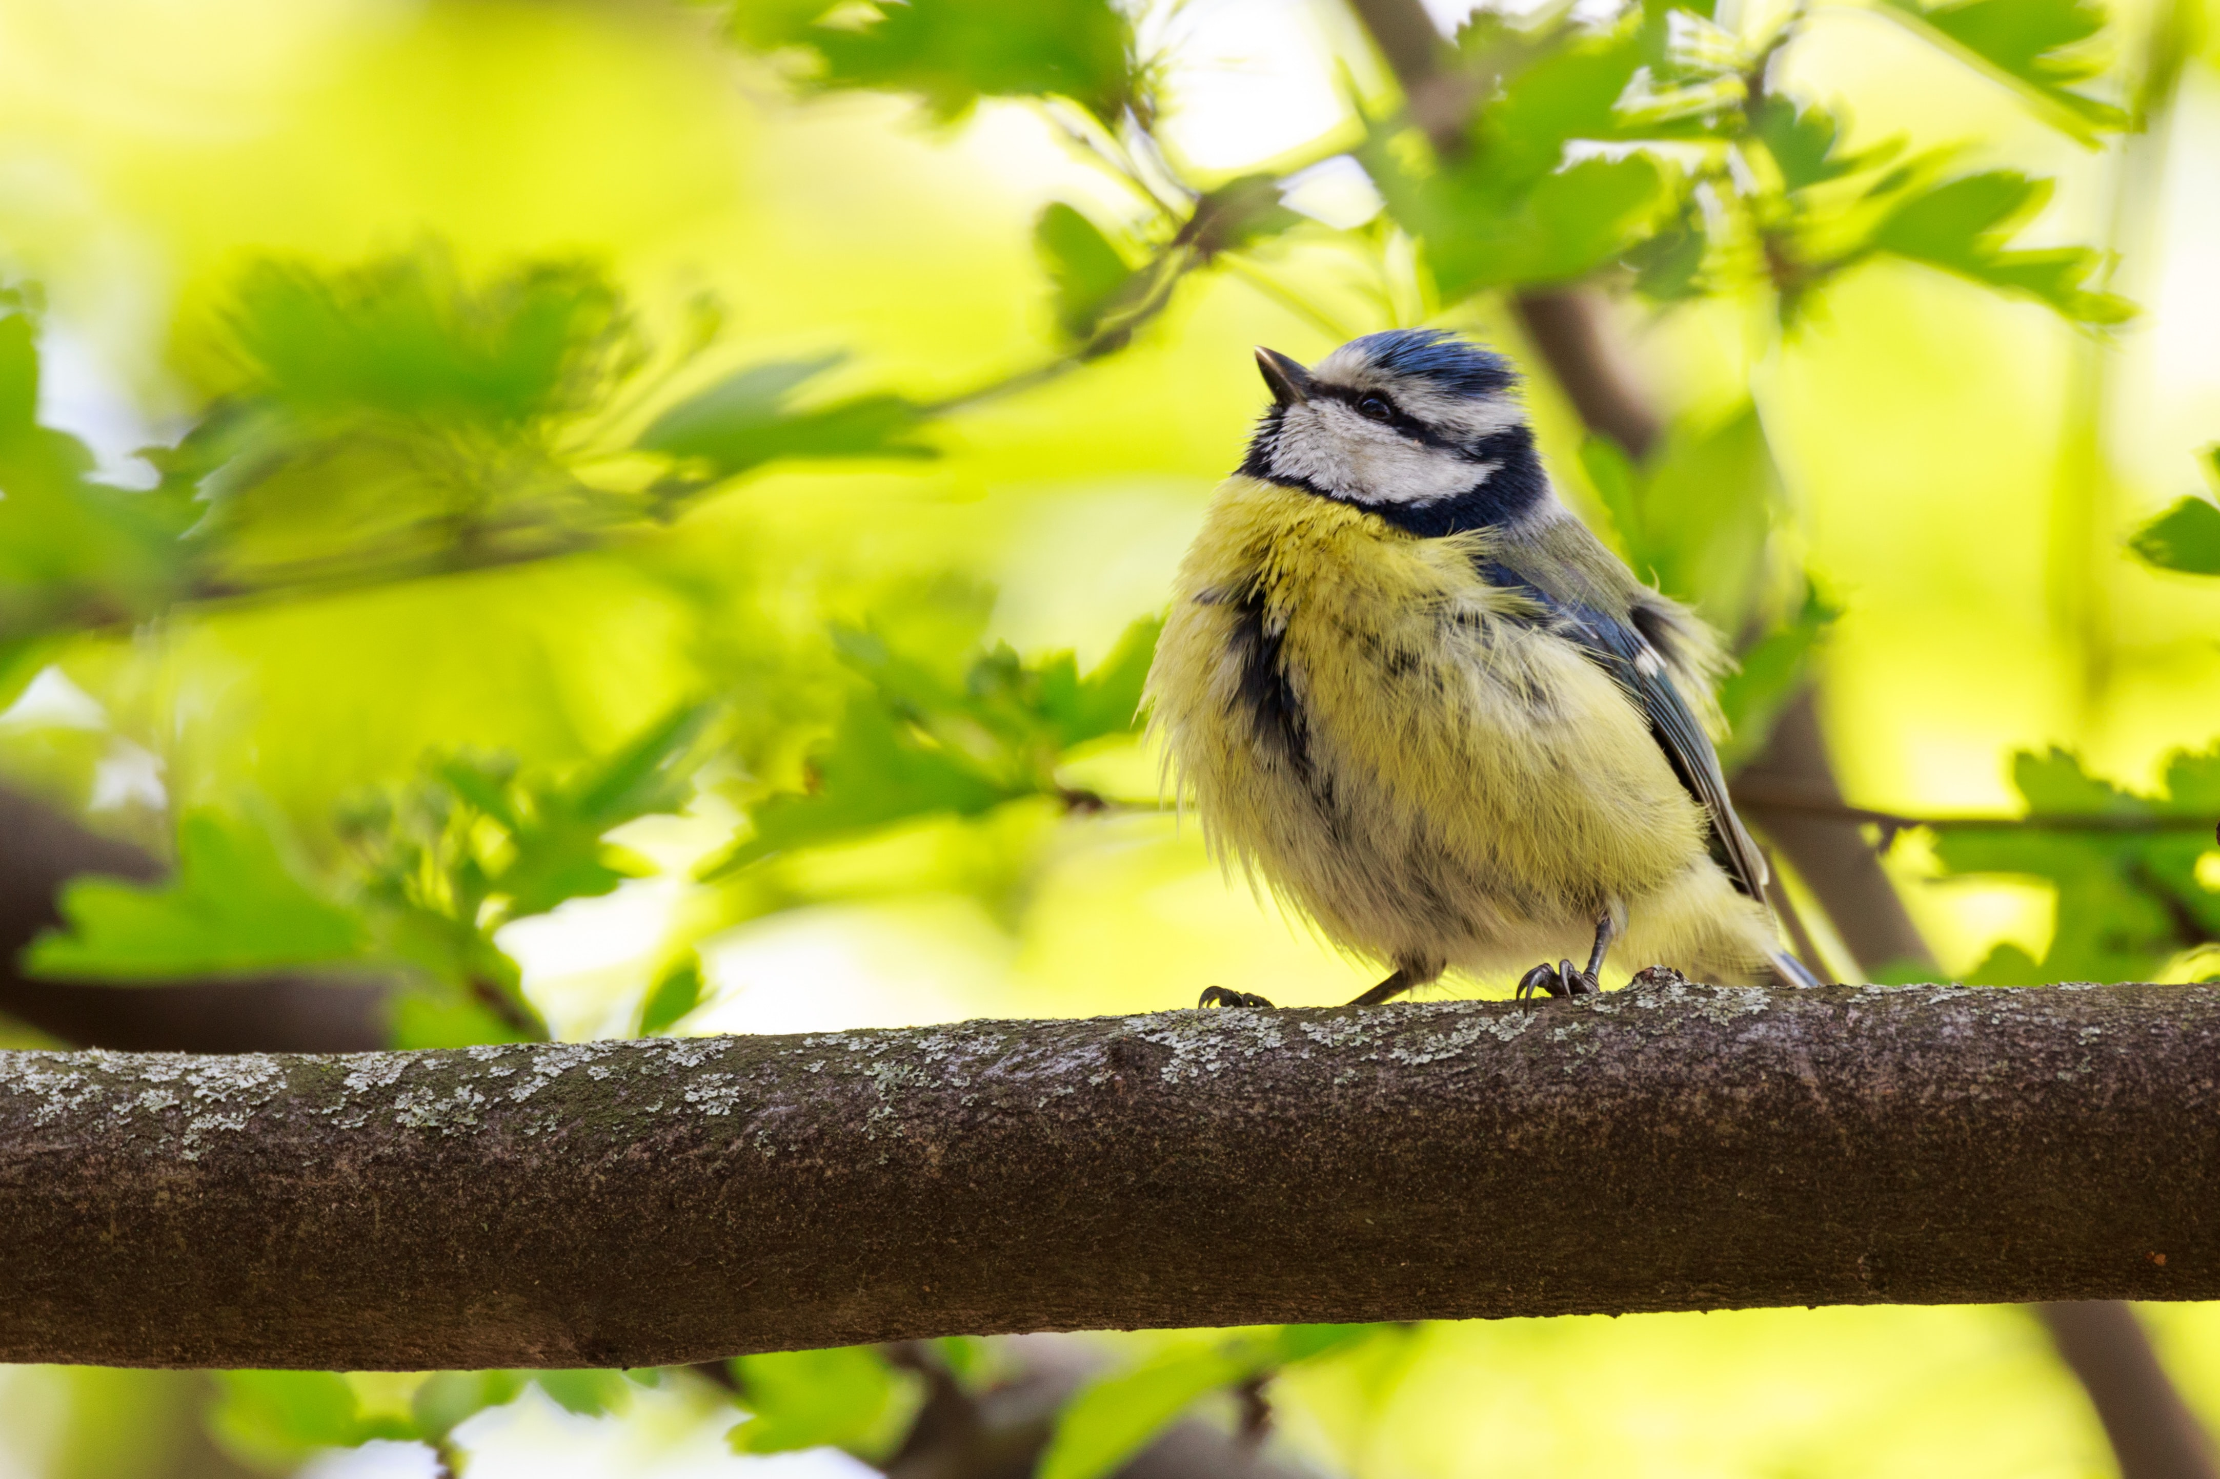
Photo by dfkt on Unsplash

