Advent Resource

Gift of Praise – a family prayer idea for Advent

As a family make a gift of praise for God. Giftwrap a small cardboard box and tie a bright ribbon around it or paste a large square of giftwrap onto backing paper and add ribbons so it looks like a present.
Then on small pieces of paper or sticky labels each of the family can draw or write something they wish to thank God for.

Write the following verse on a piece of card and display it by the box.

We thank you, our God, and praise you.
1 Chronicles 29:13

This idea is taken from:

Creative Ideas for Advent & Christmas
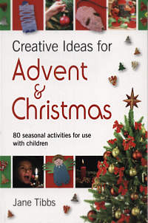
80 seasonal activities for use with children:
Jane Tibbs

Creative Ideas for Advent and Christmas
contains a wealth of inspirational easy-to-do ideas
for the busy weeks in the lead-up to Christmas.
All the ideas use readily available materials
and have instant appeal.
Many can be slotted in to any situation,
used to illustrate the story of Christmas,
or just done for pure enjoyment as part
of the exciting 'getting ready' time.
Some use seasonal objects that are easy
to find in the shops, such as paper chains,
or things that many people will have in their
Christmas box, such as last year's Christmas cards.

Ideal for 4-11s.

www.brfonline.org.uk

