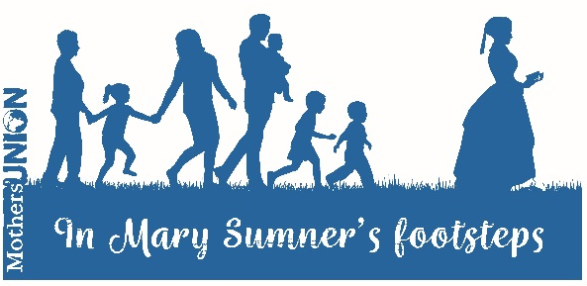
In Mary Sumner’s footsteps:
Bible Reflections on Journeying

Outline

These Bible reflections may be used singly or together.

They could form the activity for a Branch meeting or be used in a wider context, particularly where future direction is being considered.

If time allows, give everyone the opportunity to reflect silently for a while on the passage and then share what has stood out for them. Use these as a springboard to discuss the questions and thoughts which follow each passage.

Journeying with God

When Pharaoh let the people go, God did not lead them on the road through the Philistine country, though that was shorter. For God said, ‘If they face war, they might change their minds and return to Egypt.’ ¹⁸ So God led the people around by the desert road towards the Red Sea. The Israelites went up out of Egypt ready for battle.
²⁰ After leaving Sukkoth they camped at Etham on the edge of the desert. ²¹ By day the Lord went ahead of them in a pillar of cloud to guide them on their way and by night in a pillar of fire to give them light, so that they could travel by day or night.
²² Neither the pillar of cloud by day nor the pillar of fire by night left its place in front of the people.
Exodus 13:17-18, 20-22

To consider:

Reflect on what God may be highlighting to us through this passage as we seek the way ahead for Mothers’ Union in the 21st Century.

The closer we stay to Christ the easier it is to see where he is leading. Consider how as members we all stay close to Christ so we can move forward together.

Share together any times when you have particularly experienced God’s leading; or situations you’re currently facing where you need God’s guidance.

We step into the future with Christ as our guide.
Where he leads we will follow;
where he pauses we will wait;
united together as pilgrims of God. Amen

Journeying together

Now in the church at Antioch there were prophets and teachers: Barnabas, Simeon called Niger, Lucius of Cyrene, Manaen (who had been brought up with Herod the tetrarch) and Saul. ² While they were worshipping the Lord and fasting, the Holy Spirit said, ‘Set apart for me Barnabas and Saul for the work to which I have called them.’ ³ So after they had fasted and prayed, they placed their hands on them and sent them off.
Some time later Paul said to Barnabas, ‘Let us go back and visit the believers in all the towns where we preached the word of the Lord and see how they are doing.’ ³⁷ Barnabas wanted to take John, also called Mark, with them, ³⁸ but Paul did not think it wise to take him, because he had deserted them in Pamphylia and had not continued with them in the work. ³⁹ They had such a sharp disagreement that they parted company. Barnabas took Mark and sailed for Cyprus, ⁴⁰ but Paul chose Silas and left, commended by the believers to the grace of the Lord. ⁴¹ He went through Syria and Cilicia, strengthening the churches.
Acts 13:1-3;15:36-41

To consider:

You may have experienced times when a course of action began well but then got into difficulties? Reflect on the passage and share together any encouragements we can take from it.

Consider how we may get the right balance between caring for our fellow members and reaching out to families and communities?

How do we deal with conflict and differing views amongst those with whom we work to ensure we remain friends and companions on the journey?

Lord, be with us in all we do
as we journey together along your path.
Unite us as one in vision and purpose
to serve your world and glorify Christ. Amen.

