Knitted and Crocheted Octopuses

Crocheted Octopus Pattern

Materials

- 4 ply cotton yarn (100% cotton only) in main colour
- White 4 ply cotton yarn if eyes are to be crocheted.

- 3mm crochet hook
You may need to use a smaller crochet hook to ensure that your crocheting is free from holes so the filling can’t come out.

- New polyester filling
Conforming to BS1425 (for cleanliness) and BS5852 (for flammability).

- Tapestry needle

- Black thread

Abbreviations:
Dc – double crochet
Htc – half treble crochet
Tc – treble crochet
St – stitch
Sts - stitches
Ch – chain
Tg – together
Sl st – slip stitch
Yoh – yarn over hook

Body: working in continuous rounds:
1st round: 6 dc in a magic loop
2nd round: 2 dc in each st (12 sts in total)
3rd round: 2 dc in every other st, 1 dc in the other sts (18 sts in total)
4th round: 2 dc in every 3rd st, 1 dc in all other sts (24 sts)
5th round: 2 dc in every 4th st, 1 dc in all other sts (30 sts)
6th round: 2 dc in every 5th st, 1 dc in all other stitches (36 sts)
7th – 14th round: 1 dc in each st (36 sts each round)
15th round: *1 dc in the first 4 st, dc tg 5th and 6th st* repeat 5 times (30 sts remaining)
16th – 17th round: 1 dc in each st (30 sts)
18th round: *1 dc in each of 3 sts, dc tg 4th and 5th st* repeat 5 times (24 sts remaining)
19th-20th round: 1 dc in each st (24 sts)
21st round: *1 dc in first 2 sts, dc tg 3rd and 4th st* repeat 5 times (18 sts remaining)
22nd round: 1 dc in each st (18 sts)
23rd round: *1 dc in first 7 sts, dc tg 8th and 9th st * repeat once (16 sts remaining)
24th round: 1 dc in each st (16 sts)
25th round: this is where the tentacles starts: *1 dc, chain 50, turn, 2 or 3 dc in each chain (49 chains), 1 dc in next st of the body* repeat 7 times, making 8 tentacles. End with a sl st, cut yarn and sew in the end.
The tentacles must not be longer than 22 centimetres when drawn out the longest they can, as they may be a choking hazard if longer.

Bottom:
1st round: 5 dc in a magic ring
2nd round: 2 dc in each stitch (10 stitches)
3rd round: 2 dc in every other stitch, 1 dc in the other stitches (15 stitches) End with a sl st, cut yarn and sew in the end.

Assembling the octopus
Stuff the body and sew the bottom on.
Embroider on two eyes and a mouth using your preferred stitches.

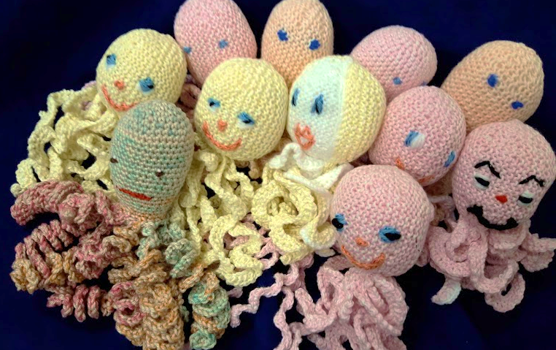

Knitted Octopus Pattern

Materials
- 4 ply 100% cotton yarn

- 2.25 mm knitting needles (UK size 13)

- New polyester filling conforming to BS1425 (for cleanliness) and BS5852 (for flammability).

- Knitting yarn or embroidery thread to embroider eyes and mouth

- Tapestry needle

Tension
32sts and 68 rows to 10cm over garter stitch (all rows knit) on 2.25 mm needles
While the finished size is not important, the stitches should be close together so that when the finished toy is stuffed, the filling does not come out through gaps in the stitches.

Abbreviations
K Knit
kfb knit through the front loop and then through the back loop of the same stitch (increase)
k2tg knit two stitches together (decrease)
sl1-k2tg-psso slip one stitch knitwise, knit two stitches together, pass the slipped stitch over the stitches knitted together (decrease)
ssk slip one stich knitwise, slip another stitch knitwise, put those tow stitches back on your left needle and knit them together through their back loops (decrease)
sts stitches

Instructions

Body & tentacles
Cast on 22 sts.
Row 1 K22, cast on 40 sts, turn [62 sts]
Row 2 K60, turn
Row 3 K18, turn
Row 4 K16, turn
Row 5 K14, turn
Row 6 K13, turn
Row 7 K11, turn
Row 8 K9, turn
Row 9 K 15, 40kfb [102 sts]
Row 10 Cast off 80sts, K to end [22 sts]
Row 11 K22, cast on 40 sts

Work Rows 2 – 11 six times more.
Then Row 2 – Row 9 again and finally, in Row 10, cast off all sts.

Cut the remaining yarn leaving a tail long enough so you could join the cast on and cast off rows.

Bottom
Cast on 3 sts
Row 1 Knit all sts
Row 2 kfb, K1, kfb [5 sts]
Row 3 Knit all sts
Row 4 kfb, K3,kfb [7 sts]
Rows 5 – 8 Knit all sts
Row 9 K1, k2tg, K1, ssk, K1 [5 sts]
Row 10 Knit all sts
Row 11 K1, sl1-k2tg-psso, K1 [3 sts]
Row 12 Knit all sts
Row 13 Cast off.

Cut the remaining yarn leaving a tail long enough to join the bottom piece with the body.

Assembling the body
Use the yarn tail to graft the cast on row with the cast off row.
To close the top of the body, weave in the yarn end around the edge of the top stitches to pull them together and close the top of the head.
Put the filling inside the body and using a tapestry needle, sew the bottom to the body.

Finishing
Embroider a smiley face using small stitches, (back stitch and stem stitch), and ensure all ends are firmly finished.

