Do’s and Don’ts for Supporting Survivors of
Gender-Based Violence

Encouraging people to talk about gender-based violence is critical in breaking the silence and stigma that victims can often face, and removing myths that can keep people silent.

A valuable support that Mothers’ Union members provides for others is giving people time and listening to them. Creating a safe and non-judgmental environment may encourage those who have experienced or are experiencing violence or abuse to speak out, including other members and friends. It is therefore important to be aware of how to respond to and support those who disclose such experiences.

The most appropriate ways to respond to disclosures of abuse may vary with culture and context. However, there are some general principles to consider:

- Violence and abuse is ALWAYS wrong and NEVER acceptable

- The responsibility for the abuse lies with the perpetrator

- Ultimately, only the person experiencing abuse can decide what course of action to take.

The below “Do’s and Don’ts” may provide some helpful insights…
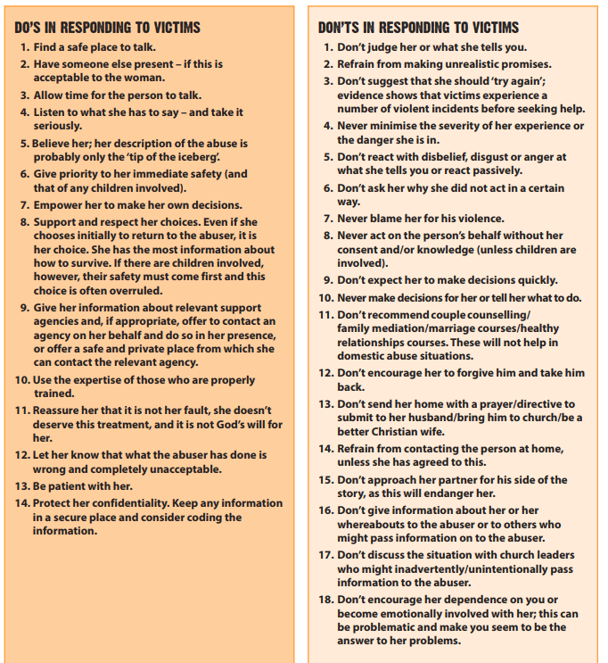

(Source: Restored, Ending Domestic Abuse: A Pack for Churches, p 26)

