FAQ – Webinars
What is a webinar?
A webinar is a web seminar. They are used as a way to communicate useful information to multiple people, often in different locations. Our webinars will have two presenters and will include information around the specific topic, as well as a question and answer section. Our webinars have been divided in to key topics, these are:

Social Media
Identifying our strengths
How to plan a project
How to show the difference
Fundraising

It is advisable to sign up for all the webinars in each of the above key topics, in order to gain all of the information.

How to sign up to Zoom?:
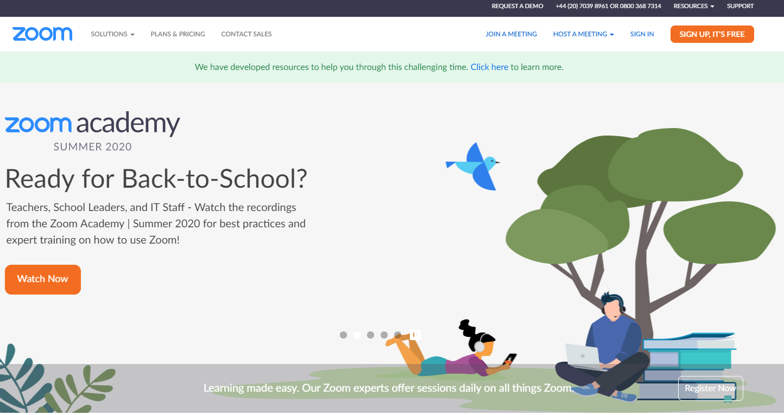
You may want to sign up for Zoom (but this is optional). If you do not currently have a Zoom account and want to then you can follow the instructions below. It is easy to sign up and you just need to click the sign up, it’s free orange button on the Zoom homepage (outlined below).

After you click the orange sign up button, you will be asked for your birthday and for your email address, Zoom will then send you an email to activate your account. After following the link in your emails you can set up your Zoom account by entering in your email and your desired password. If you already have a Zoom account then you will be able to login before the webinar starts.

How do I register for a webinar?:
The webinars can be found on the Mothers’ Union website, the link can be found here: https://www.mothersunion.org/mothers-union-member-webinars. On the webinar page you will see all of the webinars available, starting from August 17th until November, you can then click through to each of the webinars you are interested in and the Mothers’ Union Webinar Registration page will appear (shown in the above picture). You then simply need to fill in your details to register your interest in the webinar. Once you have registered your interest you will receive an email to say we have registered your interest but you need to be approved (this is for security reasons to ensure that no one incorrectly joins the webinar). This is a manual process and will likely be updated on a weekly basis so please do not be alarmed if you are not approved right away.
Note: Please do also check back regularly on the webinars page on the Mothers’ Union website, as we will likely be adding more webinars, depending on demand.

Will the webinars be available after the scheduled date?:
We have set it so the webinars will record automatically and therefore will be available for those who can’t attend on certain dates. If you watch the webinars at a later date you will miss out on having the live Q&A regarding the specific topic of the webinar, however your questions may be asked by a fellow member. You will also be able to send emails to the relevant departments to answer any questions.

What kind of equipment do I need?:
You will need access to a computer or a smart phone and have a good WiFi connection. This is if you are following the link in the confirmation email. Alternatively you can dial in on a mobile or landline using one of the numbers on the confirmation email.

I would like to suggest a webinar topic:
We would love to hear any suggestions for future webinars, please email communications@mothersunion.org with a topic you would be interested in.

