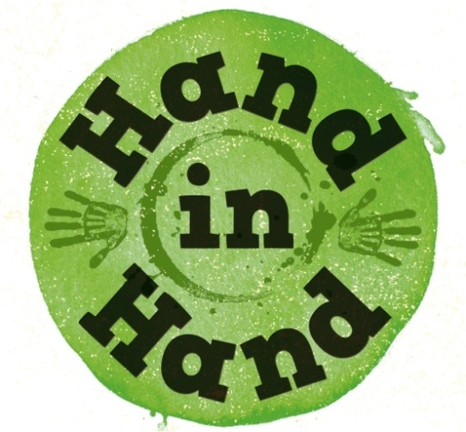


Discover Ways to Pray

In our families we talk to each other, we listen, we enjoy each other’s company. Prayer is a natural development of these family interactions – doing the same thing with God.
These are a few ideas for you to try or adapt with your family.
They may also inspire further ideas of your own!

- Have a board in the home that the family can put their prayers on in the way they want (it could be one word or a picture.) A whiteboard is easily cleaned.
Choose a family prayer of the week or praise word of the day.

- Make up actions to symbolise “thank you; help; sorry” and use them as a way of praying. It’s not necessary to vocalise what they represent.

- Draw or write what you want to say sorry for on a balloon and then pop them to symbolise that God takes away our wrongs and gives us a new start.

- Blow bubbles and silently pray whatever they make you think of as you watch them.

- Play a version of I Spy:
“I’ll pray, say thanks today for something beginning with......”

- Throw a ball. Whoever catches it calls out a word describing God; something to thank God for or an issue for prayer.

- Draw your praise and thanks to God. Use colours to spark ideas for prayers.

- Take a few moments to silently ask God what he wants to say to your family. Then either tell each other your thoughts, or draw or write them down.

Pray:
Together take turns to make your thank you, help or sorry action,
and then pray aloud or silently.


www.mothersunion.org

