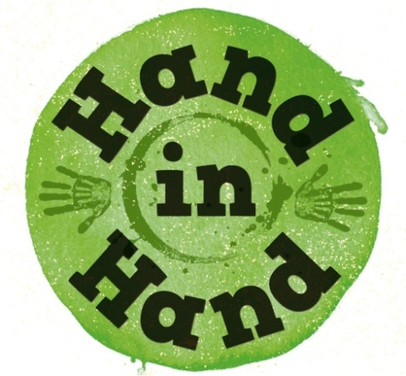


Explore the Bible Together

We can develop our personal and family faith as we discover more about the Bible. Enjoy activities together that explore Bible stories, and relate them to life.
These are a few ideas for you to try or adapt with your family.
They may also inspire further ideas of your own!

- Find some different versions of the Bible and chat about which ones you like and why?

- Build Bible scenes with Duplo or Lego; use toys to enact stories.

- “Personalise” the stories by including yourselves in the Bible events.

- Make food inspired by the stories e.g. colour coconut green to make grass for a sheep celebration when the lost sheep is found! (Luke 15:1-7) Create recipes to help use up the leftover food from the feeding of the 5000! (Mark 6:32-44)

- Imagine together what happened next in a story; try re-telling the story through God’s eyes.

- Remember the value of exploring the sad and hard parts of the Bible as well as the happy and easy parts. Talk together about how they make you feel.

- Play charades or drawing guessing games using Bible characters.

- Watch DVDs and television programmes based on Bible stories. Talk about any parts that are different to the Bible accounts, and consider together why the changes might have been made.

Pray:
After reading the Bible:
Thank God for one thing about the story.
Ask God about anything that’s puzzling about the story.


www.mothersunion.org

