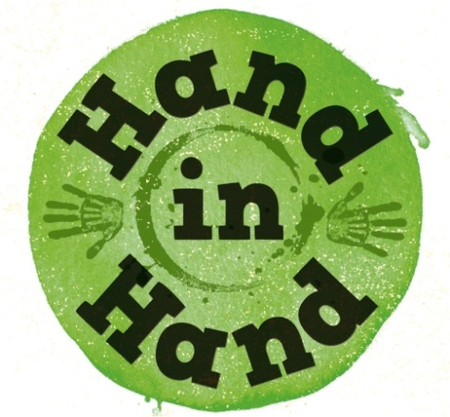


Enjoy Music Together

Music is a wonderful gift which we can use to help us enjoy faith together.
These are a few ideas for you to try or adapt with your family.
They may also inspire further ideas of your own!


- Listen to music together which helps to evoke the wonder of the universe e.g. The Planets by Gustav Holst.

- Build up a collection of favourite songs that all the family enjoy listening to or singing together.

- Take turns in choosing music to listen to when the family are together e.g. at mealtimes.

- Include a special song as part of a bedtime routine.

- Talk together about what sort of music makes you happy, sad, close to God....?

- Use instruments or singing to explore what you think God’s voice sounds like or his love sounds like.

- Make up tapping rhythms to symbolise thoughts and emotions. If you want to these could be used as a way of praying.

- Talk about how the psalms encourage us to praise God by making music or read Psalm 150 in a good children’s Bible. Think of ways that you as a family want to praise God with music – what instruments would you use? What songs?

Pray:
Listen to a piece of music.
Pray for whatever it makes you think of - either silently or aloud.

www.mothersunion.org

