Faith in the Family Harvest Idea

Fruity Fun for Harvest Prayers

Harvest is a time when we can thank God for the good things we have.
Often, we gather food to give to others to thank God for the food he has provided for us.

Place an apple, banana, lemon and some grapes on a plate in the centre of the dining table.

Use the fruit as a way into prayer as a family. For example:

- Apples - could remind us to pray for making the right choice when faced by temptation. This links to the Bible story of Adam and Eve when they disobeyed God by eating the apple they should not have done.

- Bananas - could help us to pray for justice for those who are suffering because of the unfair trade laws of our world. This links to the fact that many of the bananas now available in the supermarket are fair-trade.
This means the people who produce them get the right amount of pay
for them.

- Lemons - could help us to think of those who are facing hard and bitter times. Lemons and lemon juice are very sharp and bitter, which reminds us of the bitterness some people face in their lives.

- Grapes - could help us to pray for those who have things to celebrate at this time. Grapes and wine, which is made from grapes, were often used, and still are, as part of a celebration.

Jesus said: 'You did not choose me. I chose you and sent you out
to produce fruit, the kind of fruit that will last.'
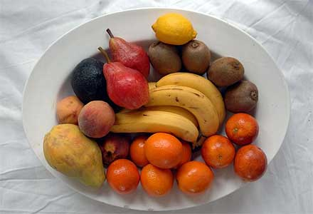
John 15:16 (CEV)
Material ©BRF

