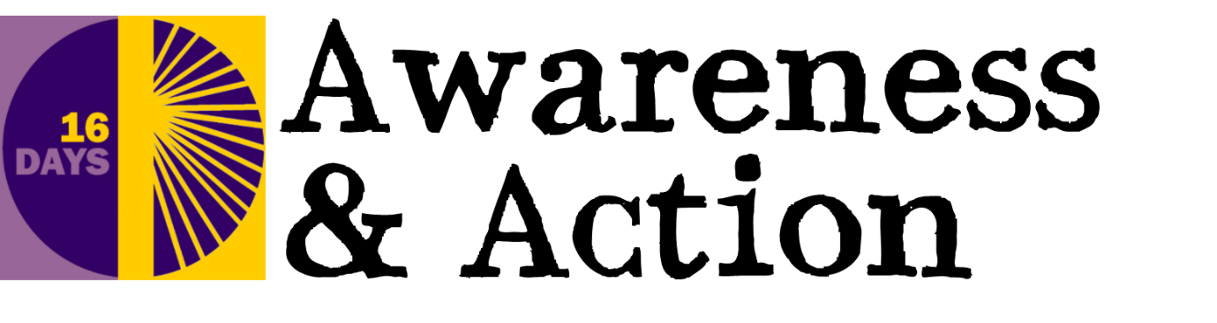

Gender-Based Violence: Facts & Figures

- In the year ending March 2018, 2 million adults aged 16 to 59 had experienced domestic abuse within the last year

- Two women are killed each week by a current or former partner in England and Wales

- The UK police receive a call every minute about domestic abuse, 89 percent are about a woman being abused by a man

- Only 24 percent of cases of domestic violence are actually reported

- 20 percent of UK women endure sexual assault throughout their lives

- 23 percent of women in high income countries, 25 percent in the western region and 38 percent of women in the south-east Asia are abused each year

- At least one in three women globally will experience some form of gender-based violence at some point in their lifetime

- Violence against women can damage the health and wellbeing of a women from physical health consequences such as chronic pain syndromes, induced abortions and disabilities to mental health consequences such as PTSD and depression

- More than 700 million women alive in the world were married as children

- In the EU, 1 in 10 women have experienced some form of sexual violence since the age of 15, and 1 in 20 have been raped. Just over 1 in 5 women have experienced physical and/or sexual violence from either a current or previous partner

- An estimated 35 percent of women worldwide have experienced either physical and/or sexual intimate partner violence or sexual violence by a non-partner at some point in their lives
- Women aged 15-44 are more at risk from rape and domestic violence than from cancer, car accidents, war and malaria

- Sexual violence is even more prevalent for younger women as one in three teenage girls have experienced some form of sexual violence from a partner

- A third of people believe women who flirt are partially responsible for being raped.

Office for National statistics https://www.ons.gov.uk/peoplepopulationandcommunity/crimeandjustice/bulletins/domesticabuseinenglandandwales/yearendingmarch2018 Amnesty International https://www.amnesty.org.uk/violence-against-women World Health Organisation https://www.who.int/violence_injury_prevention/violence/global_campaign/16_days/en/index2.html Restored https://www.restoredrelationships.org/about-vaw/statistics/

