Getting Started with the MU Live Reporting Website

Mothers’ Union members across the globe are currently putting their faith into action in an amazing way, getting involved in a whole array of activities, large and small, that are having an impact on the lives of so many people in their communities.

The aim of MU Live is to build a picture of how and where we are working, how many people are reached and how lives are being changed. This website is designed to make the process of recording our activities and reflecting on change easy. You can submit a report as often as you wish, and the website will collate all the information and give you summaries for each activity so you don’t have to do the calculations yourself.

This guide is designed to help you get started and to understand how to input and review your data. This can be used in conjunction with the demonstration YouTube clip.

First Steps – Setting a Password

Every Diocesan and Provincial President will have access to MU Live. If you are not a DP or PP, you need to ask your DP to contact development@mothersunion.org to be put onto the system.

To access MU Live go to https://mulive.org (clicking or tapping this link should take you there). On some systems you may have to press the Ctrl key at the same time as clicking and some may warn of the dangers of clicking links. If the latter happens, please confirm that it is okay to open the link.

This will load the login page. You will first need to create a password and once you have done this, this is the page you will use every time to gain access to the site.
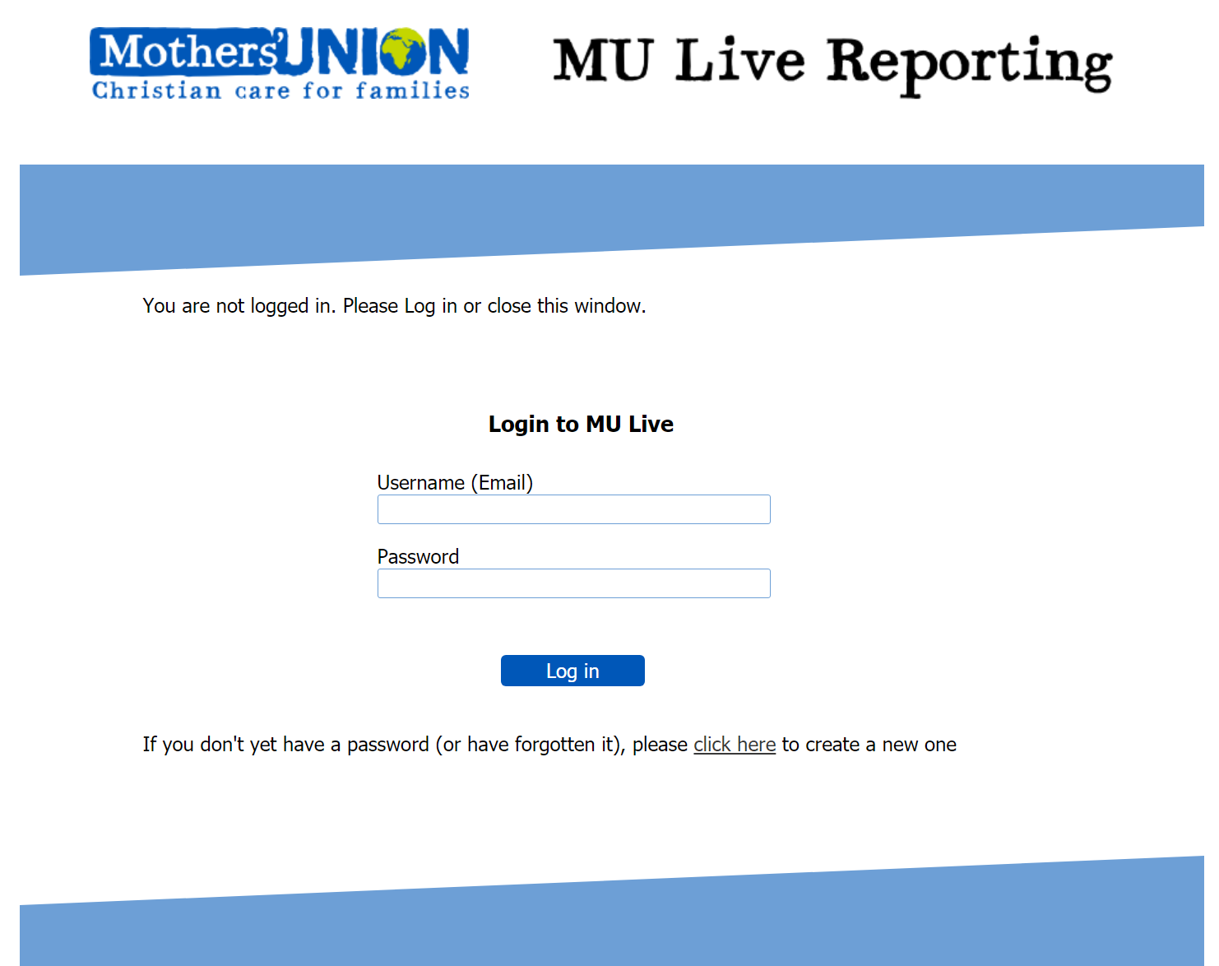

If you don’t yet have a password or if at some future time you forget what it is, please click on the circled ‘click here’ link. This will take you to the page below:

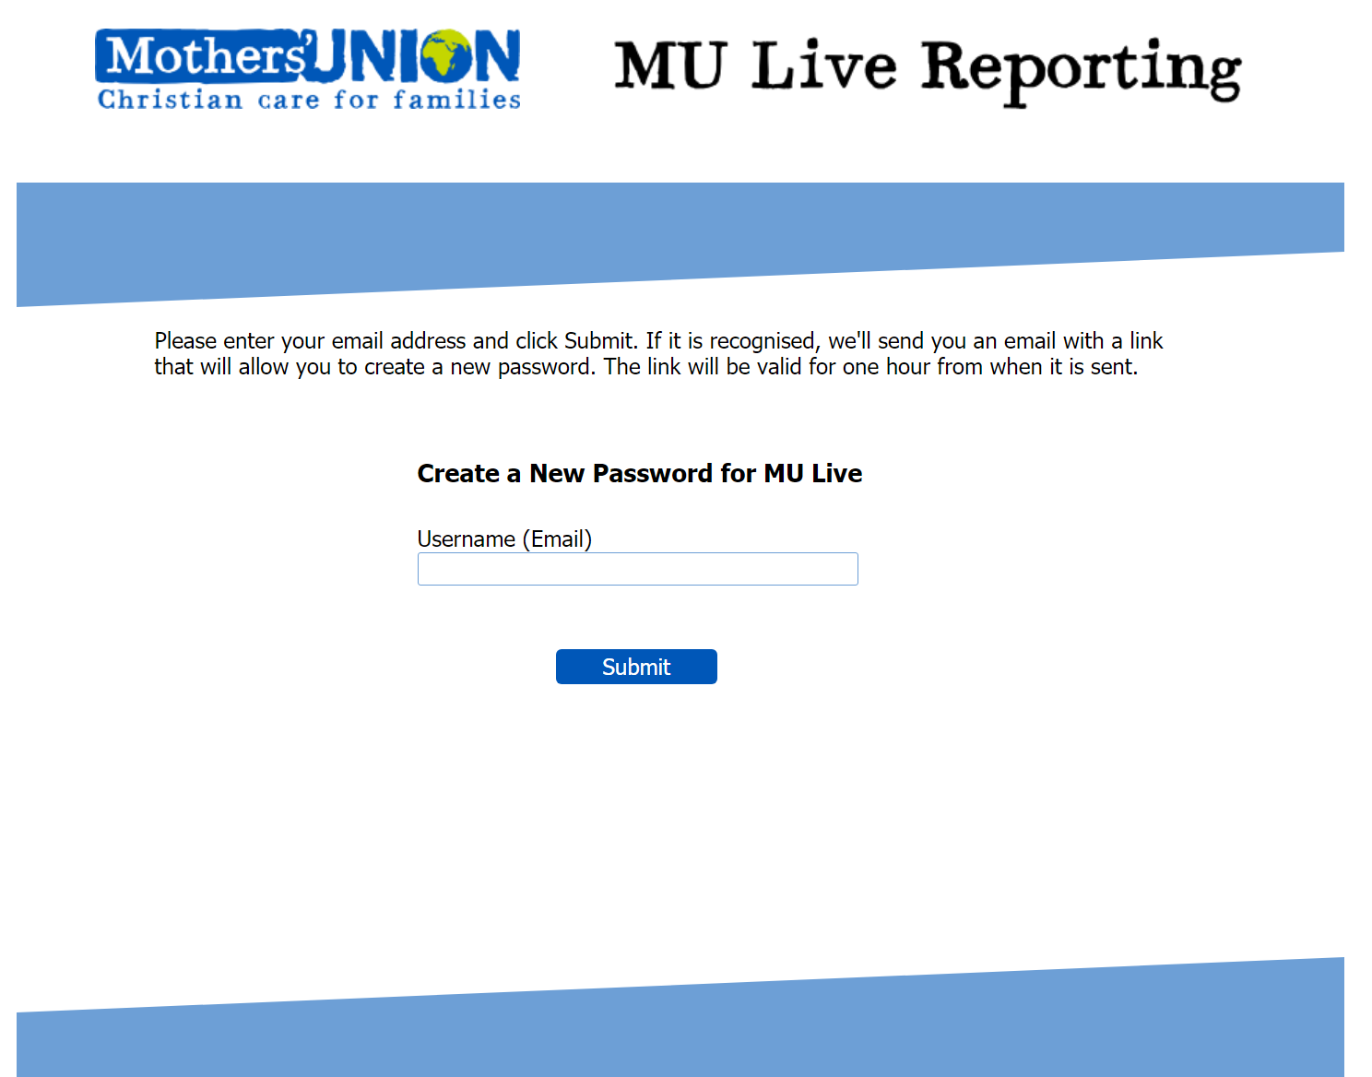

Your username is your email address. Please enter your email address and click Submit.

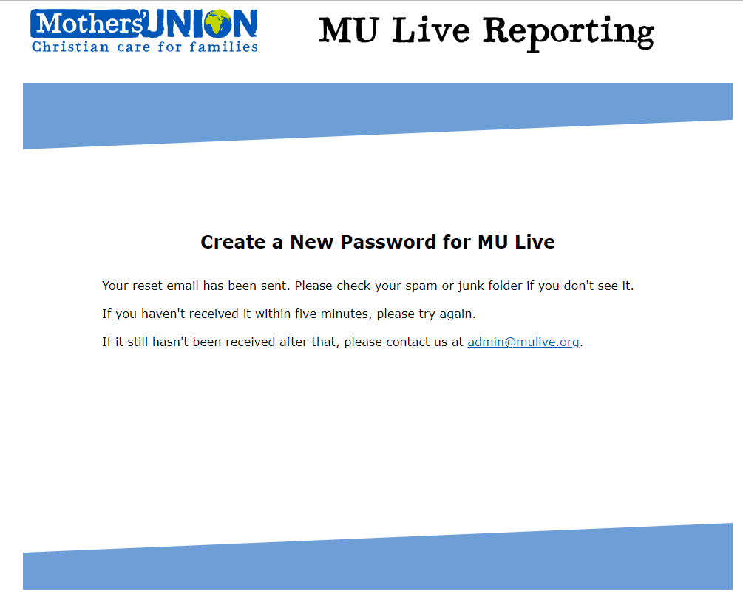

The system will respond by loading the page above and sending an email in the format below to your email address. This will only work if the email address is on our database. If the email address is not recognised, a different page will load telling you so and asking you to contact us via the admin@mulive.org (you can simply click on it to do so). If the email doesn’t arrive, please look in your spam, junk or promotion folder (usually under a Folders heading on the left of your email programme’s window).

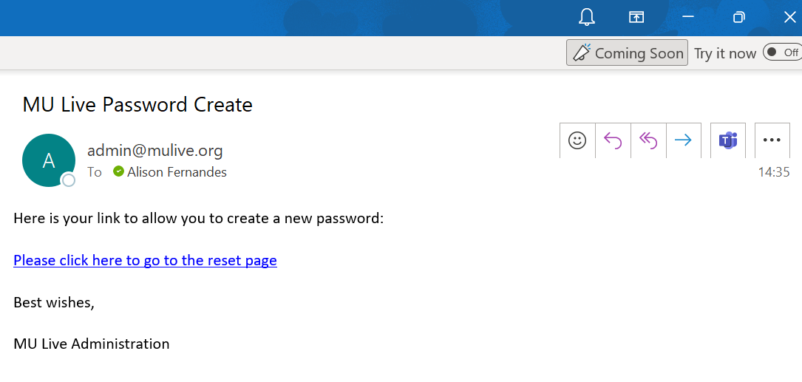
Please click on the link in the email (circled), which will take you to the webpage shown below, where you can create your password. Please note that you must do this within two hours of the email being sent. You must use the email address we already have for you and your password must be at least 10 characters long (it can be much longer if you wish) and must contain at least one capital letter, one lower case letter, one number and one symbol. It can contain more than one of any of the character types.

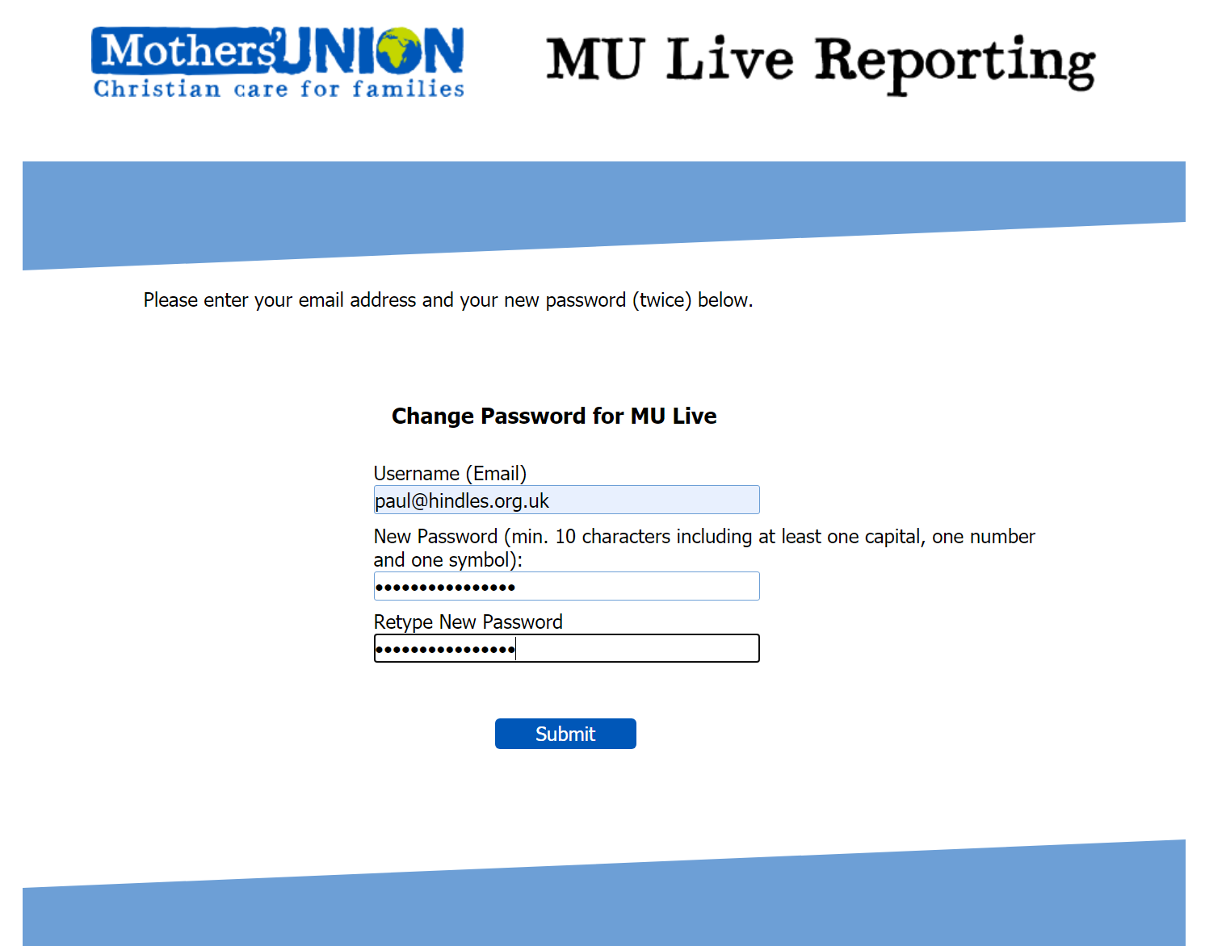

If you have successfully put in the correct email address and the correct format of password, and the two password entries are the same, the system will respond by displaying the webpage below:

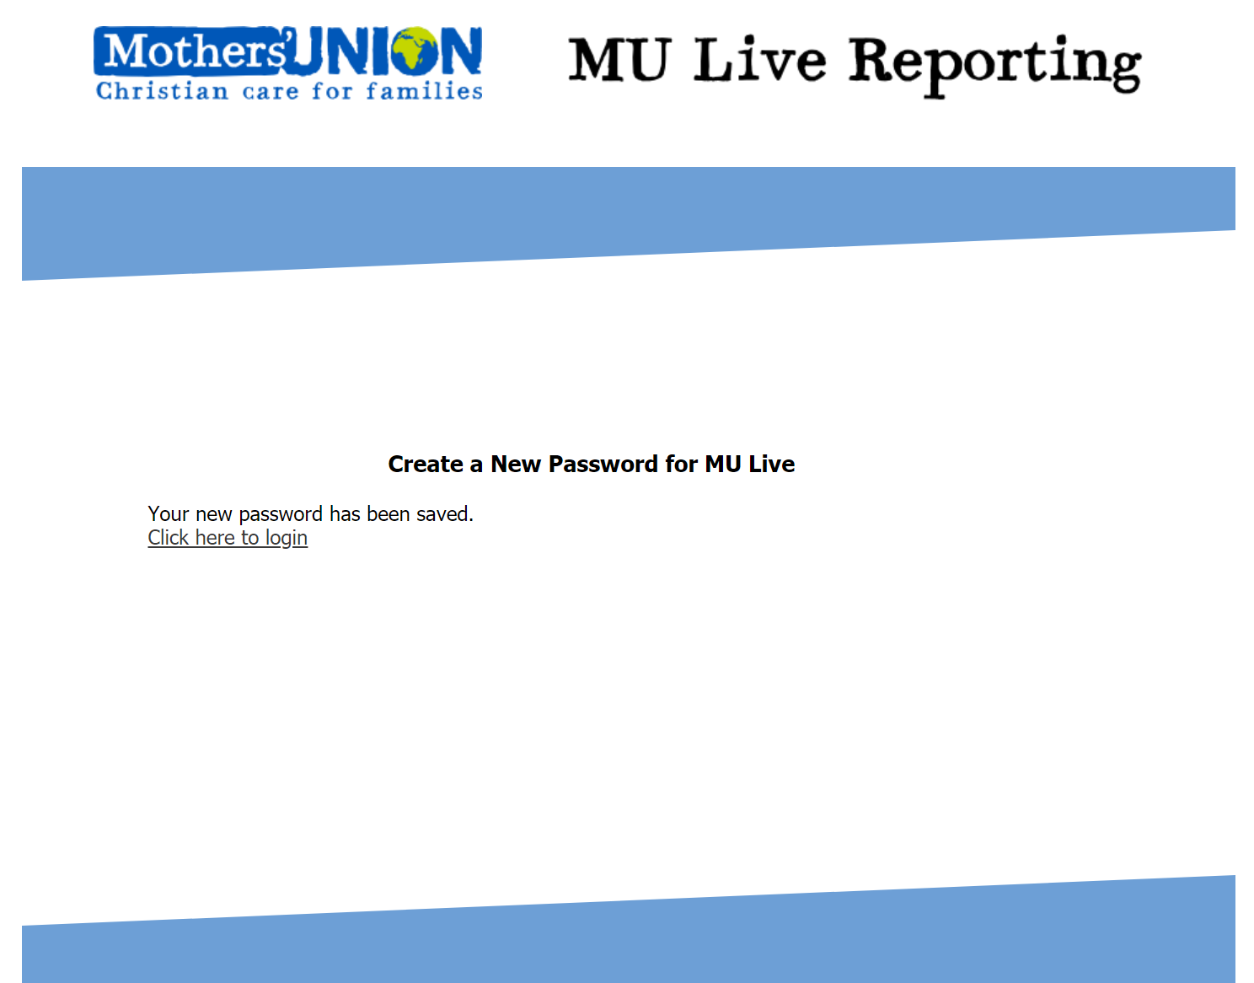

Clicking the circled link will take you to the login page you saw on page 1 of this guide. Enter you email address and password as shown on the next page.
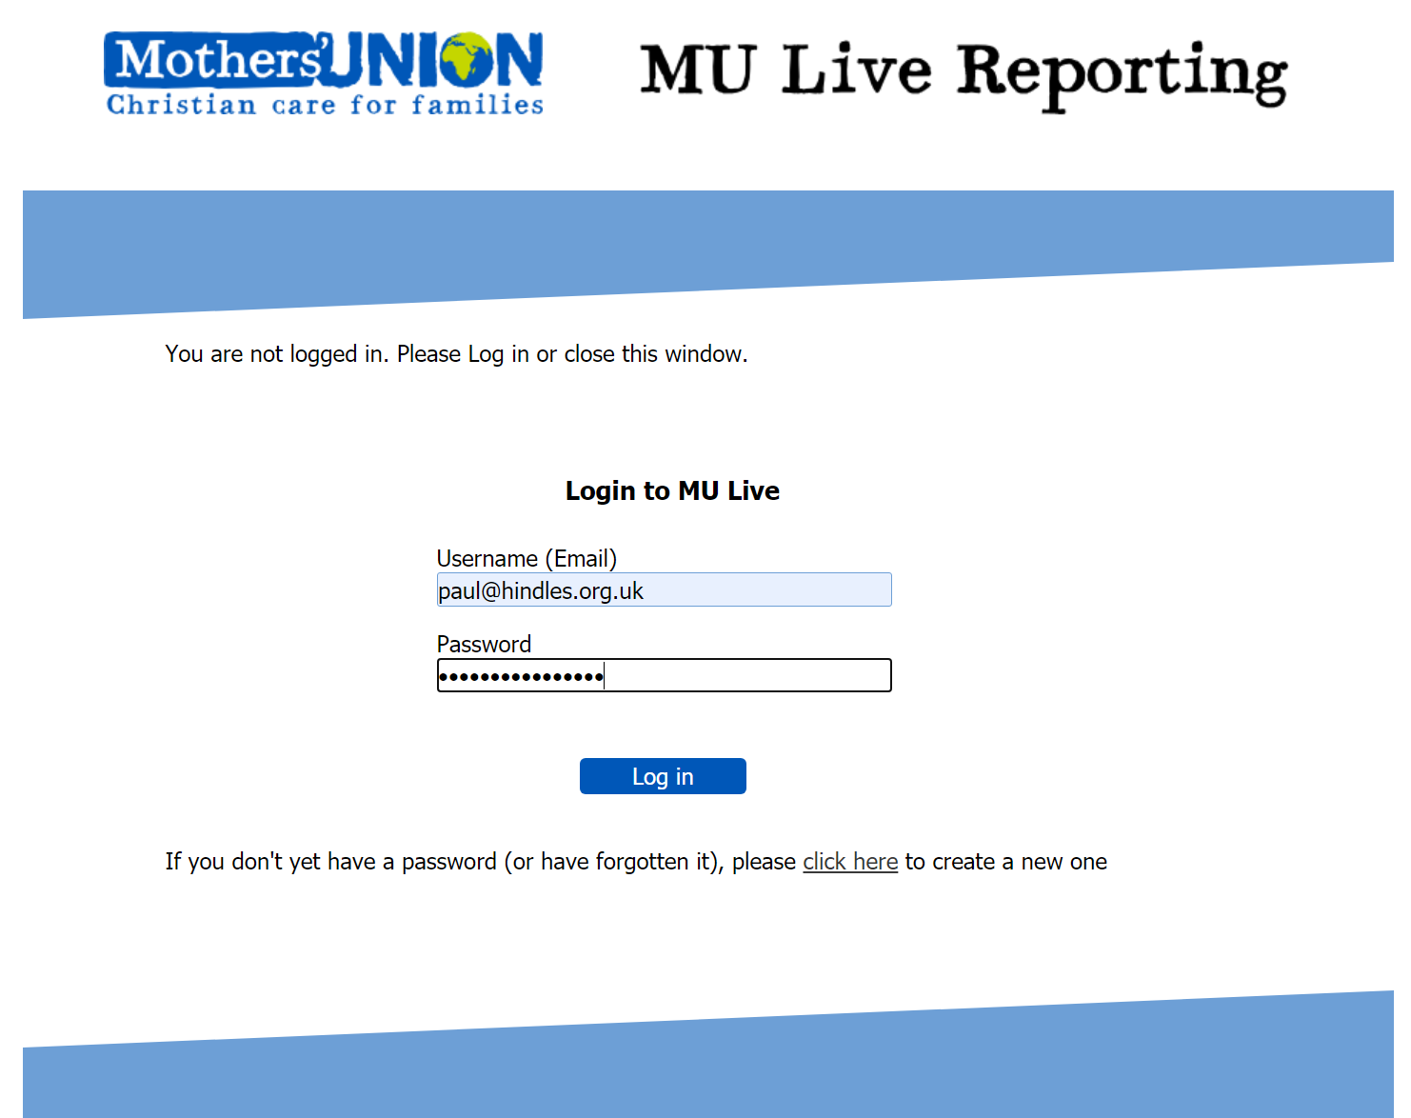

After you click Log in, you will be able to:

Create and Submit Reports
This is always the first page on the website after you login and you can get back to it from anywhere by clicking the ‘Home’ link at the top of each page (circled). To start your first report, click on the ‘Input’ link at the top of the page or the ‘Submit one or more new reports’ link (both arrowed). This will load the page shown on the next page.
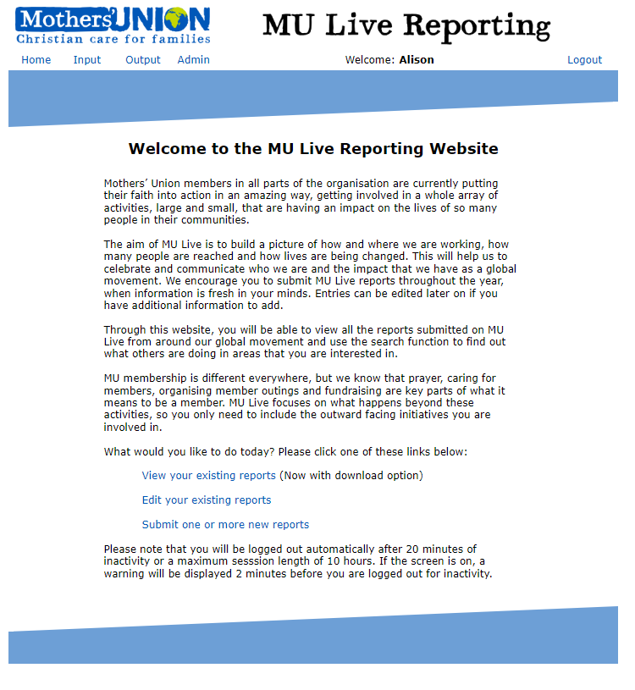

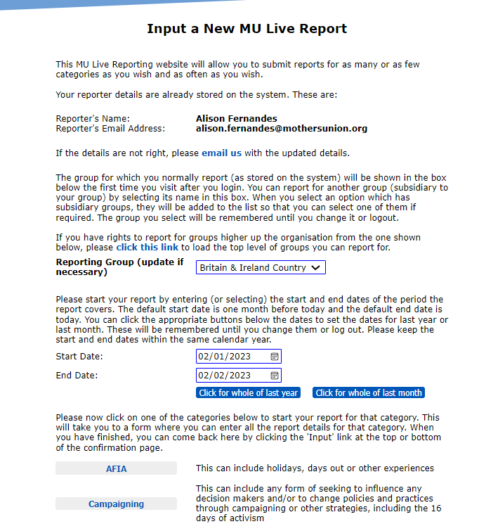

You’ll see it is already populated with your name and email address, the reporting group that you normally report for and two dates.

The end date will be today’s date and the start date will be exactly one month earlier. You can change these dates to suit the period you are reporting on. Importantly, we ask that you make sure the two dates lie within the same calendar year otherwise the report will not be picked up in the annual reports (the system should complain if the two dates are not in the same year as long as JavaScript hasn’t been disabled). The two buttons underneath the dates will automatically set the date range indicated on them (the whole of last year or the whole of last month). You can also click on the little calendar icon to the right of each date to select a date from a calendar popup as shown below:
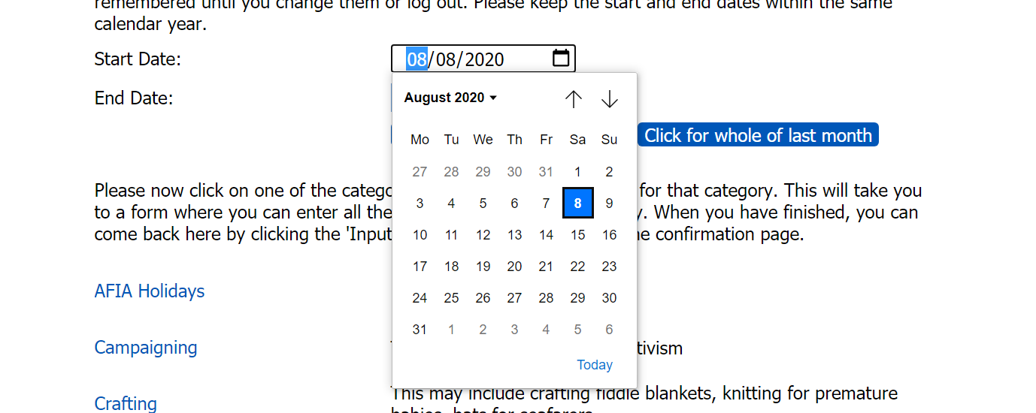
The up and down arrows take you to the next month before or after and the little triangle next to the month allows you to select earlier months or years more quickly.

If you want to report for a different group, click the little v symbol at the right end of the Reporting Group box. If there are any further groups available to you, they will appear in the dropdown menu where they can be selected:
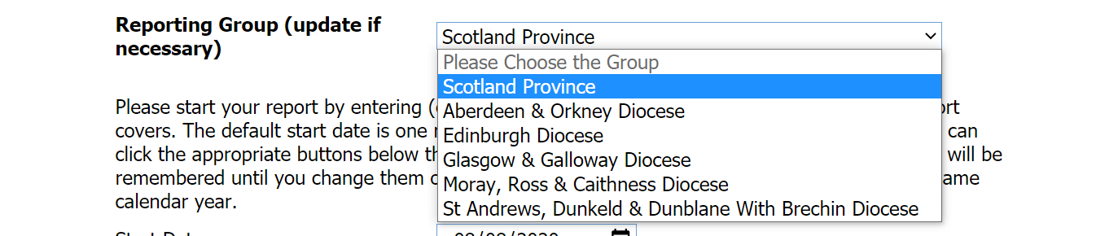

If you select one of the new options and it has further groups under it in the structure you will see a message popup for five seconds to let you know:
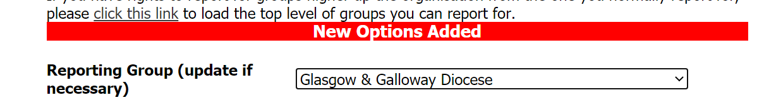

Now when you click the little v symbol, there will be more options to choose from:
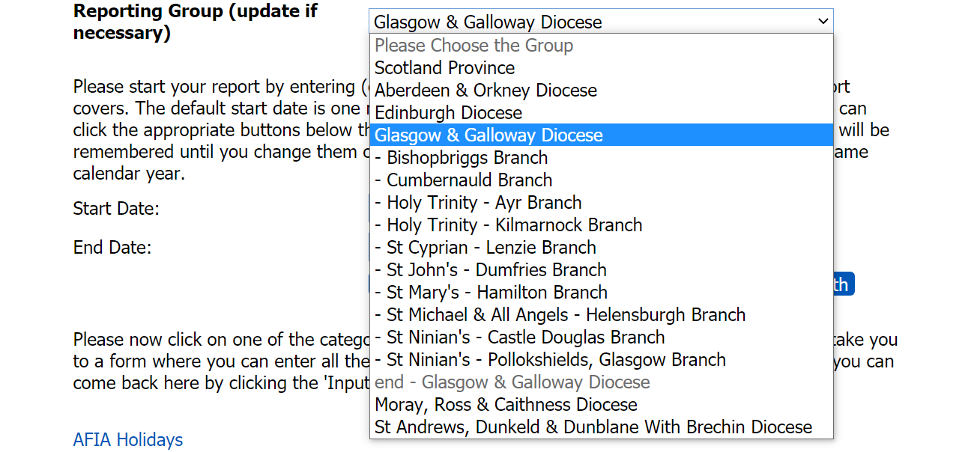

If you have rights to report for a group that is above your usual one in the structure, please click the ‘click this link’ text circled on page 6 to load the page again with your top level of the structure in the reporting group box.

Now you have the basic information selected, decide what you want to start with (one of the 7 categories of activity, a comment or a story of change) at the bottom of the page. The example below is what loads if you click AFIA:

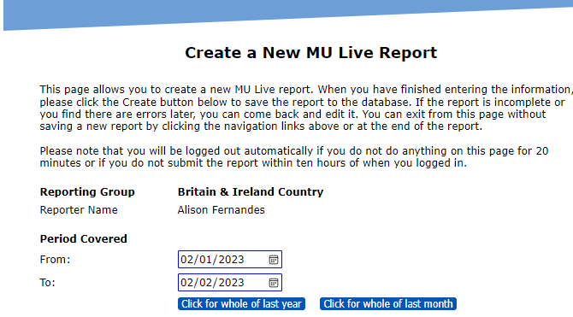
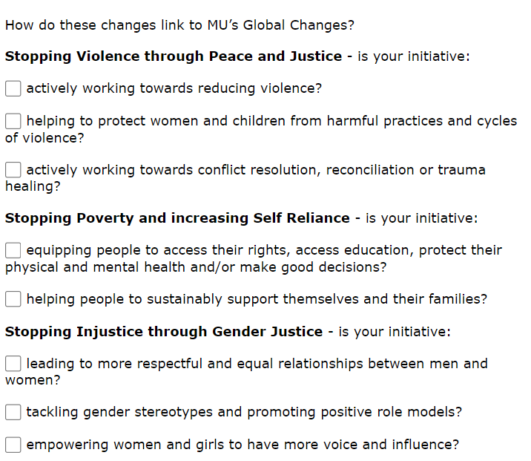
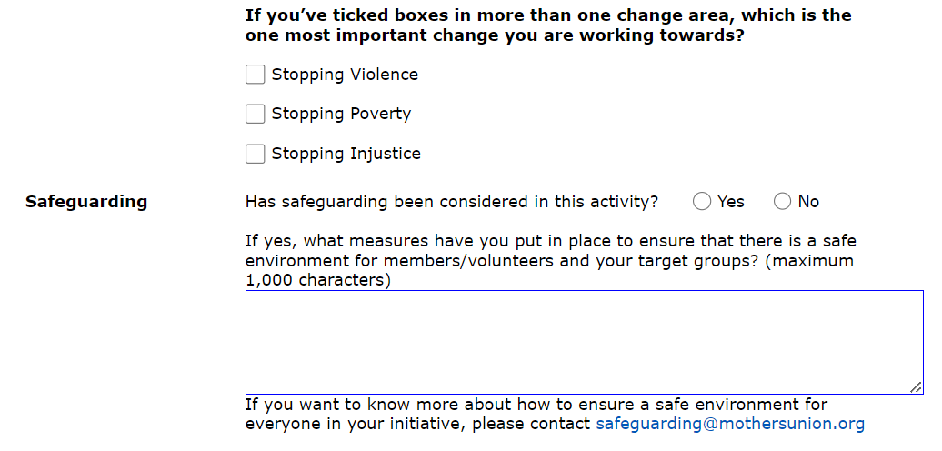

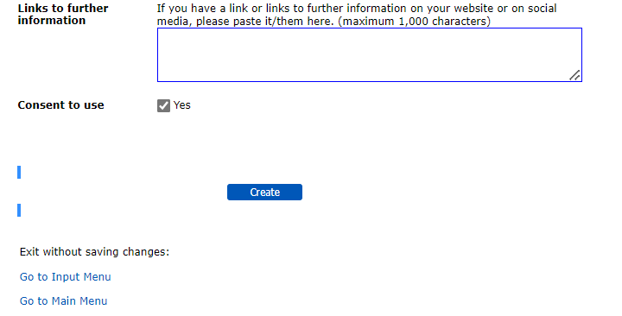

Now fill in the details you have for the activity. Please note that it doesn’t have to be totally complete in every aspect, though the more complete it is, the better for compiling impact reports later. As described later, you will have the opportunity to edit incomplete reports to add further detail.

When you have finished, please click the ‘Create’ button. This will save your report to the database and load the following confirmation page 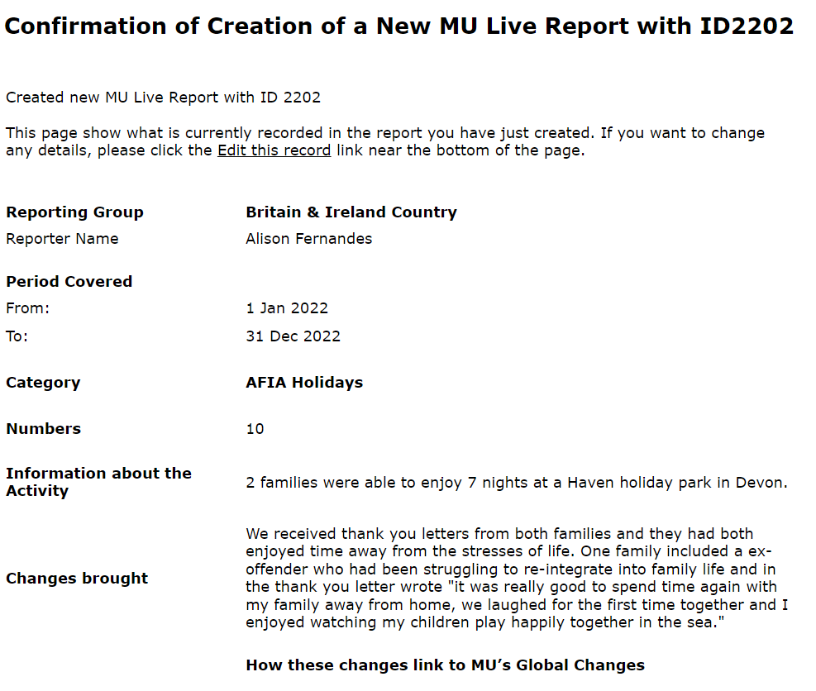
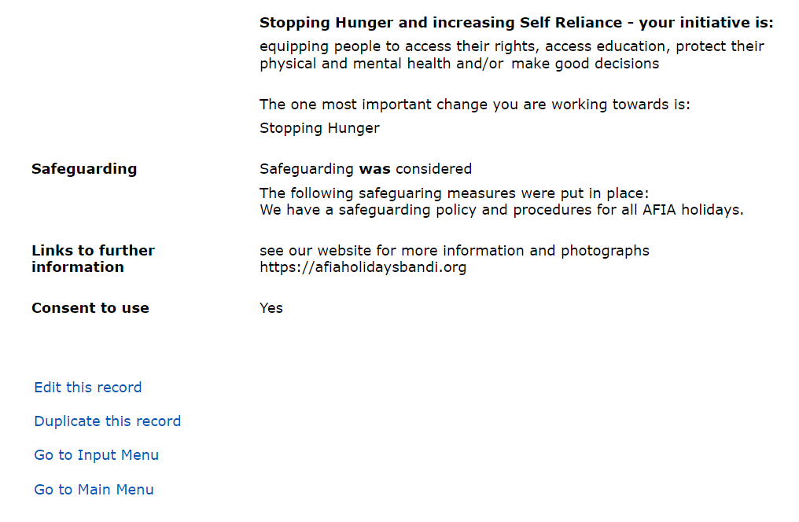

If you discover an error or something missing, you can change the report immediately by clicking the ‘Edit this record’ link (circled). This will load a page very similar to the one you used to create the report, but with all the details on record already entered.

The ‘Duplicate this record’ link (below the Edit link) also loads a page that looks similar to the Create record page, but this allows you to change the dates and the reporting group if your permissions allow access to other groups. This may be handy if you are submitting reports for different branches where much of the text of the report is similar or if you are doing a monthly report for an ongoing project.

There are slightly different styles of Create report pages depending on which link you click on the Input page (as shown on page 6 earlier). Here is the page that loads if you select ‘Crafting’:
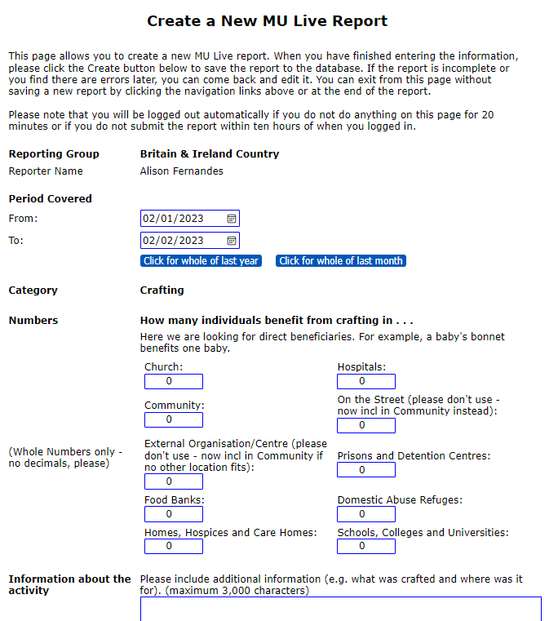
Because of space considerations, this isn’t the full page, but the bit that is missing is identical to the AFIA page. The main difference between the Crafting page and the AFIA page, apart from some of the text in the questions, is the way the numbers are recorded. We are looking to record numbers in the various settings where Crafting may apply. This same number recording format is used in all the reports except for AFIA where it is one number and ‘Campaigning’, ‘Comment’ and ‘Stories of Change’ where no numbers are recorded. On the comment page there is one input box where you can make a comment about how the website works or suggest improvements.

The stories of change requires similar information to the other reports in terms of linking the story to our global change areas and the safeguarding questions but no numbers are requested and it is more narrative in format as shown by a sample of part of the report below:
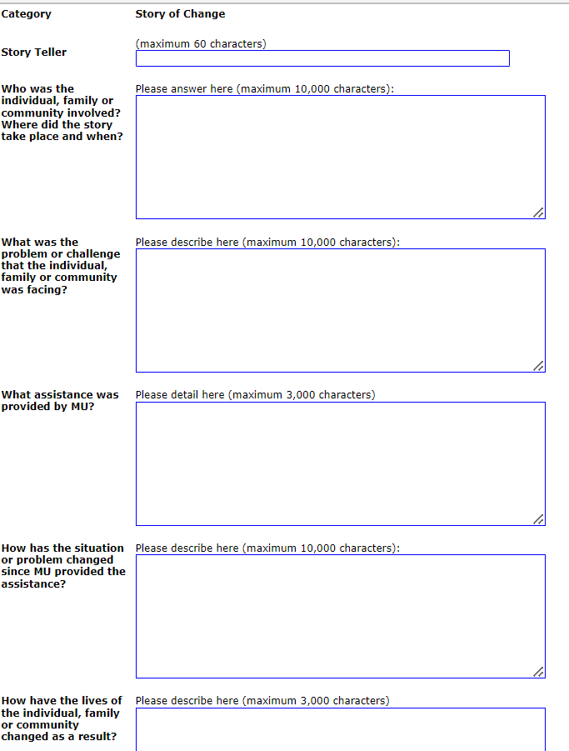

Viewing Your Existing Reports
Now you have created one or more report(s), you will want to review them. This is achieved by clicking on the ‘Home’ or ‘Output’ tabs at the top of each page and then choosing the ‘View your existing reports’ link on the page (see below for the ‘Output Menu’ and page 6 for the ‘Home’ page).
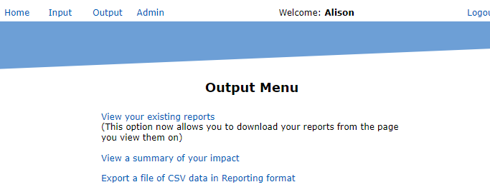
Those links take you to the page (below) where you can choose which reports you want to see.
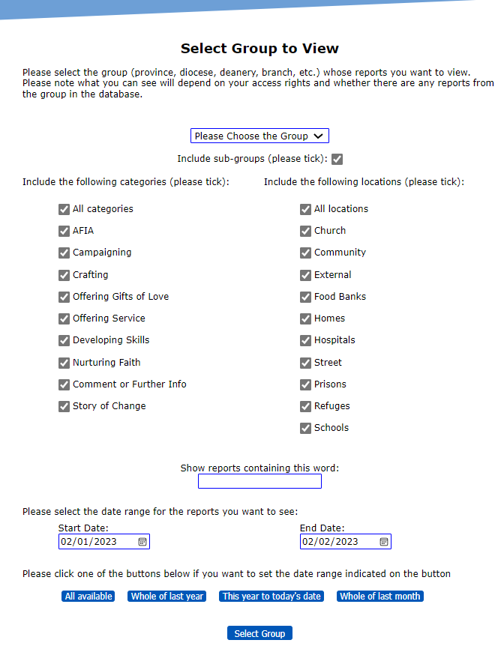
The select box for the group you want to see works in the same way as the one that we have already seen for creating reports in the first place. There is a checkbox under the dropdown that allows you to include the reports from all the groups below your selected group in the structure (e.g. for a province it would include all the dioceses, deaneries and branches in the province).

Below this are checkboxes that allow you to select only reports on a particular theme (s) and/or setting(s).

The date range boxes work in the same way as you saw during the input. The default range is the same as the range for the last new report you submitted (or the last month if you haven’t submitted any reports in this session). There are two more buttons than on the input page to allow you to set date ranges for everything available and for the year so far.

There is a search function box (circled) where you can do a keyword search for reports containing a specific word. This might be helpful if you are starting a new initiative and want to learn what others are doing to address this issue across the diocese, province or global movement.

When you click the ‘Select Group’ button the system will present you with a page of reports that meet the criteria selected. The page is much wider than the ones you have seen so far and consists of a heading section, a footer section and a scrolling window of reports. The top half of this page is illustrated below. It shows the one test report we’ve seen before for Scotland AFIA that fits in the date range.
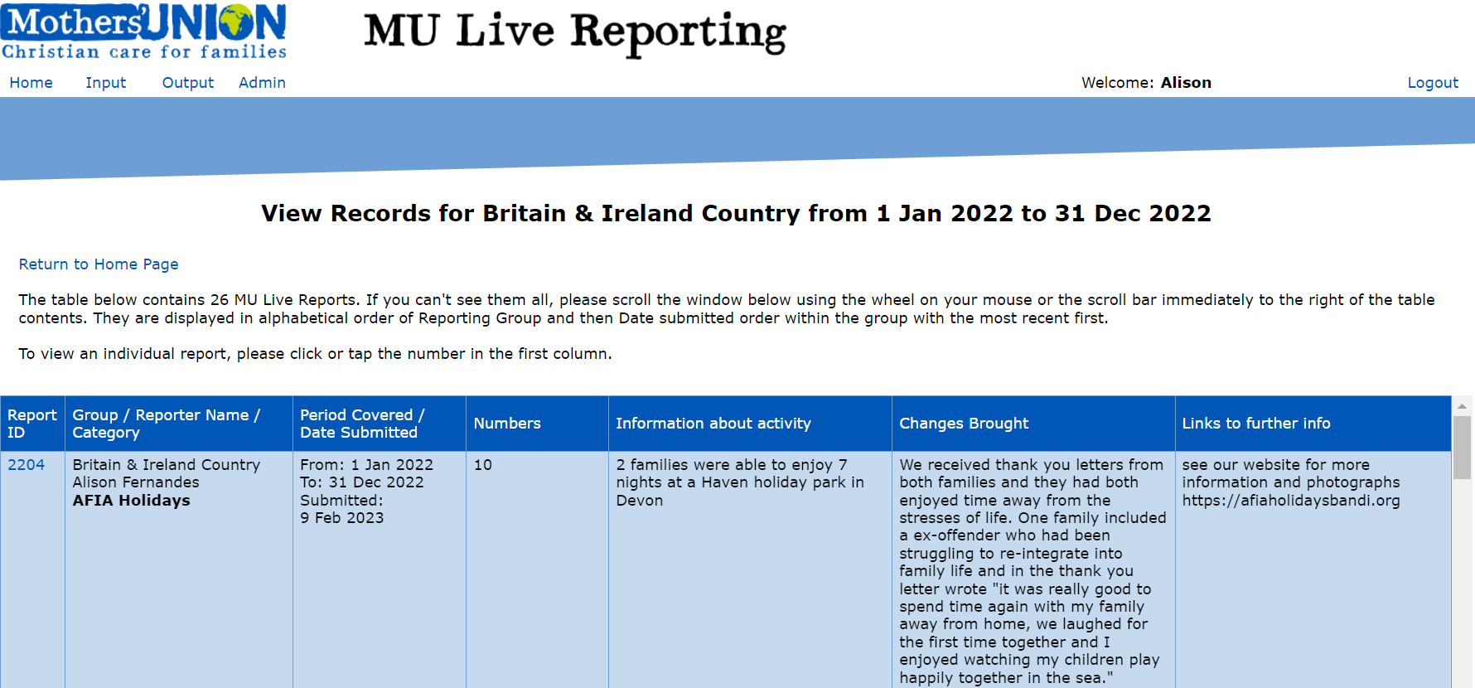

To view an individual report on its own page, you click the Report ID number in the first column (in this case 2204). This opens a new page that is very similar to the confirmation page that appeared when the report was created. Note – that Report ID numbers are automatically generated by MU Live.

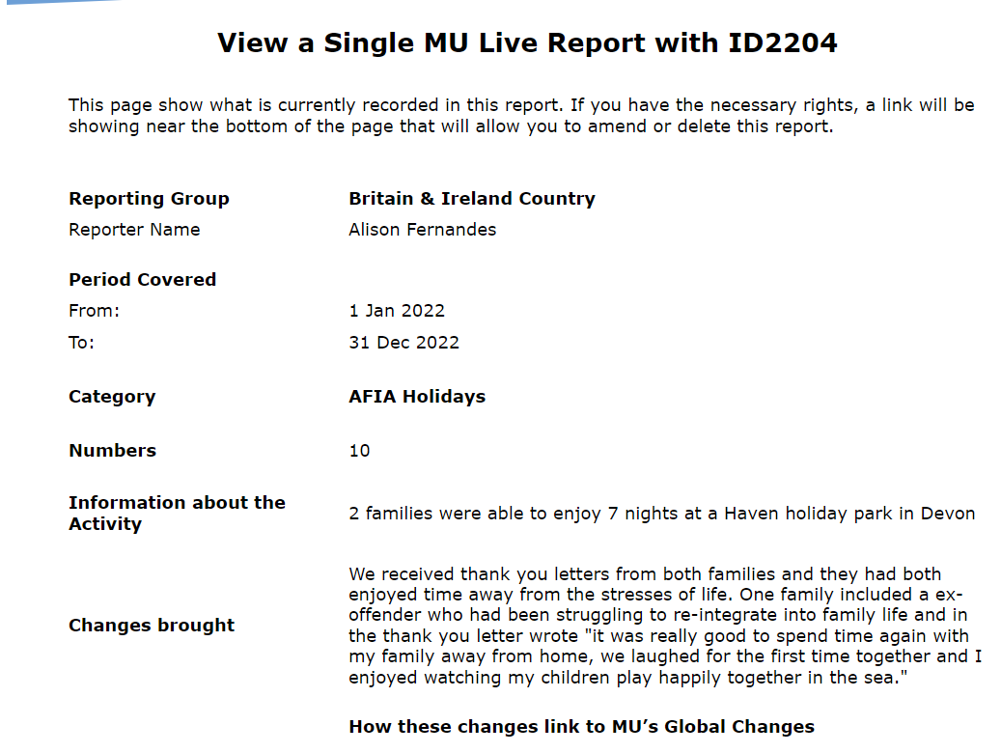
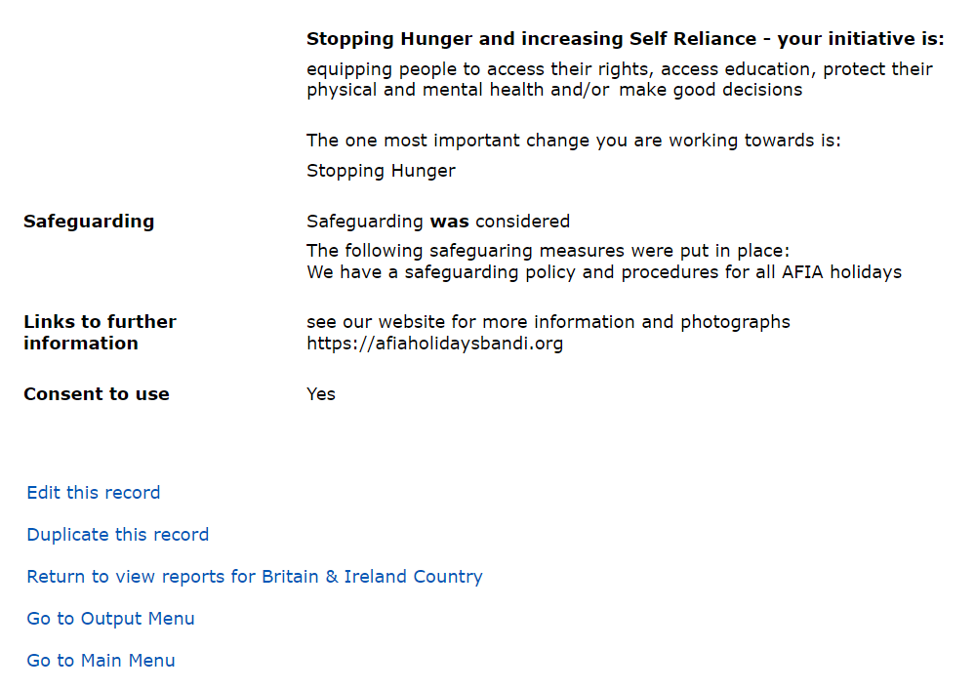

There is one additional menu item in the list at the bottom of the page. This takes you back to the page you came from with the report you clicked on at the top of the window of reports. This can be handy if you have dozens of reports and want to go back to where you were in the list.

Editing your reports
The ‘Edit this record’ link loads the report so you can make changes. As mentioned before, the page is almost the same as the one used to create the report in the first place. Apart from some wording changes, there is a further option near the bottom of the page that allows you to delete the report as you can see in this illustration from the lower half of the page:

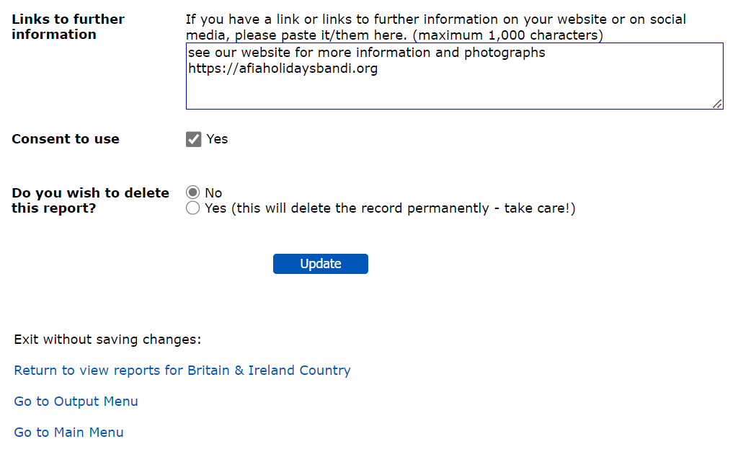
If you select the ‘Yes’ button and then click ‘Update’ the confirmation page will load with all the data in light grey text. You do have an opportunity to Edit the report again from the confirmation page and thereby undo your deletion. If you don’t take that opportunity, there is no route, at present, back to that particular report and it will not be included in any search for information (contact Paul if you desperately need to get it back!).

From the Home page, there is another route to Editing your reports through the ‘Edit your existing reports’ link. The sequence it takes you through is almost identical to the ‘View your existing reports’ but clicking the Report ID in the list of reports takes you straight to the Edit report page instead of the View report page.

Getting Summaries of Your Impact
The second option on the Output Menu is ‘View a summary of your impact’. This takes you to the Select Group page, which is similar to the one you saw when requesting to view or edit your reports. You have the same options to select the group, the categories and locations and the date range. When you click the ‘Select Group’ button, a page like the one on the next page will be displayed.
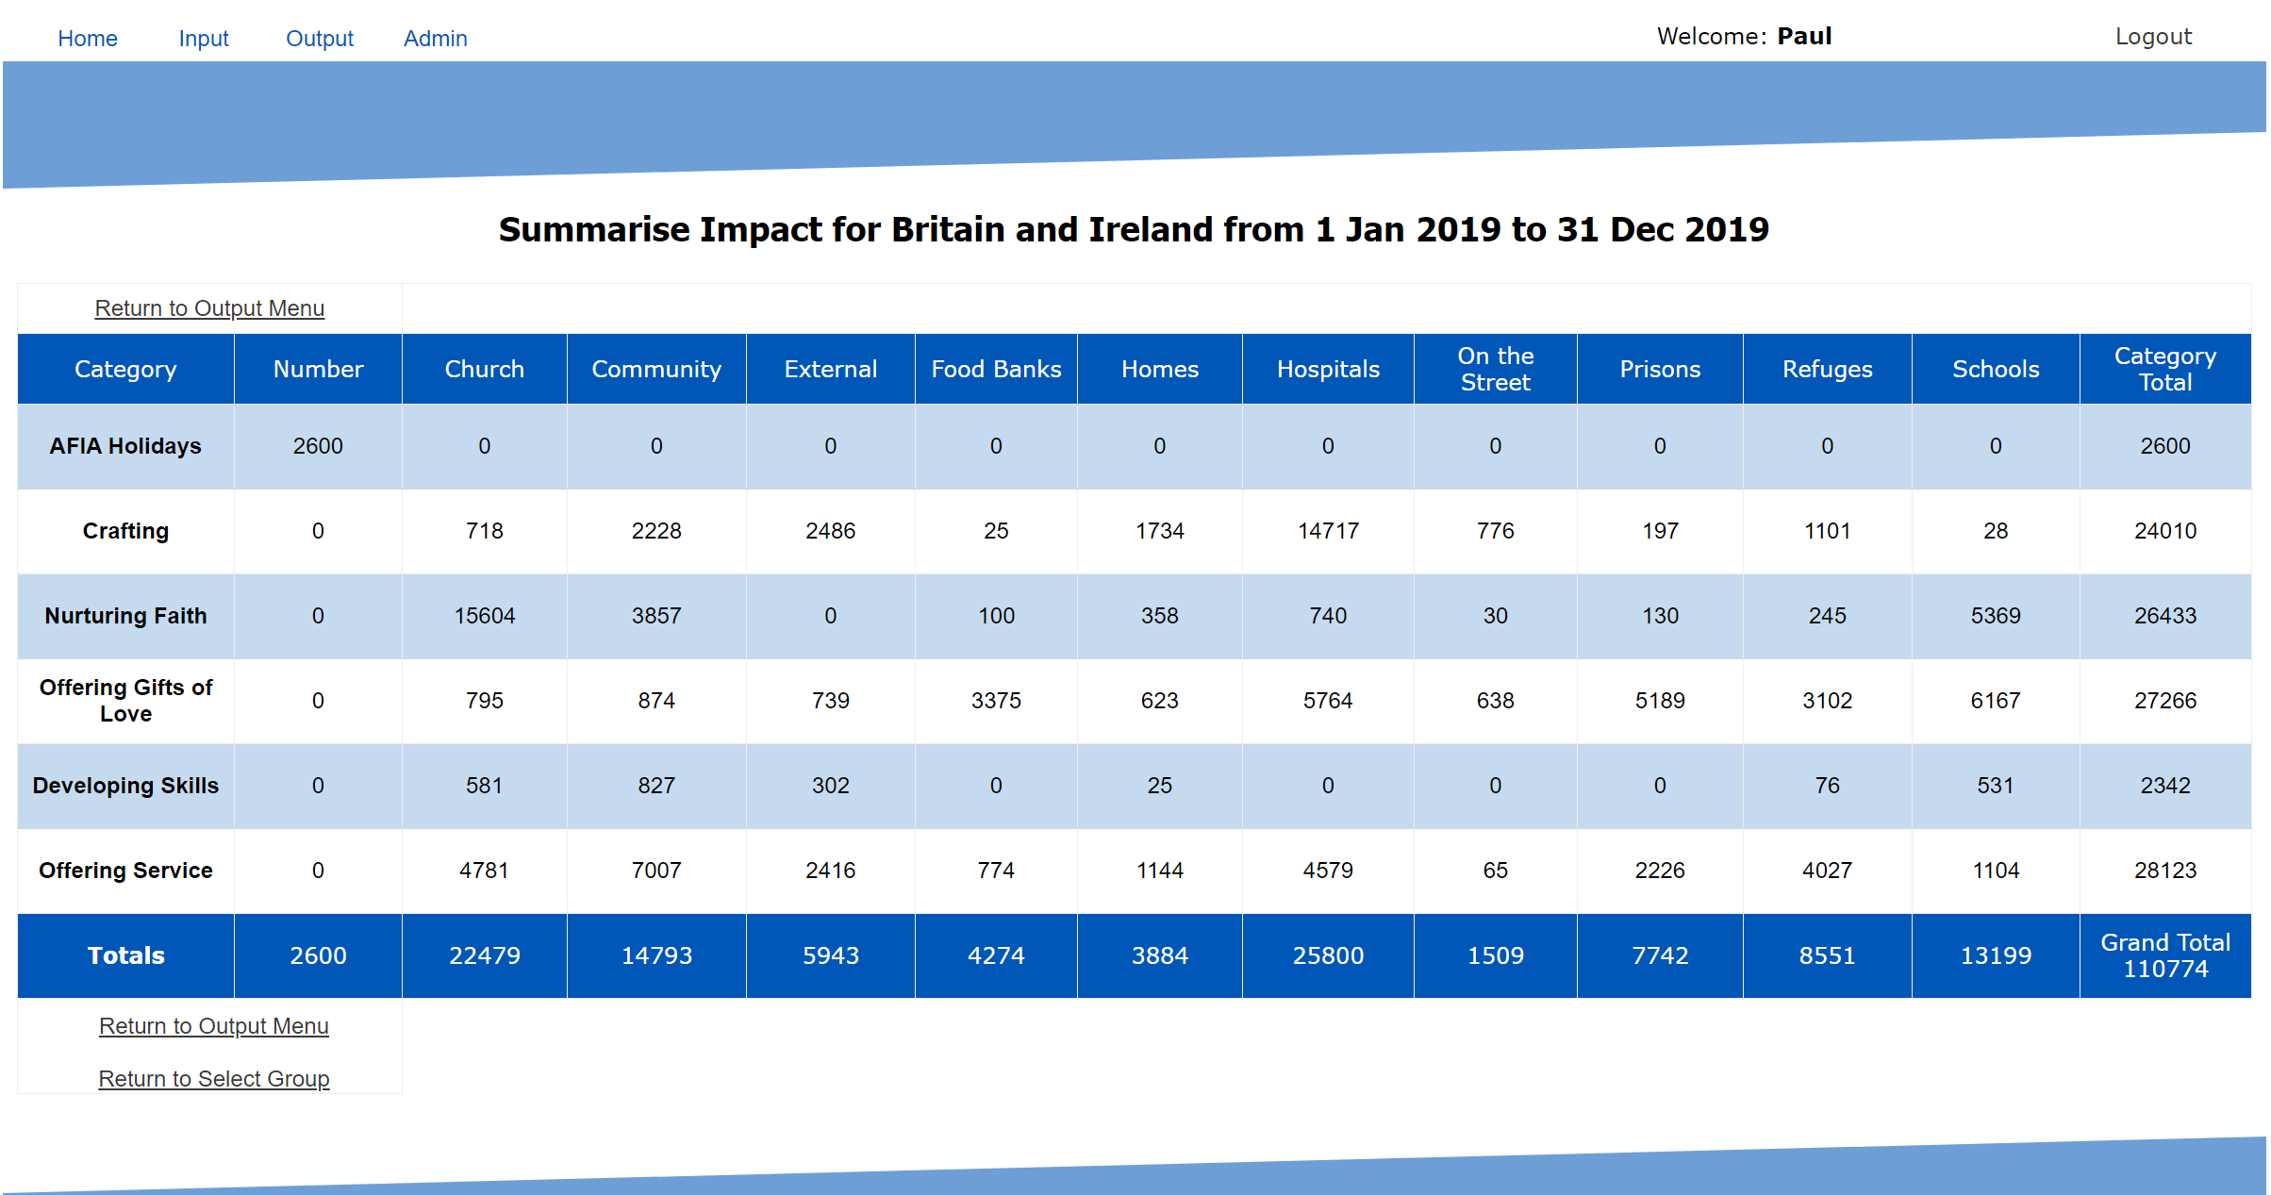

This page adds the numbers from all the reports in the selected groups between the selected dates and shows them in summary form.

Exporting the data in csv format
All data from MU Live can be exported into comma-separated values file that can then be manipulated to generate various graphs and charts to help communicate and present your data. When you click ‘Export a file of CSV data in reporting format’ you get to the following page which allows you to specify the information and information you want to download and clicking ‘select group’ then downloads the CSV file which can be opened in excel.
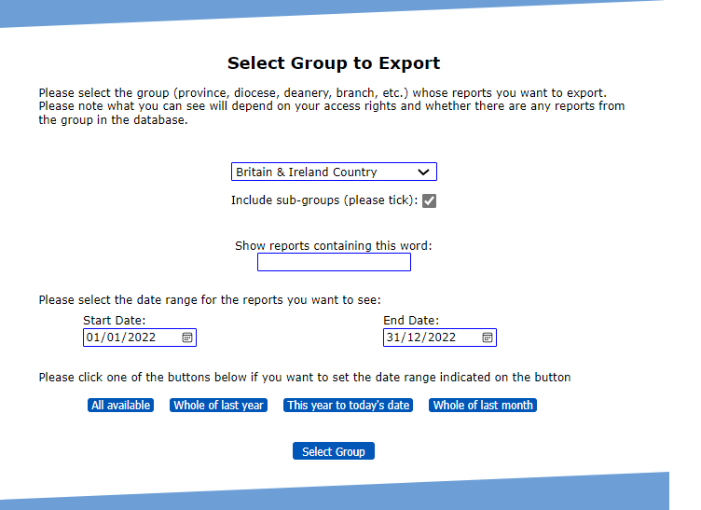

Further Information
This guide is just to get you started and has covered all the main functions you are likely to need in order to keep track of the difference you are making in your area, whether that be a province, a diocese, a deanery or a branch.

Depending on your permissions, you may not see all the links at the top of each page. However, everyone will be able to see Home and Output.

The system is still undergoing development, so please contact Paul if you experience anything unexpected or if you have problems with any aspect of the system. Please don’t assume it’s something you’ve done. It may be, but it could also be a technical problem that needs to be fixed. Also, there may be features you would like to see in order to make things work better for you. Please feed those in. Also please let us know if you need additional reporters adding to the system or existing reporters removing from the system. You can do this by emailing us.

Contacts
Development Team at Mary Sumner House: development@mothersunion.org

Technical Matters: admin@mulive.org

