First signs of spring

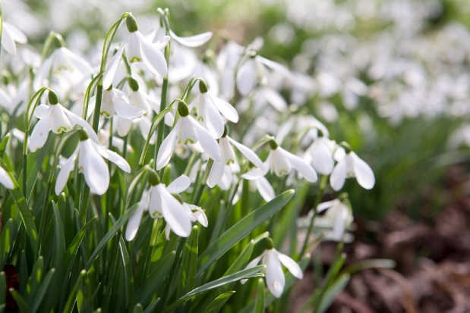
As the days grow shorter, it is always a good idea to have something that will remind us that winter isn’t forever, and that spring will come again before too long.

Snowdrops are often seen as a mark of the coming of spring as these are usually the first flowers to appear in gardens, before the daffodils and the bluebells. The first sight of a snowdrop really lifts the spirits and reminds us that spring is on the way.

So this autumn, why not give every member in your branch a snowdrop bulb to plant? Although they do best in the garden, they can also be planted indoors.

Delivering the bulbs at members at home is also a great way of making contact with everyone – being socially distanced, of course.

Ask members to take a photo on their phone when their first flower appears and share with the rest of the group. And if someone doesn’t have a camera on their phone, perhaps they could ring for another member close by to take the picture.

If you want to do something more colourful than snowdrops, you could plant crocus bulbs instead.

