In Mary Sumner’s footsteps: the story of Mary Sumner

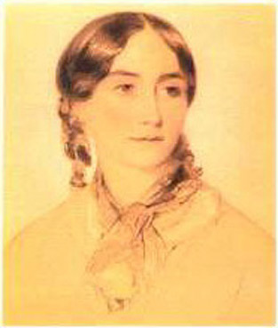
It all started when Mary, married to George, Rector of the Parish of Old Alresford, was passionate about transforming the home-lives of Parish families, by helping the women to support one another in raising their children.

Her husband was very supportive: “just share your heart – God will do the rest.”

She was so nervous at the first meeting of the parish women, that she refused to speak, and asked George to take her place. In those days, it was very unusual for a woman to be a public speaker. However, George encouraged her to speak from the heart and it went so well that she found the courage to speak at future meetings. Her talks were inspired by her faith – it was practical and down to earth – “Remember, Ladies, to be yourselves what you would have your children be”.

After groups with women became well established, she was asked to speak to the men of the Parish. Again, she was apprehensive, but agreed, and helped them to be more aware of what their wives did for them, to show more respect and love.

The meetings grew, and included women - old and young, rich and poor. Others heard about her work, and started groups in their own areas.

In 1876, she founded “the Union of Mothers” – with a membership card and promise: “to be given up, body and soul, to Jesus Christ in Holy Baptism, and that your duty is to train your children for his service”.

In 1885, at a time when it was still unheard of for women to speak to large audiences, Mary Sumner was invited by the Presiding Bishop to speak to a packed church congress session for women in Portsmouth. He anointed her with the authority to speak - he felt that he had no authority to speak to a group of women whose prime concern was to get enough food on the table so that the children would not starve. She overcame her nerves again. “Together, by the Grace of God… we can calm each other when we are afraid; strengthen one another when we are weak; and work together to raise our children to the glory of God. Unity is strength”.

The movement grew further, increasingly with the support of bishops, internationally as well as in England. Some key principles were developed, including:

That the prosperity of a nation springs from the family life in its homes

That family life is the greatest institution in the world for the formation of the character of children

That faith is the foundation of family life

That the tone of family life depends upon the married life of the parents – and ultimately, that example is stronger than precept
As the movement continued to grow, Mary Sumner asked herself what its purpose really was, and what it should strive for. She reflected: “A true home should be a light-house, shedding its quiet beams far and wide” – her dream was for every home to be filled with the light and love of Jesus, and for the movement to unite many hearts in many lands, nurturing healthy environments for little children.

And she was a living example of what she preached. From 1900 onwards, she and the members started to advocate on issues of key importance to families and children – she campaigned to stop children collecting alcohol from public houses for their families, and for the age of marriage for girls to be raised from 12 to 16. She was not afraid to speak up on difficult issues, despite resistance from members of the establishment.

She was also not afraid to act outside the social norms, to do what she believed to be right. At a time when unmarried girls with children were condemned and cast out, she cared for and protected her niece and her illegitimate son.

When she died in August, 1921, 4,000 women attended her funeral, which was a service of Thanksgiving. The last memory was one of her, on her feet in the sunlight, praising God.

She could not have conceived how the seeds which she planted would grow into a movement 4 million strong today, of members in 83 countries putting their faith into action to nurture healthy relationships in families and communities and to fight for social justice.

