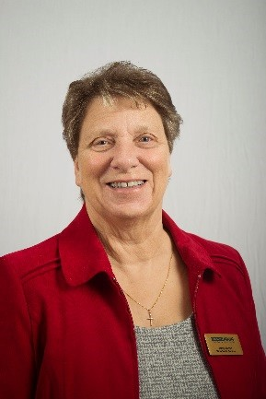
November Reflection
My Dear Friends,

what a privilege it is to share my thoughts with you, particularly at this time of remembering.

November gives us lots to remember, on the 1st of the month we celebrate All Saints Day. This month also includes Remembrance Sunday when we stand together to remember and give thanks for all those who have died in the combat of war, and of course, even in these difficult times, are still continuing to die as wars still affect many parts of our world.

At the end of this month, we begin our annual 16 Days of Activism against gender violence, which is a war in itself, when we stand together to fight for those affected. Domestic violence has been much more prevalent this year when families have been forced to remain at home. Again, we have been standing together to support our front line workers. Many people have died this year and it has been tough.

This is a month too when we can look back at the year, which is rapidly coming to an end, a year when we remember a time when we have learnt to live in a new way, a way that seems alien to us. But we have something which helps us, our faith, and someone who is always there for us, Jesus our Saviour, who together with God, Our Heavenly Father and the Holy Spirit never lets us down and bears us up to live and work for a better future. As it says in psalm 62, :5-7 I believe in God alone; I put my hope in him. He alone protects and saves me; he is my defender, and I shall never be defeated. My salvation and honour depend on God; he is my strong protector; he is my shelter.

To keep me going when things get too much I often turn to a hymn, one which I think fits very nicely here is: -
The Spirit lives to set us free, walk, walk in the light. He binds us all in unity, walk, walk in the light. Walk in the light [x3] walk in the light of the Lord.
This reminds me that Jesus is the light of the world and is always there to show me the way.

However, we have much to celebrate in life and there is one event from history, which thankfully was thwarted, which we celebrate this month, which I certainly remember from my childhood, and I am sure you do too.
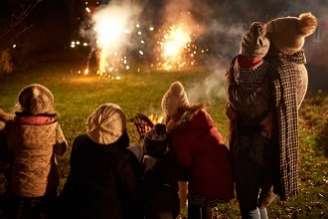
Remember, remember the 5th of November, gunpowder, treason and plot. I recall this being a day when the family came together to stand in the cold, let off fireworks and enjoy jacket potatoes taken from the ashes of the bonfire, so simple, but so enjoyable. For my family it was a day of double celebration, it was my father’s birthday. So, as we remember and look back on our lives let’s consider and weigh up the good and bad memories, I am sure we will find that overall, we have a lot to be thankful for. Not least our membership of the MU which brings us into fellowship with members all around the world.

But as usual we need your prayers. At the end of October, we said goodbye to a third of the workforce at MSH, which means those remaining are working even harder to bring us all the benefits of our membership. So, among all the other things we remember this month let us remember in prayer, Bev our CEO, her Senior Leadership Team and their teams, because right now they need our prayers. Please pray for Sheran, our WWP and the members of the Trustee Board who are also working hard to ensure the smooth running of the charity so that our work will continue into the future.

My next reflection will be in January, so I wish you all a blessed and peaceful Christmas.

Love & prayers
Jenny

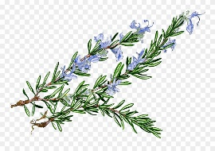

Let us pray;

Lord we thank you for the church and for our part in it as members of the Mothers’ Union. We pray for Mothers’ Union members throughout the world, and for all our work, especially in these difficult times. May we know your strength and peace day by day, heal all ills and make all things new. Help us to remember and give thanks for all the good things in our life, and to remember that you are our guiding light in the darkness. Bless us and all whom we love and care for. In the name of Jesus our Saviour.
Amen

Father God, you hold all history in your hands; all time is yours and all eternity. Help us to look beyond the small demands of our present and catch a glimpse of our everlasting home.
From, The Prayers We Breathe
