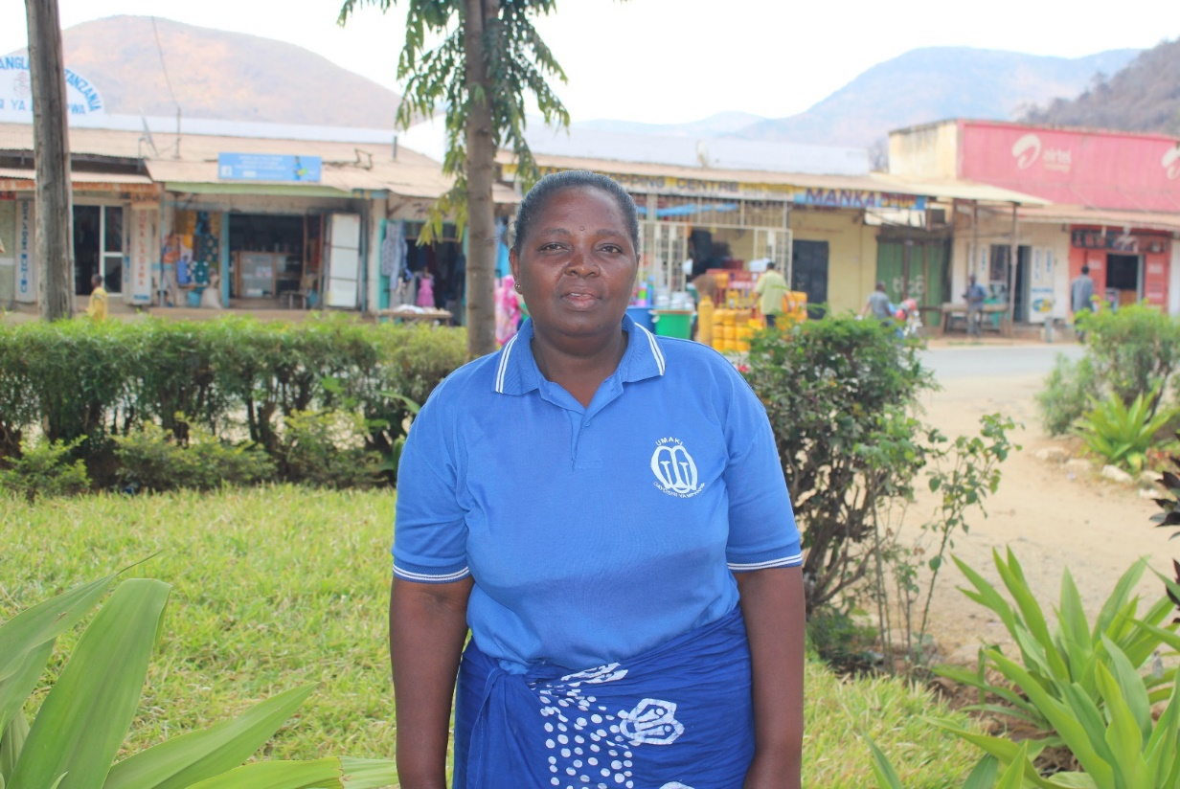
This is Jenny. She works as a tailor and also grows vegetables to sell. She has been a member of a Vicoba in Mpwapwa diocese since April this year and is already seeing the benefits. Because she has been making regular savings each week, she has been able to take a loan from the Vicoba. This is unusual because women like Jenny cannot access credit from formal banks in Tanzania. In the eyes of a bank, she is a credit risk. But in the eyes of her fellow MU group members she is a source of hope and her ability to work hard and save is a sign of God’s provision. By joining hands and sharing what God has provided to them as a group, they can lift one another up. She has used this loan to expand her vegetable growing business and in the future she hopes to purchase some chickens to grow her business even further.
As Jenny and her group receive God’s blessing individually and corporately as a VICOBA group, they are reminded to share this blessing with others by giving to the poor, the elderly and the sick. The group and its financial activities also help Jenny and the other members to make more regular contributions to the needs of the local church and the MU.

