Knitted Teddy Pattern
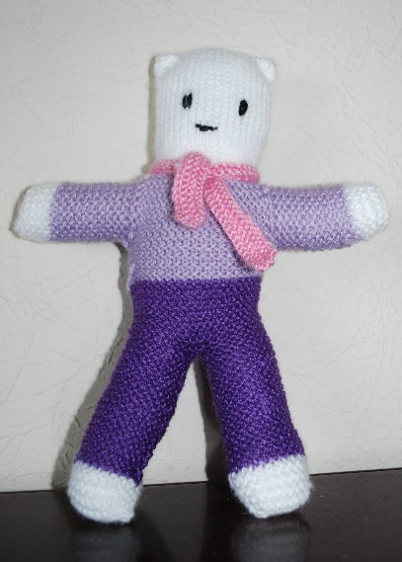

Materials
Washable double knitting yarn in four colours
main colour for head and paws
trouser colour
jumper colour
scarf colour
All knitting yarn must be new. Please avoid ‘tinsel’ yarns, those with attached sequins or mohair style yarns with fibres that pull off.

3mm knitting needles (UK size 11)

New polyester filling conforming to BS1425 (for cleanliness) and BS5852 (for flammability).

Wool or embroidery thread

Tension
26st and 36 rows to 10cm over stocking stitch on 3mm needles.
While the finished size is not important, the stitches should be close together so that when the finished toy is stuffed, the filling does not come out through gaps in the stitches.

Instructions
Cast on 10 stitches in main colour. Knit 10 rows
Change to trouser colour and knit 30 rows

Knit another leg. Then knit across both legs (20sts) and work a further 16 rows. Change to jumper colour and knit 24 rows.

Change to main colour and stocking stitch (one row knit and one row purl) for 14 cm (5 ½ inches).

Change to jumper colour. Continue the remainder of the teddy in reverse order.

Stitch down sides of head.

Make arms: with jumper colour, pick up and knit 8 stitches on each side of the neck join. (16sts). Knit 20 rows, then change to main colour and knit 10 rows for paws. Cast off.
Repeat for the other arm.

Scarf: cast on 75sts. Knit 4 rows, cast off loosely.

Weave in all loose ends. Sew up the teddy using an overcast stitch or back stitch, leaving an opening in the crutch for filling. Sew diagonal corners on the head for ears before stuffing with polyester filling. Sew up the opening.

Run a thread through the knitting to make a neck and draw it in, knot the ends and weave in the excess.

Embroider a smiley face using small stitches, (back stitch and stem stitch), and ensure all ends are firmly finished. Remember that the eyes actually come half way down the face!

Tie the scarf around teddy’s neck and stitch across the back neck to fix securely. The loose ends of the scarf must not exceed 22cm (8½ inches).

