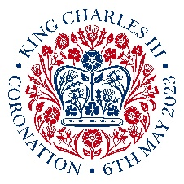
Prayers for the Coronation of King Charles 111

This is a special occasion, in particular for members in Britain & Ireland and the Commonwealth, as we celebrate the Coronation of King Charles 111 and pray for his reign. This moment is also a reminder of God’s call on us all, wherever we live in the world, both to pray for those in authority over us and to recognise that we are subjects of the Kingdom of God, whose King will reign forever.

I urge, then, first of all, that petitions, prayers, intercession and thanksgiving
be made for all people— ² for kings and all those in authority,
that we may live peaceful and quiet lives in all godliness and holiness.
³ This is good, and pleases God our Saviour.
1 Timothy 2:1-3

Almighty God,
on this joyous occasion
we, the members of Mothers’ Union,
offer our prayers for the reign
of King Charles 111.
May the wisdom of God,
the love of Christ
and the power of the Spirit
guide him to govern with righteousness,
that all may live in peace and harmony.
We pray your blessing on the King,
the Queen and the Royal Family
as they share in the privilege
and responsibilities of service.
Through Jesus Christ our Lord.
Amen

Prayer suggestions

- Ask if this prayer may be included in Sunday intercessions in your church. (Omit “the members of Mothers’ Union” to make it inclusive.)

- Use the prayer as part of your MU Coronation celebrations.

- Have a time of prayer for those in authority in the countries of your Link Dioceses, that these members and their communities may also be able to lead peaceful and quiet lives.

- Create a display of short prayers and Bible verses for the reign of King Charles, written on paper jewel templates, which are stuck onto the outline of a crown. If possible, display this in your church or local community.

