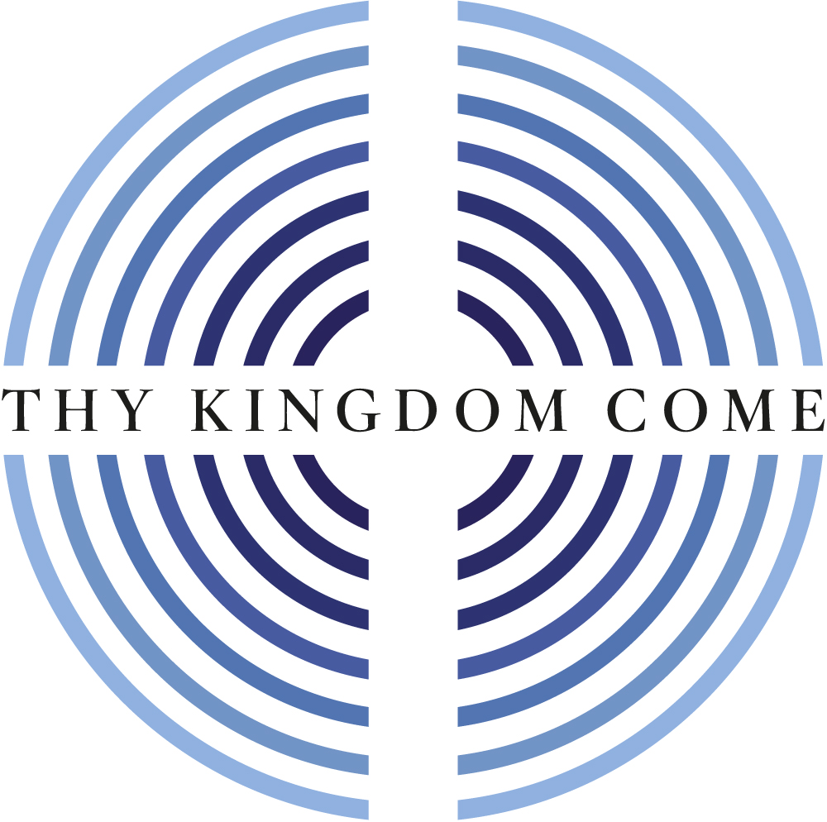

Thy Kingdom Come: Global Moment

Mothers’ Union Online Service 2021

If you would like to engage in the symbolic offering of our prayers, have four candles or tea lights and matches or taper ready for this part of the service.

Welcome

Most Revd Stephen Cottrell, Archbishop of York

Call to worship
Rev. Tim Williams, Mothers’ Union Provincial Chaplain for Wales

As a global movement, which shares the love of God through our work to rebuild hope and confidence with families and communities, we gladly join together across the world to pray thy Kingdom come.

We draw near to Christ, the way, the truth and the life, who leads us to the Father, and has promised to be with us always, to the end of time.

Opening hymn: Now thank we all our God

Now thank we all our God,
With hearts and hands and voices,
Who wondrous things hath done,
In whom his world rejoices;
Who from our mother's arms
Hath blessed us on our way
With countless gifts of love,
And still is ours to-day.

O may this bounteous God
Through all our life be near us,
With ever joyful hearts
And blessed peace to cheer us;
And keep us in his grace,
And guide us when perplexed,
And free us from all ills
In this world and the next.

All praise and thanks to God
The Father now be given,
The son, and him who reigns,
With them in highest heaven,
The one eternal God,
Whom earth and heaven adore;
For thus it was, is now,
And shall be evermore.
Martin Rinkart

Opening prayer

Loving Lord,
who calls us to follow him,
and guides us back to the way of truth
if our feet should stray from the path,
we gather as your people
to declare your praise and to pray -
send your Holy Spirit in power;
may your Kingdom come! Amen

The Mothers’ Union Prayer

Loving Lord,
we thank you for your love so freely given to us all.
We pray for families around the world.
Bless the work of the Mothers’ Union
as we seek to share your love
through the encouragement, strengthening
and support of marriage and family life.
Empowered by your Spirit,
may we be united in prayer and worship,
and in love and service
reach out as your hands across the world.
In Jesus’ name. Amen

Old Testament Reading: Psalm 25:1, 4-5
Pamela Abana, Mothers’ Union Provincial President for Melanesia

In you, Lord my God,
I put my trust.
⁴ Show me your ways, Lord,
teach me your paths.
⁵ Guide me in your truth and teach me,
for you are God my Saviour,
and my hope is in you all day long.

This is the Word of the Lord.
Thanks be to God.

Gospel Reading: John 14:1-7
Clare Stewart, Mothers’ Union member from All Ireland

Hear the Gospel of our Lord Jesus Christ.
Glory to you, O Lord.

Do not let your hearts be troubled. You believe in God; believe also in me. ² My Father’s house has many rooms; if that were not so, would I have told you that I am going there to prepare a place for you? ³ And if I go and prepare a place for you, I will come back and take you to be with me that you also may be where I am. ⁴ You know the way to the place where I am going.’
⁵ Thomas said to him, ‘Lord, we don’t know where you are going, so how can we know the way?’
⁶ Jesus answered, ‘I am the way and the truth and the life. No one comes to the Father except through me. ⁷ If you really know me, you will know my Father as well. From now on, you do know him and have seen him.’

This is the Gospel of the Lord.
Praise to you, O Christ.

Address

Rt Revd Dr Emma Ineson, Bishop of Penrith, Mothers’ Union Central Chaplain

MU Reflection on worship though service

Message of thanks to Mothers’ Union
Revd Barry Hill, Board member for Thy Kingdom Come

Prayers and offering of flames of hope

Sheran Harper, Mothers’ Union Worldwide President

Jesus says:
I am the way, the truth and the life. The only way to the Father is through me.

We light three candles to symbolise Jesus, the way, the truth and the life.

Loving Lord, we pray for all
who through life’s challenges
have wandered from your path
and need your love to guide them back
to the way of truth.

We pray for all
for whom life’s challenges
have drawn them to your truth
and need your love to guide them
onto the path of life.

We light a fourth candle from one of the three to represent our family and friends who we pray to know the love of Christ.

Loving Lord, we offer to you
our flames of hope
as we pray thy kingdom come
that the world may know your love
and follow the way of truth.

Jesus Christ,
the way, the truth and the life
we commit ourselves to follow you,
whatever life may hold.
May the light of your love shine through us
to those you call us to serve. Amen

We now reach out as hands across the world with our fellow members and with all others in the family of God who are sharing in this act of worship, to join together in the prayer for Thy Kingdom Come and the Lord’s Prayer.

Almighty God,
your ascended Son has sent us into the world
to preach the good news of your kingdom:
inspire us with your Spirit and fill our hearts
with the fire of your love,
that all who hear your word may be drawn to you,
through Jesus Christ our Lord. Amen

The Lord’s Prayer

Our Father, who art in heaven,
hallowed be thy name;
thy kingdom come;
thy will be done;
on earth as it is in heaven.
Give us this day our daily bread.
And forgive us our trespasses,
as we forgive those who trespass against us.
And lead us not into temptation;
but deliver us from evil.
For thine is the kingdom,
the power and the glory,
for ever and ever. Amen

Closing hymn: Lord for the years

Lord, for the years your love has kept and guided,
urged and inspired us, cheered us on our way,
sought us and saved us, pardoned and provided:
Lord for the years, we bring our thanks today.
Lord, for that word, the word of life which fires us,
speaks to our hearts and sets our souls ablaze,
teaches and trains, rebukes us and inspires us:
Lord of the word, receive your people's praise.
Lord, for our world where men disown and doubt you,
loveless in strength, and comfortless in pain,
hungry and helpless, lost indeed without you:
Lord of the world, we pray that Christ may reign.

Lord for ourselves; in living power remake us-
self on the cross, and Christ upon the throne,
past put behind us, for the future take us:
Lord of our lives, to live for Christ alone.
©Timothy Dudley-Smith

Final prayer, acclamation of praise, blessing and sending out

Most Revd Stephen Cottrell, Archbishop of York

Lord Christ, true light of the world,
shine, we pray, in the hearts of your people,
that we might see the Way that leads to eternal life,
and follow without stumbling;
for you are the Way, O Christ,
as you are the Truth and the Life.

Glory to God,
whose power, at work among us,
can do infinitely more
than we can ask or conceive;
to him be glory in the Church
and in Christ Jesus,
for ever and ever.
Alleluia. Amen

Go from here to follow Christ, the one
who taught us to pray thy Kingdom come;
and the blessing of God almighty, the Father, the Son,
and the Holy Spirit be among you and remain
with you always. Amen

