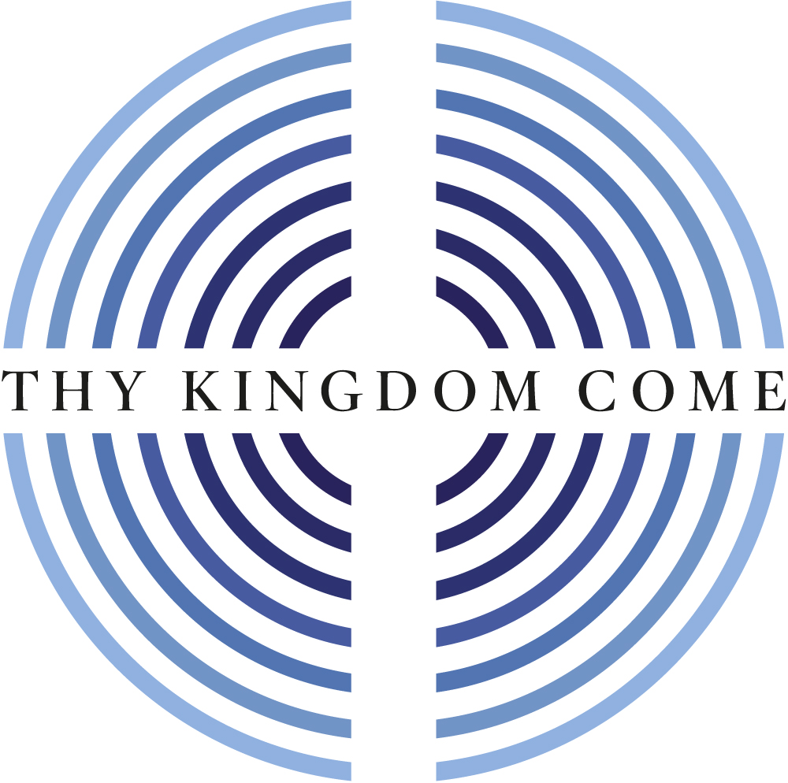
Thy Kingdom Come: Global Moment

Mothers’ Union Online Service 2022

Welcome

Bishop Emma Ineson, MU Central Chaplain

Call to worship

Bishop John Packer, MU Chaplain for York Province

As a global movement, with a vision to build the kingdom of God through the transformation of the churches and communities we work with, and of which we are a part, we gladly join together across the world to pray thy Kingdom come.

We draw near to God who transforms us into Christ’s likeness,
with ever-increasing glory, through the power of the Holy Spirit.

Opening hymn: Shine Jesus shine

St Mildred’s Church Choir, Addiscombe
Lord, the light of your love is shining
In the midst of the darkness, shining
Jesus, Light of the world, shine upon us
Set us free by the truth you now bring us
Shine on me, shine on me.
Shine, Jesus, shine
Fill this land with the Father's glory
Blaze, Spirit, blaze
Set our hearts on fire
Flow, river, flow
Flood the nations with grace and mercy
Send forth your word
Lord, and let there be light.

Lord, I come to your awesome presence
From the shadows into your radiance
By the blood I may enter your brightness
Search me, try me, consume all my darkness
Shine on me, shine on me.

Shine, Jesus, shine…

As we gaze on your kingly brightness
So our faces display your likeness
Ever changing from glory to glory
Mirrored here may our lives tell your story
Shine on me, shine on me.

Shine, Jesus, shine…
Graham Kendrick ©1987

Opening prayer

Loving Lord, transform our lives
that we may reflect the glory of Christ.
Continue in us the work of your Spirit;
the miracle of transformation
to reflect the glory of Christ
and build God’s kingdom on earth. Amen

The Mothers’ Union Prayer

Loving Lord,
we thank you for your love so freely given to us all.
We pray for families around the world.
Bless the work of the Mothers’ Union
as we seek to share your love
through the encouragement, strengthening
and support of marriage and family life.
Empowered by your Spirit,
may we be united in prayer and worship,
and in love and service
reach out as your hands across the world.
In Jesus’ name. Amen

Old Testament Reading: Isaiah 61:1-3

Lowrie Washington Jones, Llandaff Diocese

The Spirit of the Sovereign Lord is on me,
because the Lord has anointed me
to proclaim good news to the poor.
He has sent me to bind up the broken-hearted,
to proclaim freedom for the captives
and release from darkness for the prisoners,
² to proclaim the year of the Lord’s favour
and the day of vengeance of our God,
to comfort all who mourn,
³ and provide for those who grieve in Zion –
to bestow on them a crown of beauty
instead of ashes,
the oil of joy
instead of mourning,
and a garment of praise
instead of a spirit of despair.

This is the Word of the Lord.
Thanks be to God.

Gospel Reading: Matthew 6:9-13 (NCV)

Rev Annonciata Kabega,

Provincial Community Development Coordinator for MU Rwanda

Hear the Gospel of our Lord Jesus Christ.
Glory to you, O Lord.

When you pray, you should pray like this:
Our Father in heaven,
may your name always be kept holy.
¹⁰ May your kingdom come
and what you want be done,
here on earth as it is in heaven.
¹¹ Give us the food we need for each day.
¹² Forgive us for our sins,
just as we have forgiven those who sinned against us.
¹³ And do not cause us to be tempted,
but save us from the Evil One.
[The kingdom, the power, and the glory are yours forever. Amen.]

This is the Gospel of the Lord.
Praise to you, O Christ.

Dramatic reading:

Jeanette Lawrence, Rochester Diocese
Thine is the Kingdom, the Power and the Glory. Dorothy M Stewart

Address

The Most Reverend Mark Strange, Bishop of Moray, Ross & Caithness

MU stories of transformation

Christine Sharp, MU Diocesan President for Manchester

Jocelyne Razafiarivony, Provincial Community Development Coordinator for MU Madagascar

Message of thanks to Mothers’ Union

Very Reverend Bob Key,

Anglican Communion Lead for Thy Kingdom Come

We give thanks for the words of encouragement we have heard, and now, in faith and hope, we bring to God our prayers for transformation.

Prayers for transformation

Sheran Harper, MU Worldwide President, and worldwide MU members

Our Father in heaven,
we put our trust in you.
Give us open hearts and minds
to discern your perfect direction
to build your kingdom on earth.

Affirm us in your love
that we may be bold to seek your face.

Strengthen us with resolve
to embrace new ways with confidence.

Unite us in heart and mind
that we may move forward with gladness.

Inspire us in our faith
that all things are possible with God.

Transform us into a people
empowered by the Spirit,
overflowing with hope,
to build your kingdom on earth. Amen

We now reach out as hands across the world with our fellow members and with all others in the family of God who are sharing in this act of worship, to join together in the prayer for Thy Kingdom Come and the Lord’s Prayer.

Almighty God,
your ascended Son has sent us into the world
to preach the good news of your kingdom:
inspire us with your Spirit and fill our hearts
with the fire of your love,
that all who hear your word may be drawn to you,
through Jesus Christ our Lord. Amen

The Lord’s Prayer

Our Father, who art in heaven,
hallowed be thy name;
thy kingdom come;
thy will be done;
on earth as it is in heaven.
Give us this day our daily bread.
And forgive us our trespasses,
as we forgive those who trespass against us.
And lead us not into temptation;
but deliver us from evil.
For thine is the kingdom,
the power and the glory,
for ever and ever. Amen

Closing hymn: Hope of our calling

St Mildred’s Church Choir, Addiscombe

Hope of our calling: hope through courage won
by those who dared to share all Christ had done.
Saints of today, Christ’s banner now unfurled,
will bring his gospel to a waiting world.

Hope of our calling: hope by strength empowered
inspired by all that we have seen and heard.
This call is ours, for we are chosen too,
to live for God in all we say and do.

Hope of our calling: hope with grace outpoured.
From death’s despair the gift of life restored.
Our call to serve, to wash each other’s feet,
to bring Christ’s healing touch to all we meet.

Hope of our calling: hope by faith made bold;
to sow God’s righteousness throughout the world.
Bring peace from conflict, fruitfulness from weeds,
the kingdom’s harvest from the kingdom’s seeds.

Hope of our calling: Spirit-filled, unbound,
old joys remembered and new purpose found.
Our call refreshed by sacrament and word,
we go in peace to love and serve the Lord.

© Ally Barrett, 2006

It has been a joy and privilege to gather in this virtual way to pray together the words that encapsulate the vision and mission of Mothers’ Union across the world - thy Kingdom come. We end with a final acclamation of praise and blessing as we go from here to live out our faith in service to the world Christ came to save

Final prayer, acclamation of praise, blessing and sending out

Glory to God,
whose transforming power
at work among us,
can do infinitely more
than we can ask or conceive;
to him be glory in the Church
and in Christ Jesus,
for ever and ever.
Alleluia. Amen

Go from here to reflect the glory of Christ,
the one who taught us to pray thy Kingdom come;
and the blessing of God almighty, the Father, the Son,
and the Holy Spirit be among you and remain
with you always. Amen

