**MU on the Move 2023**



**Guide to running your event**

# **MU on the Move Fundraising pack**

Thank you so much for your interest in taking part in our MU on the Move Challenge. This year it will be part of our Summer of Hope Campaign and you can take part on your chosen date in June or July.

If the dates in June / July does not work for you then do not worry, you can complete the challenge any time in the year or you may ask your branch / diocese to undertake the event individually, combining it as a group event.

You could also open the challenge further by completing the 5km over a few days or a week, to encourage even more of your members to get involved.

This year you may also want to buddy up with a friend. Or you get your family involved, including your pets, it has been wonderful to see members with their friends, pet dogs and children get involved in the past.

MU on the Move has also been created so you can talk about Mothers’ Union and the work we do either with each other or of course with people you may encounter through your event – we have thinking and prayer points for each kilometre you move.

**What your support means to us:**

It doesn’t matter how many people take part, it all makes such a difference! With your support we can continue our projects both oversea and in the UK to end poverty, violence and injustice.

**Supporting you:**

We want to help support you with the planning of your MU on the Move challenge therefore inside this pack you will find fundraising tips and ideas. As one of our amazing fundraisers you can receive support from us along the way. We will be more than happy to provide advice and share some fundraising ideas. You can contact the Fundraising team at [Fundraising@MothersUnion.org](mailto:Fundraising@MothersUnion.org) or by calling 02072 225 533. We also love to hear about your amazing events (and it’s even better if you have some pictures to share as well!).

You can also find our downloadable Fundraising ideas, sponsorship form and the individual resources here:

<https://www.mothersunion.org/summer-hope-2023>

**Contents**

**Organising your MU on the Move event** 4

**Top 10 Fundraising tips** 6

**How to set up a fundraising page – Just Giving** 7

**Fundraising ideas** 9



# **Organising your MU on the Move event**

MU on the Move has historically been a 5km run which has taken place in October. Once again we are combining the event with our Summer of Hope Campaign. We recommend 5km as it is a very manageable distance, but you can choose a different distance should you wish! It also does not have to be a run, it can be a run, swim, bike ride or walk.

When you start planning the route, it is worth thinking about the following:

* Aim for a circular route. Your route should start and end in the same place, which should be off road.
* If you are doing this individually, please make sure you route is safe.
* It can be nice to start and finish at your local Church where your branch / group is based.
* Pavements make for nice solid ground but be aware of any busy junctions that might interrupt your route.
* Think about facilities. Aim to find somewhere with toilets and possibly a refreshment venue. Large parks are a good place as well churches.
* Measuring the distance to make sure its 5km. One of the easiest ways of doing this is via a website or app like MapMyRun (<https://www.mapmyrun.com/gb/>)
* Once you have planned your event you need to register it with Mothers’ Union (via [fundraising@mothersunion.org](mailto:fundraising@mothersunion.org)) so we can help support you.

**Health and Safety**

When planning your event please make sure you consider the following:

* Consider the abilities of participants - could your route pose any problems for younger, older, or disabled people?
* First Aid - It is advisable to have someone who is First Aid trained present at the event. Larger events may need to consider St Johns Ambulance – this is something that will be discussed when you speak to the Fundraising team about organising an event.
* Any participants aged under 18 must provide a signed guardian consent form and the guardian should be encouraged to attend the event. These forms can be found in this pack.
* You may wish to provide a disclaimer to all participants so that they know they are taking part at their own risk. Please contact Mary Sumner House for suggested wording

**Communicating your run!**

* Use the posters in this pack to advertise and promote your event and get other people to sponsor you / your group. We have also kept the posters in a word document, so you edit them as you so wish.
* Send an email to your friends and family to ask them to support you.
* It is a good idea to contact local churches and businesses to ask to support your event. If they promote your event you might get more people involved or they may provide refreshments.
* You could write an article for your parish magazine asking for support.
* Advertise on your diocesan Facebook page.
* Contact the local press to see if they may be interested in covering your event. It is useful to have some sort of hook for this – perhaps an anniversary being celebrated by the branch, a member’s personal story or the reason you are fundraising. Please contact us if you would like more support on this.

# **Top 10 Fundraising tips**

Follow these top 10 tips to help you smash your sponsorship targets:

1. Set up a Just Giving page - make sure it is compelling, explains your motivation and includes a link to the Mothers’ Union website: <https://www.mothersunion.org>

1. Tell people what your fundraising target is and what their contribution will help to achieve. For example:

*£27 can help someone in Ethiopia complete a two-year course to learn to read and write, providing them with a basic skill that completely changes their life.*

*£65 can start a savings and credit association in Rwanda, allowing group members to save collectively and provide each other with loans to buy household items, start businesses, care for others in the community and build a secure future for their families.*

1. Time your donation request - people are more likely to donate after payday.
2. Don’t forget to ask for Gift Aid as it means Mothers’ Union will receive an extra 25p for every £1 sponsored.
3. Ask close friends and family to donate first as other people may then match their generosity. Ask them to spread the word about your fundraising too – they’ll be keen to help you get more sponsors.
4. Help people put their donation into perspective. For example £10 might mean giving up just one takeaway dinner.
5. Set yourself small weekly fundraising targets rather than thinking about a daunting total target.
6. Collect as many donations before the event as possible, so you don’t have the difficult job of chasing up pledges afterwards. Encouraging people to donate through Just Giving helps with this and means the money comes directly to Mothers’ Union.
7. Do continue to keep asking for sponsorship after the event though - as much as 20% of donations can come in at this time!
8. Mention your fundraising event at every opportunity – on social media, in your answer phone messages, email signatures, notice boards.

# **How to set up a fundraising page – Just Giving**

1. Go to [www.justgiving.com](http://www.justgiving.com)
2. In the top right hand side of the screen, either click on ‘Log in’ - if you already have a JustGiving account - or ‘Sign up’ - to set up an account.
3. Once your account is set up and you have logged in, click “**start fundraising”** in the top left hand corner of the page.
4. Then click on the button that says you want the money to go to a charity:

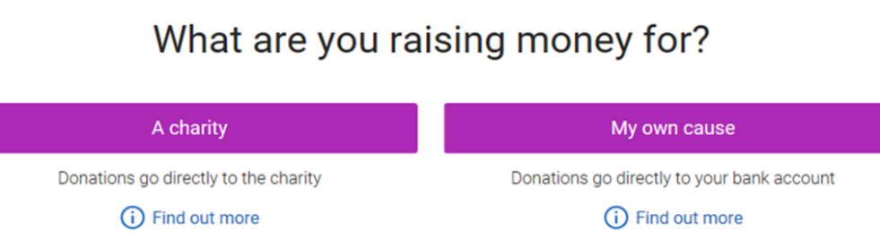

1. Search for Mothers’ Union as the cause you want to support, choosing ‘United Kingdom’ on from the drop down list on the right hand side. Make sure you choose the option that has our current logo (see below).

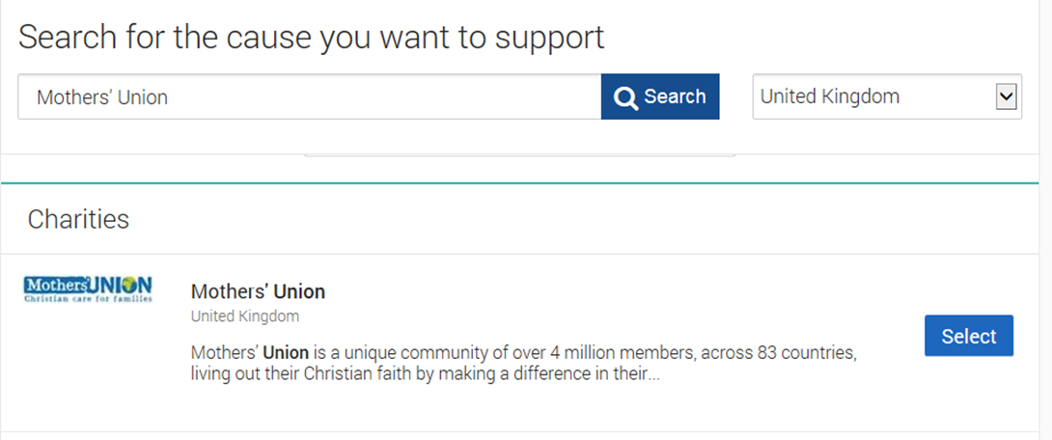

1. You will then be asked ‘What are you doing?’ Click on ‘Doing your own thing’

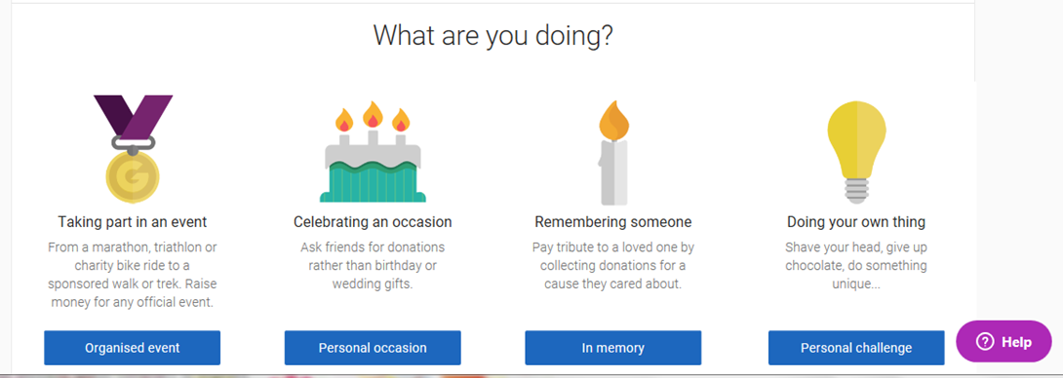

1. On the ‘Tell us about your event page’:
   1. Choose either ‘a personal run / marathon’ or ‘a personal walk’ as your event type, depending on which you have chosen to do.
   2. Type in MU on the Move (and then your branch / own name) as the Event name.
   3. Set your event date
   4. Leave the two check boxes marked as ‘No’ (see below)

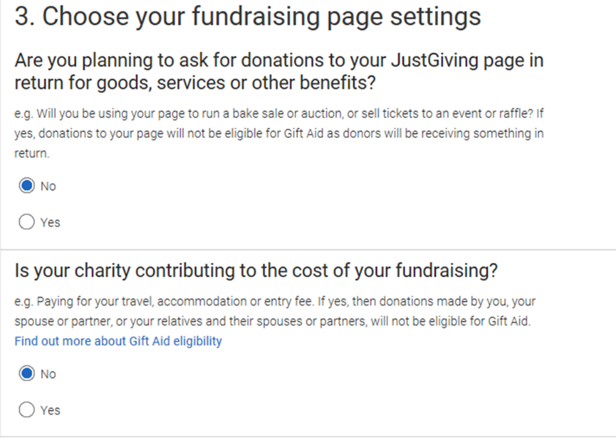

* 1. Choose whether you would like to receive fundraising information in future from Mothers’ Union.
  2. Click “**Create your page”** - You have now created a fundraising page!
  3. You can click on “**edit your page**” at the top of the page to add more information.

1. Under ‘Donations made to your page’ on the right hand side you can edit your fundraising target and keep your total up to date by saying how much money you have raised offline.
2. Under’ Edit and personalise your page’ on the left hand side, click on ‘Edit your page title, summary and story’ then say a bit about why you have chosen to take part in this event. It would be great if you could add something along the lines of:
   1. Your connection with Mothers’ Union…
   2. Why people should donate e.g. By supporting and working with people in need all over the world, Mothers’ Union are enabling real change and improvement to the lives of a great many people and their families.
   3. Add a link to our website and video to provide more information about Mothers’ Union and our work: e.g. You'll see a lot more detail on their website: <https://www.mothersunion.org/> and I also recommend this video for a succinct summary: <https://www.youtube.com/watch?v=kERCG7y52mc>
   4. A line or two about your motivation…
   5. A sentence to encourage people to donate e.g. please give generously!
3. Click on ‘Add photos’ to add a picture of yourself. You can then add more photos later – of you training, taking part in and completing the event etc. You can also add updates during your training and after the event.
4. Click on “**Visit your page**” to see how it now looks. Once you are happy with your page, share it on social media or email it to friends and family and watch the donations roll in!

*We wish you the best of luck with your run! Don’t forget if you want any help or support, you can email* [*fundraising@mothersunion.org*](mailto:fundraising@mothersunion.org) *or call us on 020 7222 5533 and we can help answer any questions that you may have!*

# **Fundraising ideas**

We have put together a few ideas which can be done alongside the money you raise through sponsors. They have been chosen as a simple way to raise some extra money, as we are aware you may have your hands full with the planning of your MU on the Move event.

To note, we have included ideas which can be adapted to be safe during lockdown as well as being great ways to fundraise once we get back to normal. For even more ideas please click here _____ for our A-Z of fundraising ideas.

**Virtual quiz:**

This is a simple and effective way to raise money, it is also a fun way to catch up with your friends. We recommend setting a price per person to enter the quiz (as a suggestion, £5 per person). We have created a virtual quiz which you can use or adapt, you can find the quiz here:

**Collection jar:**

You could just have a jar at home where you can put your loose change in now and again, or you could have a set amount you put in the jar each day. Also, when it is easier to have visitors, you could ask them if they would like to donate a little something. Once you have filled the jar you could donate the money to MU.

**Host a virtual murder mystery:**

Why not host a virtual murder mystery night? It’s a bit different from the norm and is a little bit of fun. There are a number of websites that have free murder mystery night games you can download (see below for some free murder mystery links) and some that cost a little bit. You could of course create your own murder mystery story.

<https://www.birthdayinabox.com/pages/preteen-teen-party-ideas-murder-mystery-party-ideas>

[Michael Akers - Free Murder Mystery Party Game: Sour Grapes of Wrath (whodunitmysteries.com)](http://www.whodunitmysteries.com/sour.html)

**Upcycling:**

Depending on how adventurous you are feeling you could try upholstering an old chair, re-imagining an old pillowcase or making sock poppets. You can then sell your creations online and donate the proceeds.

**Host a virtual workshop:**

Why not share a specific skill with your friends and fellow members and ask for a donation to attend. Depending on the type of workshop, for example a crafting workshop, you may want to charge a little extra to send the attendees any materials in the post. Alternatively, you could choose a workshop where people will likely have the items at home (we recommend sending those attending the workshop a list of items they will need, so they can be fully prepared).

**Event: Date:**

**Registered charity no: 240531**

**Event Parent/Guardian Consent Form**

For your child’s safety, we require all young persons under the age of 18 to provide written consent from a parent or guardian to take part in Mothers’ Union events.

**Child’s Name:**……………………………………………………… **Date of Birth:**……………………………… **Parent/Guardian’s Name:** ………………………………………………………………

**Address:**………………………………………………………………………………………………………………………………………………………………………………………………………………………**Postcode:**………………………………………

**Phone No:**……………………………………………… **Mobile:**…………………………………………………………

I give permission for my child to take part in the event stated above.

Anyone under the age of 16 must be accompanied by an adult. I am unable to attend and therefore give permission for my child to attend the event with:

**Name of Accompanying Adult:**…………………………………………………………………

**Phone No. of Accompanying Adult:**…………………………………………………………

I give consent for Mothers’ Union to use any photos of my child for future publicity purposes, which may include publication by the press and use on our website and publicity materials.

**Signature of Parent/Guardian:**……………………………………… **Date:**……………………………

**Health History**

If your child suffers from any illnesses, disabilities (learning or behavioural) or allergies (foods, medicines, stings) that might affect them during the event please give details below, along with any medication you require for these (and where they are kept if you have them with you)

……………………………………………………………………………………………………………………………………………………………………………………………………………………………………………………………………………………………………

I understand that in the event of illness or accident that the event organiser considers needing medical attention, medical aid will be sought and all attempts made to contact parents/

guardians. In the event of no contact being possible a doctor will decide whether examination and subsequent treatment are necessary.

**Signature of Parent/Guardian:**…………………………………… **Date:** ………………………………

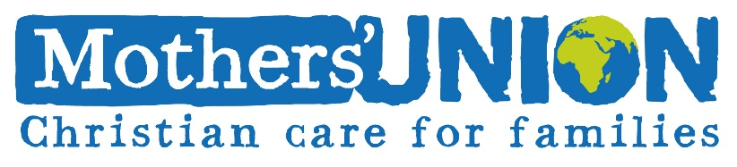

**Help making a donation**

Thank you for enabling Mothers’ Union members across the world empower women and strengthen communities. Your generosity is allowing them to reach more people and leave a lasting impact, year on year. Making a donation to Mothers’ Union is simple, and can be done by any of the following methods:

|  |  |  |
| --- | --- | --- |
| **Online** | **Postal** | **Phone** |
| Via our website **mothersunion.org/donate** | Sending a cheque made out to ‘**Mothers’ Union’** to **‘24 Tufton Street, LONDON, SW1P 3RB’.** | We would be happy to take a card payment over the phone on **02072 225 533** |
| By Bank Transfer, please contact us for more information. | Completing one of our **Credit Card forms** and sending it to the above address. For a copy, please get in touch. |  |
| By choosing **‘Mothers’ Union’** when starting a Just Giving/Virgin Money campaign. | We accept **Charities Aid Foundation** (CAF) vouchers in the post as well. |



If you are a UK taxpayer, you can make your gift worth 25% more at no extra cost to you. Simply check that you agree with the Gift Aid declaration, then provide your details.

If you would like to Gift Aid your donations, you can do so by:  
 Returning this form to the address above  
 Verbally declaring this by calling the number above  
 Choosing the option when making a donation online

If you are new to Mothers’ Union and don’t want us to write to you by post, or wish to alter your existing contact preferences , please call **0207 227 0620** or email **marketing@mothersunion.org**. We will never share your details for marketing purposes. Please get in touch for more information.

**\*Gift Aid declaration** I want to Gift Aid my donation shown above and any donations I have made to Mothers’ Union in the last four years or make in the future, until further notice from me. I am a UK taxpayer and understand that if I pay less Income tax and/or Capital Gains Tax than the amount of Gift Aid claimed on my donations in a tax year, it is my responsibility to pay any difference.

Please notify Mothers’ Union if you want to cancel your Gift Aid declaration or no longer pay sufficient tax on your income and/or capital gains to qualify for Gift Aid, or change your name or home address.



|  |  |  |  |  |  |
| --- | --- | --- | --- | --- | --- |
| **Title** |  | **First Name** |  | **Last Name** |  |
| **Home Address** | |  | | | |
|  | | | | | |
|  | | | | **Post Code** |  |
| **Email** | |  | | | |
| **Phone number** | |  | | **Date** |  |

If you would like to Gift Aid your donations, you can do so by:

* Returning this form to the address above
* Verbally declaring this by calling the number above
* Choosing the option when making a donation online

**\*Gift Aid declaration** I want to Gift Aid my donation shown above and any donations I have made to Mothers’ Union in the last four years or make in the future, until further notice from me. I am a UK taxpayer and understand that if I pay less Income tax and/or Capital Gains Tax than the amount of Gift Aid claimed on my donations in a tax year, it is my responsibility to pay any difference.

Please notify Mothers’ Union if you want to cancel your Gift Aid declaration or no longer pay sufficient tax on your income and/or capital gains to qualify for Gift Aid, or change your name or home address.

**\*Gift Aid declaration** I want to Gift Aid my donation shown above and any donations I have made to Mothers’ Union in the last four years or make in the future, until further notice from me. I am a UK taxpayer and understand that if I pay less Income tax and/or Capital Gains Tax than the amount of Gift Aid claimed on my donations in a tax year, it is my responsibility to pay any difference.

Please notify Mothers’ Union if you want to cancel your Gift Aid declaration or no longer pay sufficient tax on your income and/or capital gains to qualify for Gift Aid, or change your name or home address.

**\*Gift Aid declaration** I want to Gift Aid my donation shown above and any donations I have made to Mothers’ Union in the last four years or make in the future, until further notice from me. I am a UK taxpayer and understand that if I pay less Income tax and/or Capital Gains Tax than the amount of Gift Aid claimed on my donations in a tax year, it is my responsibility to pay any difference.

Please notify Mothers’ Union if you want to cancel your Gift Aid declaration or no longer pay sufficient tax on your income and/or capital gains to qualify for Gift Aid, or change your name or home address.

If you are new to Mothers’ Union and don’t want us to write to you by post, or wish to alter your existing contact preferences, please call **02072 225 533** or email **marketing@mothersunion.org**. We will never share your details for marketing purposes. Please get in touch for more information.