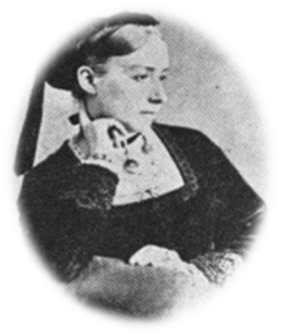
Ideas to celebrate Mary Sumner Day

Celebrate Mary Sumner Day by focussing on Mary Sumner’s personal faith, vision and service in the name of Mothers’ Union.

The following quote about Mary Sumner is very pertinent to remind us to not only look back with gratitude, but forward with faith and vision.

Her foresight, her wisdom and judgment laid the great foundation stone for us. And as the building grows, and far and wide her early message goes forth – the same message, though to a different generation – we pray that the faith which shone through her every word and thought may illumine ours, that we, with grateful hearts, may build well and truly, as she did.
Mrs Boustead, Central President of Mothers’ Union: December 1927*

Suggestions:

- Consider holding your own festal evensong on Tuesday 9th August.

- If a formal service is not appropriate, you may like to use prayers and reflections as part of a more informal act of worship and thanksgiving.

- Use the following quotes* about Mary Sumner’s life and service in the name of Mothers’ Union to inspire you. Reflect together, or as individuals, on what ways your service for Mothers’ Union follows her example. The quotes could form part of a display to highlight the foundations of Mothers’ Union service and its ongoing work in the 21st century.

Mrs Sumner’s pen was as busy as ever, as the packets of answers to her letters show; some from the Members of Parliament to whom she wrote personally; some from the highest leaders of Church and State.

Referring to her campaign to raise the standards of Christian teaching in all schools; and also in the home:
“Prayer and dogged work will win the day!”

“I and a certain number of earnest friends are praying daily for our present government... I want to live in prayer for them.”

- Spend time reflecting on Mary Sumner’s personal prayer:

All this day, O Lord,
let me touch as many lives as possible for thee;
and every life I touch, do thou by thy spirit quicken,
whether through the word I speak,
the prayer I breathe,
or the life I live.
Amen

Consider how these words are an inspiration today, both for us as individuals and in our work for Mothers’ Union. Reflect on particular initiatives in your diocese and how through these we can touch lives through our prayers, words and actions. You may like to create a prayer focus which uses the prayer to
highlight and give prayer points for some of your initiatives.

Loving Lord,
We give you thanks for the far-reaching vision
of our founder, Mary Sumner.
We look back with gratitude and praise for her witness,
and for all that has been achieved thus far
in the name of Mothers’ Union worldwide.

As we look forward with faith for all that is to come
help us to build a future together
which will enable our work to flourish;
through far-reaching vision
and commitment to your will.
Amen

Collect for Mary Sumner Day

Faithful and loving God,
who called Mary Sumner to strive
for the renewal of family life:
give us the gift of your Holy Spirit,
that through word, prayer and deed
your family may be strengthened and your people served;
through Jesus Christ your Son our Lord,
who is alive and reigns with you,
in the unity of the Holy Spirit,
one God, now and forever.

*All quotes are taken from the 1928 edition of
Mary Sumner, her life and work by Mrs Horace Porter.

