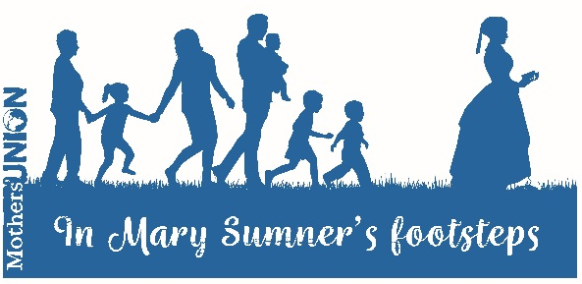

Mary’s Game

Outline

‘Kim’s Game’ is a well-known simple memory game – but this is a slightly different version to help your branch think about the life and legacy of Mary Sumner.

Activity

Put out the ten ‘Mary’s Game’ pictures (or you could use some actual items) on a table or tray. Allow members about 3 or 4 minutes to memorise as many as they can. Then cover the pictures and give everyone a few minutes to jot down as many as they can remember.

Ask people to call out the pictures they remember. Each picture represents something about the life and work of Mary Sumner or the early Mothers’ Union. The ‘Background Information’ gives an explanation of the reason for the picture – as well as a challenge for members of your group to consider, either personally or together.

It is hoped that Mary’s Game will offer a light hearted opportunity to discover more about this inspirational woman.

Background Information

Microphone

Mary Sumner was speaking at public events at a time when this wasn’t considered appropriate for a respectable woman. But she took these opportunities to speak about the work she believed God was calling her to do.
- How can we tell others about the work and mission of Mothers’ Union?

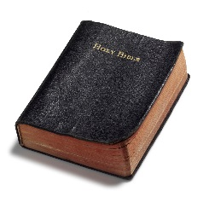
Bible
Mary Sumner believed that children should be brought up in the Christian faith and that was her primary aim in bringing mothers together in the parish of Old Alresford.
- In what ways can we support and encourage parents today to develop the faith of their children?

People
Mary Sumner brought together women from all classes in her local community to support them in nurturing their children, not just women from her own social class. She also engaged with groups of men in her parish, encouraging them to show respect and love for their wives.
- What could we do to encourage a wide range of people to become involved with Mothers’ Union? What particular groups would we like to encourage?

Mary Sumner Prayer
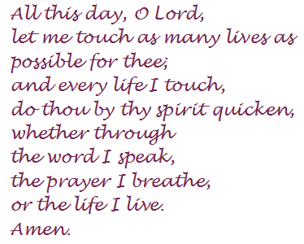
Many members take inspiration from the personal prayer of Mary Sumner and the importance of showing our faith in what we do and what we say.
- In what ways can we demonstrate our faith in our church and in our community?

Globe
The global outreach of Mothers’ Union began while Mary Sumner was Central President of Mothers’ Union and since them, the worldwide fellowship of Mothers’ Union has expanded to over 80 countries.
- What do we know about our worldwide links through the Wave of Prayer and what can we do to support Mothers’ Union members worldwide?

Wedding rings
Mary Sumner believed in the importance of marriage and family life and to support married life remains the first Mothers’ Union objective.
- What could you do to support marriage ministry in your parish?

Young children
In the 19th century, children were exploited through child labour in factories, mines and on farms. Today we are aware of the potential for the exploitation of children through the commercial world.
- What do we know about the commercial pressures on children today? How can we help families resist the pressure?

Family
When Mary Sumner saw families facing difficulties, she thought about what she could do to improve their situation.
- What difficulties do we see being faced by families today? What can we do about this?

Mothers’ Union badge
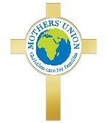
The first Mothers’ Union badge appeared in the early 1900’s and there have been a number of different designs over the years.
- Why is it important for us to wear our Mothers’ Union badge?

Families Worldwide and web address
In 1888, the Mothers’ Union Journal was launched because Mary Sumner couldn’t communicate individually with all the members who wrote to her.
- How many different ways can we think of that enable us to keep up to date with all that’s happening in Mothers’ Union today?

Pictures

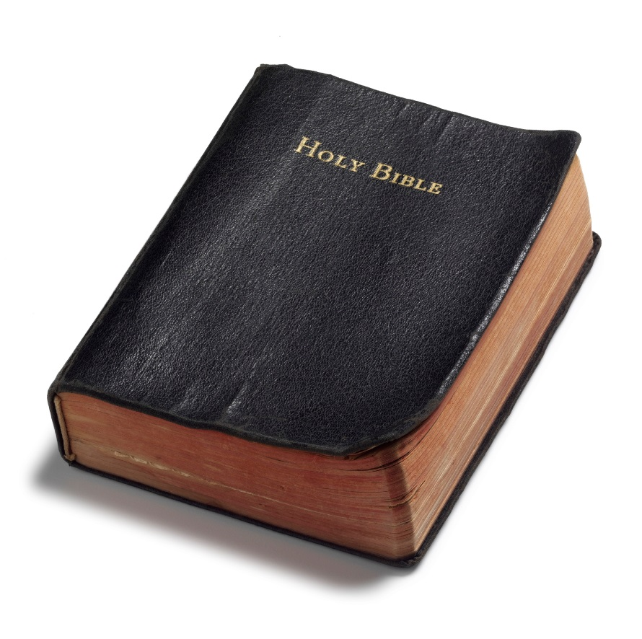

All this day, O Lord,
let me touch as many lives
as possible for thee;
and every life I touch,
do thou by thy spirit quicken,
whether through
the word I speak,
the prayer I breathe,
or the life I live.
Amen

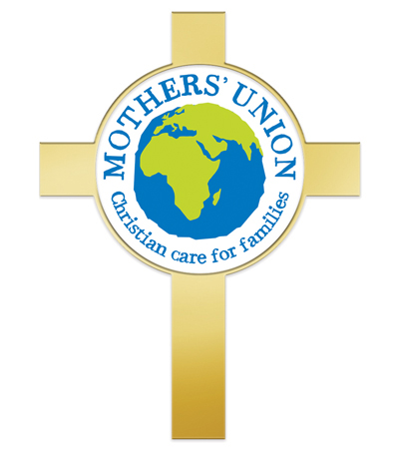

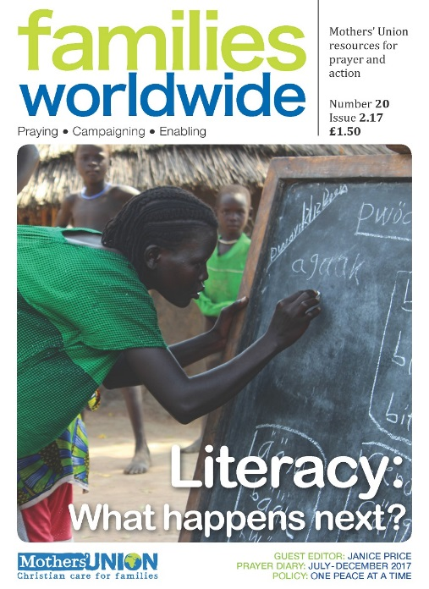
www.mothersunion.org

