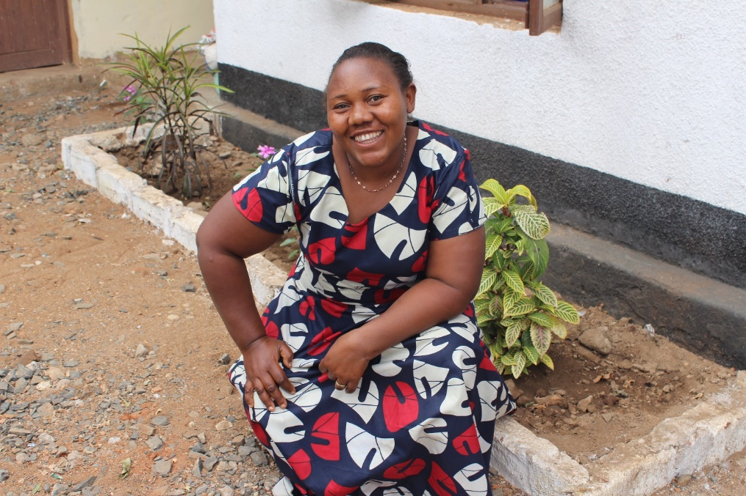
This is Monica. She is married with 3 children between the ages of 7 and 17. She has been part of an MU Vicoba since April 2018 which has had a huge impact on her business and her self-esteem.
“Since being a member I am more [financially] independent. I can do anything like paying my children’s school fees or paying for medication when they are sick. I don’t have to rely [only] on my husband anymore.”
Monica owns a food shop and has been able to expand the range of produce she sells through the savings she has accumulated. Through her business she is able to provide a much needed second income to her family, relieving financial pressures and sources of conflict from her marriage. By doing so, Monica and MU members like her demonstrate that God can use their talents too to provide for their homes and families.
She also makes regular payments into Vicoba social fund which can be used by group members in case of emergency such as sickness or death of a loved one. Social funds in MU Vicoba act like a form of social insurance—by providing insurance to one another, Monica and her Vicoba group are part of less than 30% of Tanzanians that have any form of insurance. By working together, the group is able to provide for and minister to group members in need or distress as a sign of the group’s care and love for one another.

