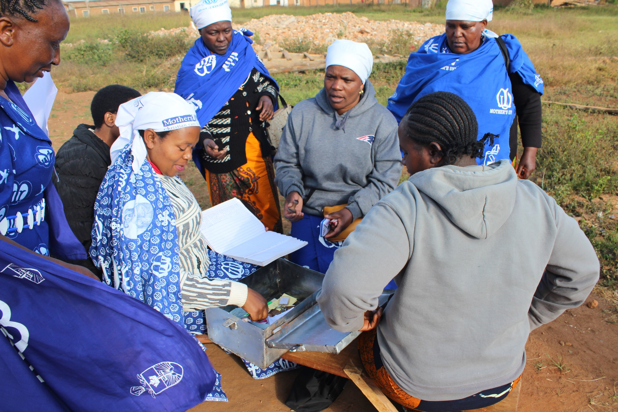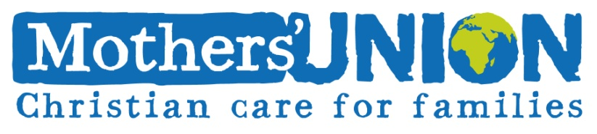

<http://www.themothersunion.org>

Mothers’ Union in Tanzania has seen a lot of progress in the past few years. Two schemes have been successfully piloted and are now being implemented across several Dioceses:

Church Community Mobilisation - which uses facilitator-led Bible studies and other tools to work with church groups to transform their communities.

Kingdom Savings and Credit, based in traditional savings and loan associations & using CCM to teach financial responsibility.

These schemes empower our members to become financially independent, support their families and contribute to their communities.

**Mothers’ Union Tanzania**