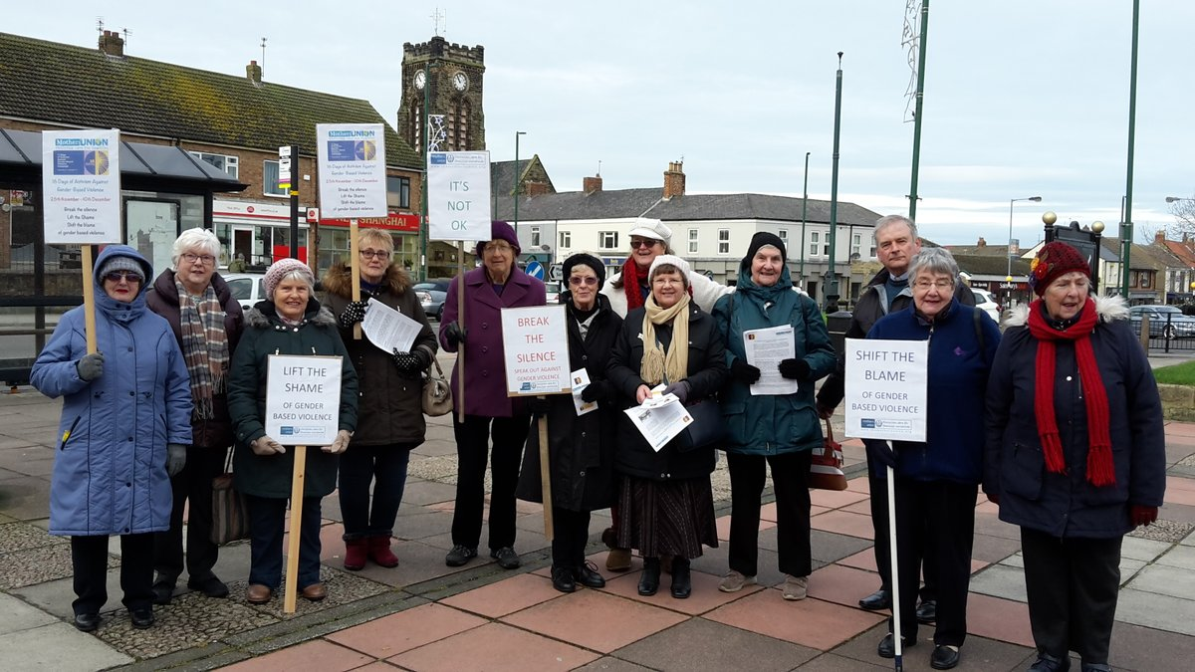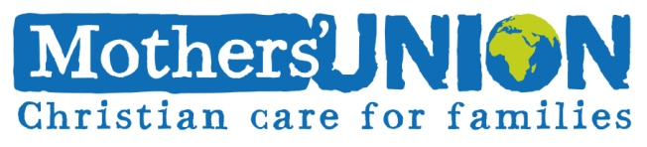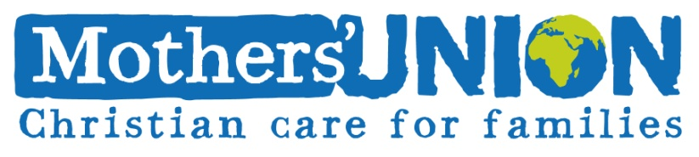

https://www.mothersunion.org/projects/16-days-activism-against-gender-based-violence

Once again, Mothers Union are involved in the worldwide campaign 16 Days of Activism to end Gender-Based Violence. The campaign raises awareness of and promotes action to combat GBV.

From the International Day for the Elimination of Violence against Women (25th November) until Human Rights Day (10th December), join our members as they hold vigils, attend 16 Days church services and advocate for an end to GBV.

Learn more about the campaign, access our resources and get involved, visit our website

**Mothers’ Union 16 Days Campaign**

[www.mothersunion.org](http://www.mothersunion.org)