Mothers’ Union cross stitch patterns
Mothers’ Union – Worldwide

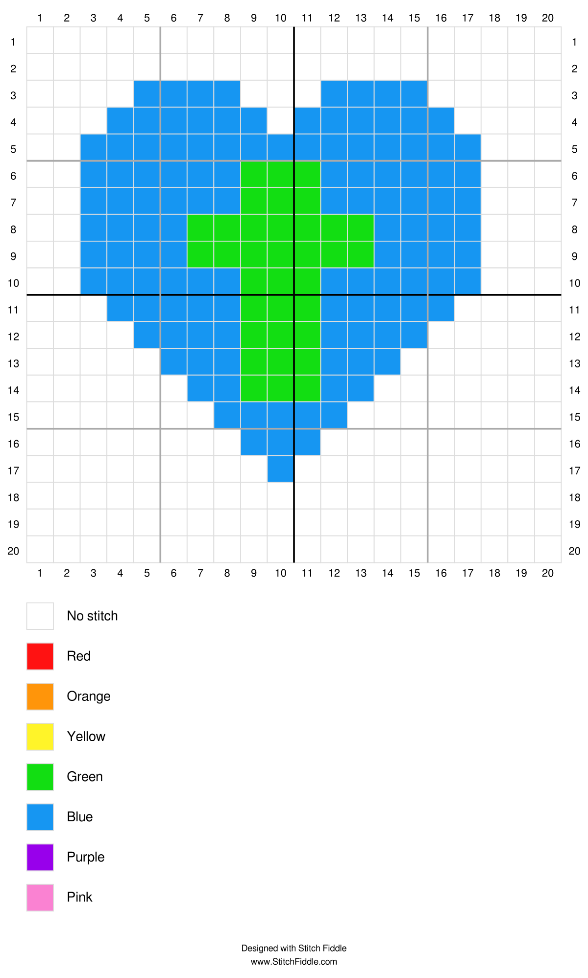
Mothers’ Union - Cross

