Mothers’ Union

Holy Week and Easter Resource Pack

Introduction & Contents

For the majority of us, the season of Holy Week and Easter this year (2020) will look very different to those in the years gone by as the world lives through the COVID-19 pandemic.

This does not stop it from being a deeply spiritual and holy time for us all and perhaps this year, in the silence and quiet we can reflect on the sacrifice of the cross and the hope that the resurrection provides us, even in the most difficult circumstances.

We have produced this pack with some reflections, prayers and activities which we hope will help guide you through this time and feel connected to our Heavenly Father and of course our Mothers’ Union family across the globe.

For God so loved the world that he gave his only Son, so that everyone who believes in him may not perish but may have eternal life.

John 3:16

Contents

Palm Crosses & Wreath Activity 3

Holy Week Reflection: Encounters with Jesus 5

Easter Reflection: Encounters with Jesus 7

Reflection for Holy Week: Mothers at the Cross 12

Easter Recipe: Honey Cake 13

Holy Week and Easter Prayers 15

Easter Word Search 16

Palm Crosses and Wreaths

‘They took palm branches, and went out to meet him, shouting, “Hosanna! Blessed is he who comes in the name of the Lord!’” John 12:13

This Palm Sunday we know that many of us will not be able to attend church and receive our palm crosses – here are some suggestions of what you could do instead! Whilst you do, why not reflect on the Bible verse above?

Palm Wreaths

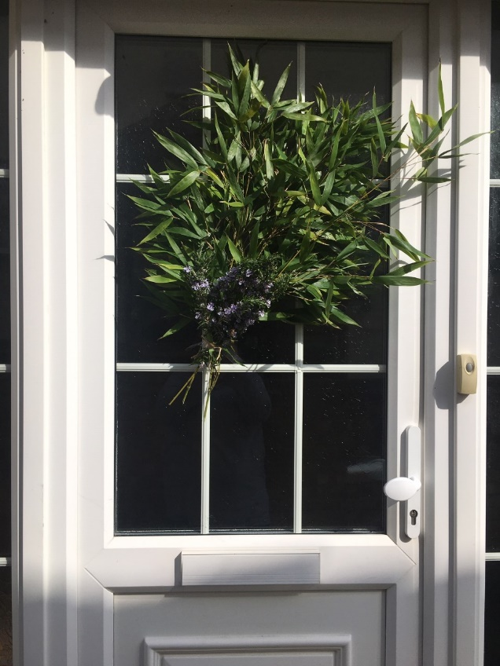

Rather than a Palm Cross why not create a palm wreath? Simply take some cuttings from your garden and wash them. In this instance we used rosemary and some greenery. Tie them together with some ribbon or string and then affix to your front door. We love how simple this is to do but looks so effective.

Palm Crosses

We love this video from St Andrews Church, Newlands’ Facebook page which shows you how to make a palm cross:

https://www.facebook.com/standrewsnewlands/videos/149710473063675/

Whilst they show you how to make the cross with a palm frond, they also show you how to make these with pieces of paper. You could also try with materials like these ones that have been made with ribbon (as shared by MU member Judy Ford!)

Holy Week Reflection: Encounters with Jesus

This Holy Week let us take time to reflect on those who first encountered our loving Saviour.

May God use this reflection to deepen our own relationship with Him.

The betrayal of Judas

In this moment, in my heart,
may I encounter afresh
my loving Saviour.

Jesus asked him,
‘Judas, are you betraying the Son of Man with a kiss?’ Luke 22:48

Lord, how could you bear
the hate of betrayal expressed though a symbol of love?
We weep at the deed of a faithless friend.

And yet...

Daily we betray you afresh
in deeds and words and silence.
We sully the gift of your friendship
through our kiss of faithlessness.

We marvel at your love for us;
Your commitment despite our weaknesses
and the poverty of our discipleship.

Forgive us, loving Saviour.
Accept our thanksgiving,
and strengthen us to live our lives
in total devotion to you. Amen

May my life bear witness
to an encounter with my loving Saviour.

The abdication of Pilate

In this moment, in my heart,
may I encounter afresh
my loving Saviour.

Pilate took water and washed his hands in front of the crowd.
‘I am innocent of this man’s blood,’ he said. ‘It is your responsibility!’
Matthew 27:24

When we wash our hands of your commission to us;
when we turn aside from your people in need.
When we pass the buck, when we close our eyes,
we mirror the past; we shun you afresh.
Forgive us, dear Saviour, and renew our hearts.

May we stand before you with hands open wide,
ready to embrace the commission of God.
For your burden is easy, your load is light,
and your presence gives rest to our souls.
Inspire us, dear Saviour, and renew our hearts.

May my life bear witness
to an encounter with my loving Saviour.

The revelation of the Soldier

In this moment, in my heart,
may I encounter afresh
my loving Saviour.

When the centurion, who stood there in front of Jesus,
saw how he died, he said, ‘Surely this man was the Son of God!’ Mark 15:39

Let our eyes behold the truth;
let our lips declare the truth;
this man is the Son of God.

Let our actions arise from the truth;
let our lives bear witness to the truth;
this man is the Son of God.

Open the eyes of those who are blinded to the truth;
soften the hearts of those who are hardened to the truth;
that together we may proclaim,
throughout heaven and on earth:
this man is the Son of God.

May my life bear witness
to an encounter with my loving Saviour.

Lamb of God, who takes away the sins of the world,
have mercy on me.
Lamb of God, who takes away the sins of the world,
grant me your peace. Amen

Easter Reflection: Encounters with Jesus

This Eastertide let us take time to reflect on those who first encountered the risen Lord.
May God use this reflection to deepen our own relationship with Him.

The joy of Mary

In this moment, in my heart,
may I encounter afresh
my risen Lord.

Mary Magdalene went to the disciples with the news:
‘I have seen the Lord!’ John 20:18

Risen Lord,
open our eyes.
Give us a glimpse of your resurrection glory.

Wipe away our tears of mourning;
fill us with joy in your presence
Take away our spirit of heaviness;
clothe us with a garment of praise.
And send us out to spread the news:
the Lord is risen.

Hope has been renewed; joy has been rekindled.
Death has been defeated; eternity beckons.
The Lord is risen.
Hallelujah!
Glory to our God.

May my life bear witness
to an encounter with my risen Lord.

The doubt of Thomas

In this moment, in my heart,
may I encounter afresh
my risen Lord.

Jesus told him,
‘Because you have seen me, you have believed;
blessed are those who have not seen and yet have believed.’ John 20:29

We pray for those whose faith is tested
through trials of life; through challenging times.
As they struggle to believe, help them in their unbelief.
We pray for those whose faith is tested
through the mysteries of unanswered prayer;
As they struggle to believe, help them in their unbelief.

We pray for those whose faith is tested
in the face of suffering and pain.
As they struggle to believe, help them in their unbelief.

When doubts fill our hearts;
when faith dims and certainty fades;
Lord we believe; help us in our unbelief

May my life bear witness
to an encounter with my risen Lord.

The restoration of Peter

In this moment, in my heart,
may I encounter afresh
my risen Lord.

Jesus said, ‘Simon son of John, do you truly love me?’
He answered, ‘Yes, Lord, you know that I love you.’
Jesus said, ‘Take care of my sheep.’ John 21:16

We hide in the shadow of our faithlessness and sin;
we whisper our love for our Lord.

We bathe in the light of forgiveness and mercy;
we speak out our love for our Lord.

We revel in the glow of restoration;
we shout out our love for our Lord.

Anyone who belongs to Christ has become a new person.
The old life is gone; a new life has begun!
And all of this is a gift from God,
who brought us back to himself through Christ.
2 Corinthians 5: 17-18

May my life bear witness
to an encounter with my risen Lord.

Christ has died.
Christ has risen.
Christ will come again.
Hallelujah!

Reflection for Holy Week: Mothers at the Cross

Read Luke 23:33-43 and then reflect on the dramatised reading below. This does not pretend to be biblically accurate. It features Mary the mother of Jesus and the mother of the penitent thief on the cross and explores what the feelings of these two women may have been in the week leading up to the crucifixion of their sons.

Mary and the mother of the thief
(The words of the mother of the thief are in italics) From ‘Touching the Cloak’ (Biblical monologues) by Jackie Mouradian

Mary: Yes my love, I’m making bread again. We’re back in Jerusalem for Passover. You are here too, somewhere with your friends. You will have Passover with them, I think. You will be missed here – by me anyway. I wish I could see you.

MOT: They won’t let me see you. There’s no compassion for the mother of a thief. I tried my love – they wouldn’t let me through. So your last days will be spent with him – your ‘friend’. What comfort is he I wonder? Careless of his own life and careless of yours.

Mary: Ah, but I do love Passover. I love making the bread. It takes time, and I love that. It takes energy and effort, and I love that too. It reminds me of a time when I had some control, before I had to let you go.

MOT: I should never have let you go. You were safe here with me. But somehow I couldn’t stop you. Your father had gone and part of you went with him.

Mary: When you were little you used to sit and watch me as I worked. I would work away at the dough and you would talk, of many things - normal boy stuff as well as higher spiritual things. Yes, the human and the divine were both there, right before my eyes, even then.

MOT: When you were little you would come to the synagogue. You would listen so intently and afterwards you would ask me questions and get so frustrated when I couldn’t answer them. Yes, you had a temper, but you knew right from wrong.

Mary: Then, when you were grown up, you would work away at a table or a chair as I worked away at the bread. And still we would talk, about good and bad; your growing desire to serve - you couldn’t hide your excitement when you knew your time was coming. And then, when your dear father died, we would talk away our grief. You were such a comfort to me then.

MOT: And when your father left us, everything changed. You had longed for his attention and his affirmation, but there was nothing in him to give. He took the easy way out and left you thinking you should do the same. You looked for someone else to impress, and he was easily found. Took you under his wing and led you down a different path of violence and stealing.

Mary: So now I still talk to you as I make bread; foolishly perhaps, I imagine you listening somewhere.

MOT: Foolishly, I would imagine you wanting to come home.

Mary: I don’t see you much now – you have so much to do – and I wonder if you ever think of me, making bread.

MOT: Did you ever think of me waiting here?

Mary: You did say, when you were out in the wilderness, looking at the rocks around you and feeling the ache in your stomach, all you could think about was my bread.

MOT: Did you think of me at all out in the wilderness, with your friend, waiting for your next victims? Did you think of those days in the synagogue?

Mary: Do you have time to think of me at all –maybe not?

MOT: Are you scared – sitting there – waiting to die?

Mary: But I’m still your mother.

MOT: I’m still your mother.

Mary: And if you were here now, I’d tell you to be careful.

MOT: I’d tell you that I’m sorry for not being stronger.

Mary: I’d tell you to watch out for those people, powerful people, who resent you and the attention you are getting.

MOT: I’d tell you that it’s not too late.

Mary: But I’d tell you how proud I was too – proud of the man you are.

MOT: I’d tell you it’s not too late to be the man you really are – not the one that others have made you.

Mary: A man who brings comfort and healing with a touch or a word.

MOT: A man who knows truth when he sees it.

Mary: May God protect you my love.

MOT: May God have mercy on your soul.

To reflect on:
- What emotions and insights has this reading evoked in you?
- How can you use these to worship God and to pray for yourself and others?

Easter Recipe: Honey Cake

When I was growing up, daughter of the local parish vicar, I would often accompany my dad to various church events in the evening and would always love helping out in the kitchen for various meals and fundraising functions. One of my favourites was the Passover meal that the church would hold on Maundy Thursday – even as a little girl I would love the simplicity of the meal and the scriptures that were read as we would eat. I would always make this honey cake as my contribution towards pudding and I was always asked for the recipe (which was embarrassingly easy and simple) – I share it with you now, with fondest memories of Easter’s past.

Rachael Anderson

Ingredients
250g clear honey
225g unsalted butter
100g dark muscovado sugar
3 large eggs, beaten
300g self-raising flour
Optional:
1 tsp mixed spice
½ tsp ground ginger / or ground cinnamon

For the icing
55g icing sugar
1 tbsp clear honey
hot water

Method

Heat oven to 180C/160C fan/gas 4. Butter and line a 900g loaf tin with baking parchment.

- Cut the butter into pieces and drop into a medium pan with the honey and sugar. Melt slowly over a low heat. When the mixture to turn to liquid, increase the heat under the pan and boil for about one minute. Leave to cool for 15-20 minutes, to prevent the eggs cooking when they are mixed in.

- Beat the eggs into the melted honey mixture using a wooden spoon. Sift the flour and spices, if using, into a large bowl and pour in the egg and honey mixture, beating until you have a smooth, quite runny batter.

- Pour the mixture into the tin and bake for 40 minutes-1 hour until the cake is well-risen, golden brown and springs back when pressed. A skewer pushed into the centre of the cake should come out clean.

- While the cake is still warm, make the icing by mixing the sugar and honey together with 2-3 teaspoons of hot water. Trickle over the cake in whatever design takes your fancy.

Holy Week & Easter Prayers

Prayers written by our members, all of which can be found in our Dear Lord prayer book.

Holy Week

Dear Lord, you gave us Holy Week to reflect on what you went through for us. Heavenly Father, help us to make every day of our lives a holy one that we might hide your word in our heart and meditate on it day and night. In the name of your son, Jesus Christ, we pray. Amen
Ebele Okonkwo, Mothers’ Union Silver Spring, Maryland USA

Easter

Christ is risen, Alleluia!
Lord Jesus Christ, in dying you conquered death and rose again in glory.
Through your great love and abiding grace, we will one day be with you in your heavenly kingdom.
Lord, we pray that we may make each day of our earthly life worthy of your great sacrifice on the cross. Thank you that we can find sanctuary in your love because you have chosen to love us just as we are, with all our faults and failings and that, if we truly repent, you will forgive our sins. Amen
Margaret Delvin, Diocese of Newcastle, UK

Easter Word Search

