Palm Crosses and Wreaths

‘They took palm branches, and went out to meet him, shouting, “Hosanna! Blessed is he who comes in the name of the Lord!’” John 12:13

This Palm Sunday we know that many of us will not be able to attend church and receive our palm crosses – here are some suggestions of what you could do instead! Whilst you do, why not reflect on the Bible verse above?

Palm Wreaths

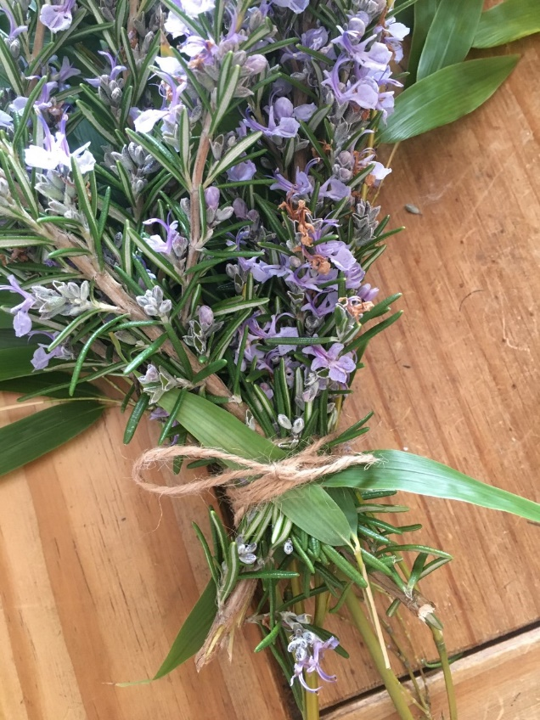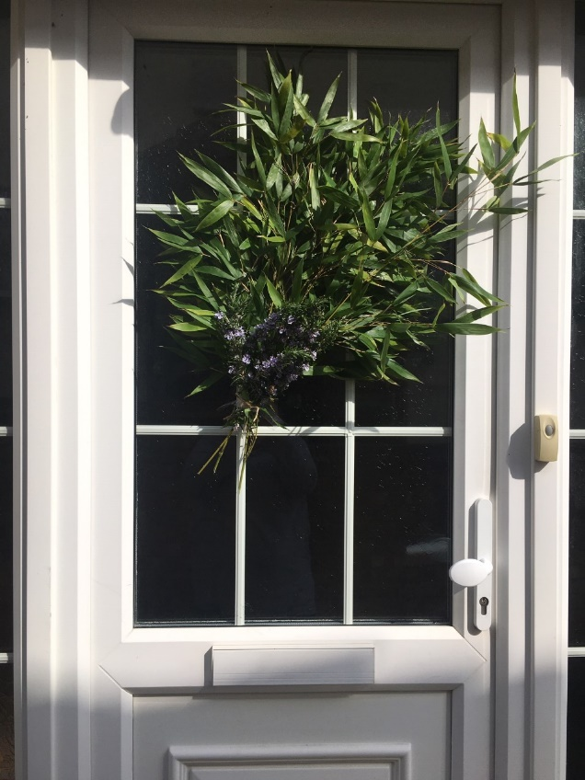

Rather than a Palm Cross why not create a palm wreath? Simply take some cuttings from your garden and wash them. In this instance we used rosemary and some greenery. Tie them together with some ribbon or string and then affix to your front door. We love how simple this is to do but looks so effective.

Palm Crosses

We love this video from St Andrews Church, Newlands’ Facebook page which shows you how to make a palm cross:

https://www.facebook.com/standrewsnewlands/videos/149710473063675/

Whilst they show you how to make the cross with a palm frond, they also show you how to make these with pieces of paper. You could also try with materials like these ones that have been made with ribbon (as shared by MU member Judy Ford!)

