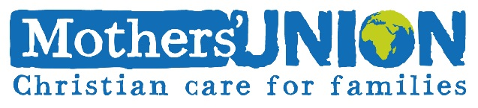
Event Parent/Guardian Consent Form
Registered charity no: 240531

Event: Date:

For your child’s safety, we require all young persons under the age of 18 to provide written consent from a parent or guardian to take part in Mothers’ Union events.

Child’s Name:…………………………………………………………… Date of Birth:……………………………… Parent/Guardian’s Name: ………………………………………………………………

Address:…………………………………………………………………………………………………………………………………………………………………………………………………………………………Postcode:………………………………………

Phone No:…………………………………………………… Mobile:…………………………………………………………

I give permission for my child to take part in the event stated above.

Anyone under the age of 16 must be accompanied by an adult. I am unable to attend and therefore give permission for my child to attend the event with:

Name of Accompanying Adult:………………………………………………………………………

Phone No. of Accompanying Adult:………………………………………………………………

I give consent for Mothers’ Union to use any photos of my child for future publicity purposes, which may include publication by the press and use on our website and publicity materials.

Signature of Parent/Guardian:…………………………………………… Date:……………………………

Health History

If your child suffers from any illnesses, disabilities (learning or behavioural) or allergies (foods, medicines, stings) that might affect them during the event please give details below, along with any medication you require for these (and where they are kept if you have them with you)

……………………………………………………………………………………………………………………………………………………………………………………………………………………………………………………………………………………………………
I understand that in the event of illness or accident that the event organiser considers needing medical attention, medical aid will be sought and all attempts made to contact parents/guardians. In the event of no contact being possible a doctor will decide whether examination and subsequent treatment are necessary.

Signature of Parent/Guardian:………………………………………… Date: ………………………………

