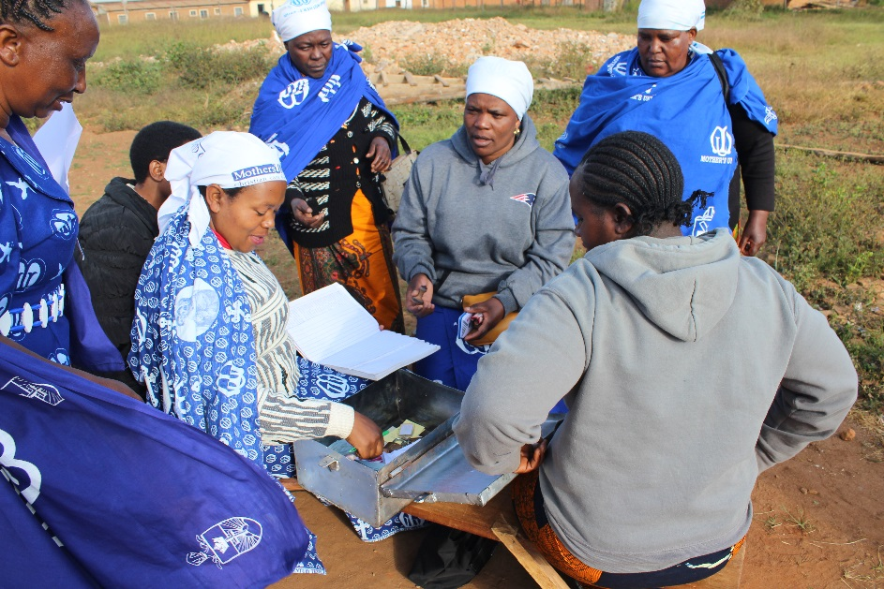
Mothers’ Union in Tanzania

Mothers' Union Tanzania has one of the largest memberships in our organization with over 815,000 members and counting! Members across Tanzania are involved in caring for those in need in various ways from collecting money and materials to support vulnerable children with school fees to helping widows and people living with HIV/AIDS.

One of the main schemes that members use is called Church and Community Mobilisation (CCM). CCM uses facilitator-led Bible studies and participatory tools to work with church groups to encourage and enable them to transform their communities. The groups inspire the church to realise that God has already made provision for them, and has given them the skills they need to live well, bringing about lasting change. This enables them to become more self-sufficient.

In addition to CCM, Kingdom Savings and Credit (KSC) is an initiative based in traditional savings and loan associations, but using tools from CCM to teach financial responsibility. KSC came about when many of the existing CCM groups asked for a way to be able to fund new projects such as building churches, schools or buying better farming equipment. Once they set up a group each family or individual that has contributed can request to borrow from the village community bank.

Further to these schemes, our Tanzanian members are becoming more active and vocal in local, regional and national issues. They campaign and call for the empowerment of women, work on countering the issues of gender-based violence including Female Genital Mutilation. Members have also raised awareness of the vulnerability of orphans and other children, who are now getting more attention from health authorities and protection in law.

As a result of CCM, several dioceses are now working on income generation projects that allow women to learn a skill that will be productive and provide an income, and many more will be starting throughout 2018. These skills include farming using better techniques and crafting goods such as mats, clay pots or batik clothes. These activities then allow more women to go on to join the savings and credit groups resulting in a reduction of poverty.

One member named Violet said of CCM and KSC: ‘I now know how to take care of my family. They have more money in their pockets. The offering has raised up as people are now contributing. People sit together and learn the Bible…When we see each other now we ask about people who are not there, if they need help or if they are okay. We have learnt to help the needy and the orphans.’

Learn more about Mothers’ Union on our website: http://mothersunion.org/

