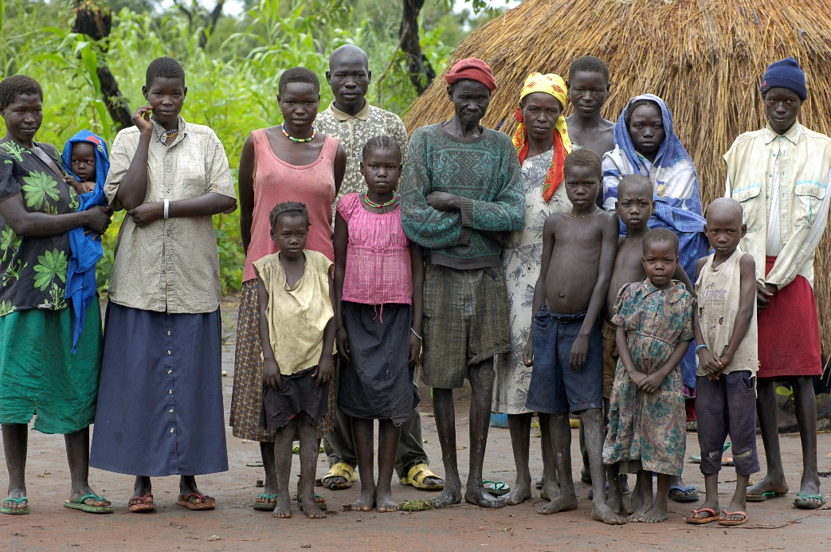
Mothers’ Union Harvest Appeal 2018

In 2017 we successfully called on our members and the public to help us support families in South Sudan who were in desperate need of food and other essential items. With your help we were able to raise over £30,000 - making it possible for Harriet Baka, our coordinator for South Sudan, to transport aid into areas made too dangerous for many other agencies. The money raised alongside other contributions led to over 20,000 refugees affected by the ongoing conflict being assisted. This year we’re asking you to continue supporting Harriet ‘Mama Baka’ as she works with even more refugees by introducing them to our “EAGLE” process.

Originating in Uganda, EAGLE is aimed at helping communities first identify the fundamental issues facing them such as high illiteracy and innumeracy, gender-based violence and poverty. Groups then work to identify the skills they already possess and what may need further development. Once this has been established, they then work on achievable, realistic plans for how they can use these strengths and assets to solve the issues, meaning that they get resolved in a process fully owned by the community - creating lasting change. So far, EAGLE has been a huge success. For example one group of farmers in rural Uganda are now able to grow crops such as the Physalis fruit and export it to the EU, making them a successful and sustainable source of income. In a much larger case over 5,000 people in the South Sudanese diocese of Lui (one of 26 Dioceses) have now received financial training.

Because many South Sudanese who were forced to flee now live in camps in Northern Uganda and the border region between the two countries it made sense to trial EAGLE within the refugee camps. Over the past year Mama Baka and our development team been using EAGLE with small groups to assess its impact and now want to expand the process to as many refugees as possible. As the example in Lui shows, there is a great need for this programme to expand to include as many of the 50,000 Mothers’ Union members who can benefit from it.
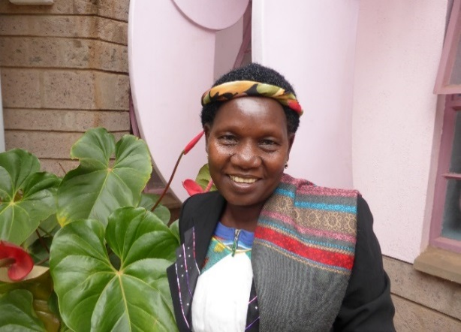
So, if you want to help Harriet (pictured left) and the thousands of refugees she has been aiding then get involved with our Harvest appeal. As well as donating, we always love to see people holding harvest-themed events in their churches and communities.

Visit our website today https://www.mothersunion.org/harvest

