Mothers’ Union Thank You Key Workers Appeal
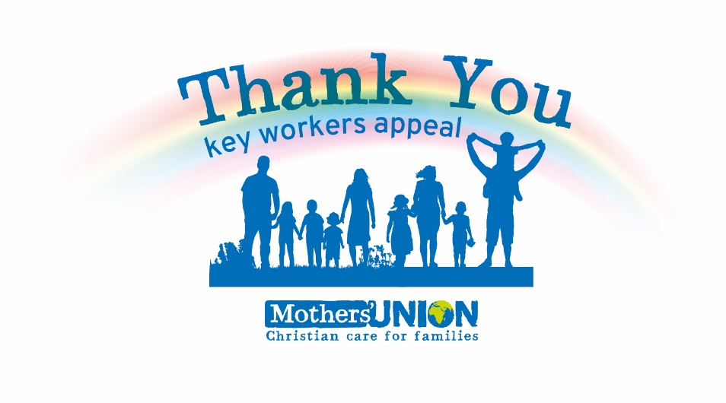

Since 1965 Mothers’ Union has run the “Away From It All” (AFIA) programme of experiences and holidays across Britain and Ireland and has helped many families rebuild relationships that had become strained, fractured or even been kept apart.

Most of us had our lives turned upside down in a matter of days due to the COVID-19 pandemic. We had to come to terms with restrictions on everyday activities, such as seeing family and going to Church and School. Many of us also had to become technology gurus overnight and reinvented our dining tables to be our new offices! It was an adjustment for us all. But while all this was happening, an army of individuals were keeping us all going – from shop workers to care workers, refuse collectors to bus drivers, nurses to delivery drivers. Without them, our lockdown would have been so much harder. They ensured we were as safe as possible, often putting themselves at risk in the process.

We now want to say a huge thank you for all they have done, which is why we have used all our experience from AFIA to launch our Thank You Key Workers Appeal in order to recognise those who have continued to go above and beyond to help others. While all the work our key workers have done has been a triumph of compassion and care, it has meant a great deal of personal sacrifice – including the very important quality family time.

We want to provide similar AFIA day experiences and short breaks for key workers to help them rebuild family connections and togetherness. We especially want to provide this for families who have been kept apart or who are on low incomes, so they will be prioritised.

The appeal officially launched on the 5 July and we have been working hard to increase awareness of it outside the Mothers’ Union movement, so that we can not only raise vital funds but also raise the profile of the amazing work we do through AFIA every year! You can find out more about the appeal at www.mothersunion.org/thank-you-keyworker-appeal and we invite you to share this link with anyone you think might also like to say thank you to a key worker. You can also nominate a key worker that you think really deserves an opportunity such as this.

To apply or nominate please visit: www.mothersunion.org/thank-you-keyworker-appeal

