Prayer Shawl Patterns

Most prayer shawls are made to be long enough to reach from wrist to wrist, which is about 130 – 140 cm for an adult.

Ladder Pattern

You will need:
Double knitting yarn – about 300g
7.5mm knitting needles

Instructions
Cast on 69 stiches.
Work the whole length of the shawl in garter stitch to the finished length.

Every alternate row – making ladders:
Knit 6, drop 1 stitch off needle.
Pick up a loop where the stitch has dropped, knit into the back of loop (this is to make up for the dropped stitch), repeat to end.

Cast off loosely.

Attach fringes to the cast on and cast off stitches.

Triple Moss Stitch Pattern

You will need:
Double knitting or Aran yarn – about 400g
5mm knitting needles

Instructions
Cast on 105 stitches.
Knit 3 purl 3 every row to the desired length.
Cast off when the finished length has been reached.

Attach fringes to the cast on and cast off stitches.

Knitted Rib Pattern with border

You will need:
Double knitting yarn – about 300g
6.5mm knitting needles

Instructions
Cast on 126 stitches and knit 5 rows.
Knit 2 together across row (63 stitches remaining)

Row 1: Knit 3, purl 3 to end of row
Row 2: Purl 3, knit 3
These two rows form the pattern.
Continue until the shawl is about 2cm shorter than the desired length.

Make the end border by increasing into each stitch once (126 stitches).
Knit 5 rows and cast off.

Prayer Shawl with Cross

You will need:
Double knitting yarn – about 200g
7.5mm knitting needles

Instructions
Cast on 81 stitches
Work pattern knit 3 purl 3 for 36 rows
Cross block
Row 1: Pattern 27 stitches, purl 27 stitches, pattern 27 stitches
Row 2: Pattern 27 stitches, knit 27 stitches, pattern 27 stitches
Repeat rows 1 & 2 twice more.
Row 7: Pattern 27 stitches, purl 10, knit 7, purl 10, pattern 27 stitches
(This begins the base of the cross)
Row 8: Pattern 27 stitches, knit 10, purl 7, knit 10, pattern 27 stitches
Repeat rows 7 & 8 for 24 rows.
Next row: Pattern 27 stitches, purl 3, knit 21, purl 3, pattern 27 stitches
Next row: Pattern 27 stitches, knit 3, purl 21, knit 3, pattern 27 stitches
Repeat these 2 rows 10 times
Next row: Pattern 27 stitches, purl 10, knit 7, purl 10, pattern 27 stiches
Next row: Pattern 27 stitches, knit 10, purl 7, knit 10, pattern 27 stitches
Repeat these 2 rows 11 times.
Repeat rows 1 & 2 for 8 rows.
This completes the cross block and a single cross will show on one end of the shawl.

Continue in knit 3, purl 3 pattern.
The shawl without fringe should be about 114cm (45 inches). However, if you would like it longer, use another ball of wool.
(Before joining the last ball of wool, cut 108 threads about 35.5cm (14 inches) long for the fringe.)
Cast off.

Darn in threads.
Attach cut threads singly or in bunches at both ends of the shawl.

Crocheted Pattern

You will need:
Double knitting yarn – about 400g
4.00mm Crochet hook

Instructions
Chain 80 stitches.
Chain 2, turn, double crochet in each of the chain stitches to end.
Chain 3, turn, treble crochet in the top of each double crochet. Repeat this row 2 more times.
Chain 2 and do 1 row of double crochet to end.. Chain 3 and turn.
Do 3 rows of treble crochet.
Repeat the pattern (1 row double, 3 rows treble) to desired length, ending with one row of double crochet.

Finish each end with fringe.

A prayer for healing

O Christ who healed the broken in body and spirit,
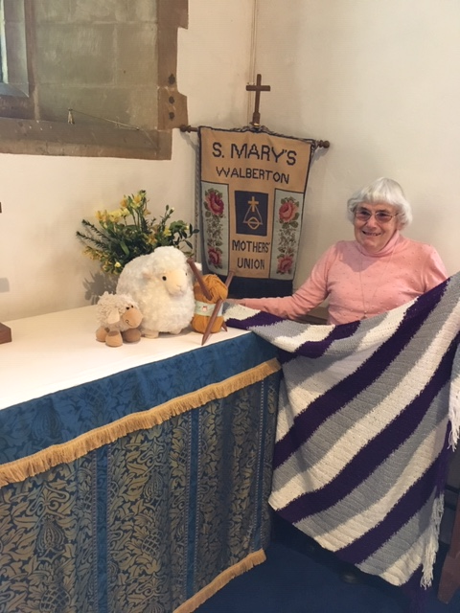
be with me and all who suffer this day.

Be with the doctors, nurses, technicians, chaplains,
and all who care for the sick.

Be with those families and friends
abiding with and comforting the sick.

May your gentle, yet strong, touch
reach out to heal the broken and hurting people
and places in our world. Amen.

