Praying with Purpose: Prayers for projects and initiatives

These prayers focus on specific aspects of Mothers’ Union mission.

They may be adapted to suit your specific situation or style of praying.

Away From It All

Loving Lord,
we pray for Away From It All
and thank you for the blessing it is
to so many families who are struggling
and carrying heavy loads.

We pray for volunteers involved in AFIA:
May your strength sustain them in all their work;
where problems arise may solutions be found.
Loving Lord, who gives us rest
lift their burdens and hear our prayers.

We pray for families who enjoy these times:
May they be refreshed in body, mind and soul;
may the benefits they gain be rich and lasting.
Loving Lord, who gives us rest
lift their burdens and hear our prayers. Amen

Loving relationships

God of relationship,
We thank you that marriage is enriched
when you are at the centre;
the third strand in a cord of love. Amen



Lord, we pray for our work to support marriage
May those involved reflect your love
to the couples they will meet.
May they help relationships to be built
on a basis of love and respect.

We pray for those who prepare couples for marriage
and all who counsel when challenges arise.
May they advise with the wisdom of God,
the source and sustainer of love.

We pray that couples will be helped
to build their marriage on solid foundations.
May they reflect the love of God
in their care for one another. Amen
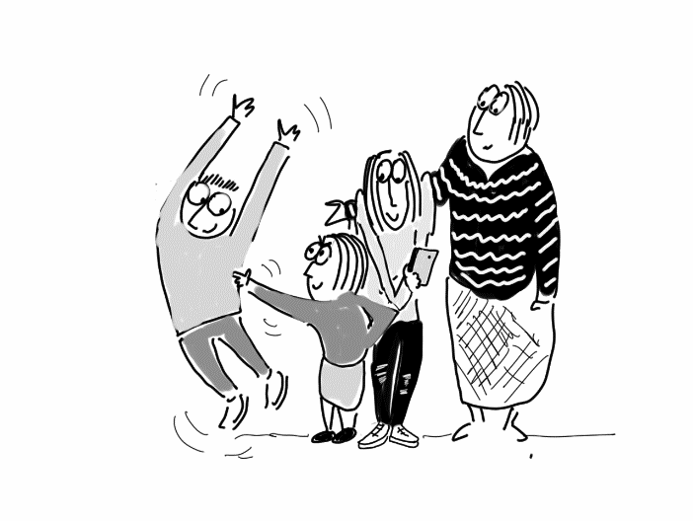

Family life

Father God, we pray for our work with families.
We ask that parents will have family life enriched through sharing and learning together
with other parents.

We pray that parents and children will be helped
to develop harmonious relationships.
Father God, fill them with your unity
though the highs and lows of family life.

We pray that families everywhere may experience joy in the adventure of parenting.
In confidence and trust we bring our prayers
to our Father God. Amen



Heavenly Father,
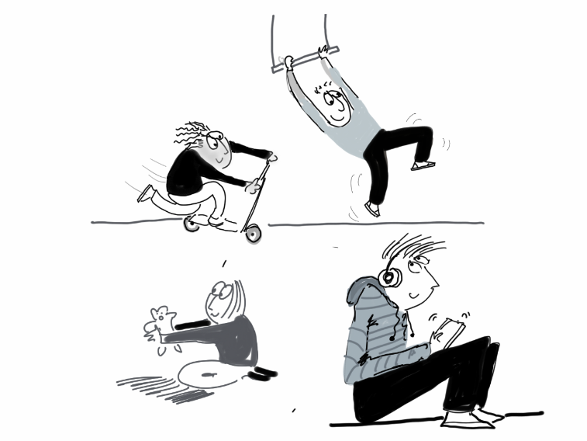
we pray for those who care for families
by encouraging them to grow in faith;
showing ways to encounter God
hand in hand together.

We thank you that you love us all,
adults and children alike,
and call us into relationship with you.

We pray that families
will be helped to enjoy faith
as a natural part of family life;
experiencing the love of God
hand in hand together. Amen

Self-reliance

Lord, we ask for your blessing on initiatives to encourage self-reliance:
(Add name of particular one if appropriate)
May these enable women and men
to be better equipped for life.
May families’ lives be transformed
through the knowledge they attain.

We pray for facilitators who provide education
which can lead to prosperity and respect.
Lord, help them to teach clearly,
and with true consideration.

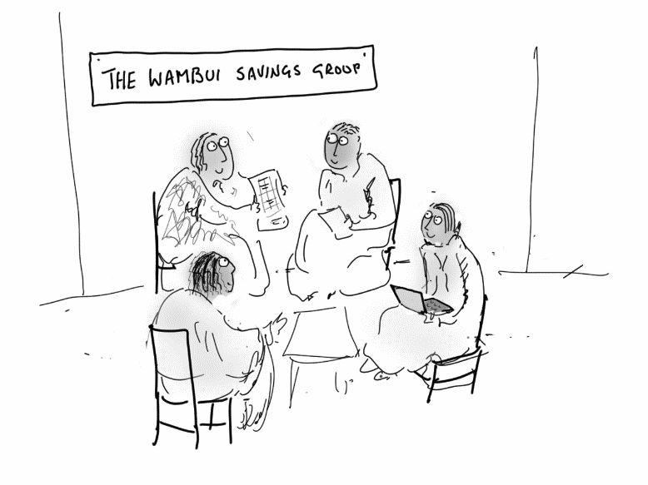
We pray for those who are learning new skills
that knowledge will be quickly absorbed.
Lord, help them to learn extensively,
and with true understanding.

We pray for the growth of these initiatives
that many more families would profit and thrive.
Lord, open doors to new opportunities
For people to access your tools for life. Amen

Campaigning for social justice

Let us not turn from the world,
but be engaged within it.
Where there is injustice
may we find ways to eradicate it.

Where peoples' human rights are so exploited
that they have no life to call their own –
let us fight for equality and dignity.

May our politics be based upon Gospel values,
our motives be to serve our God alone,
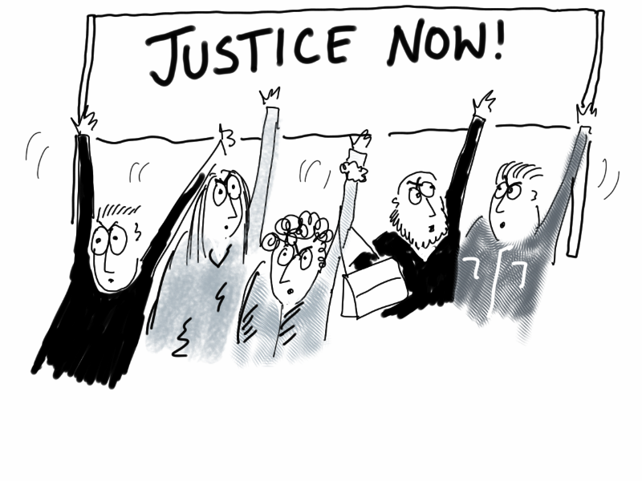
and through our God, to transform this world.



Righteous God,
we pray for all initiatives
to share your love through
speaking out for the helpless
and campaigning for social justice.

Righteous God,
we pray for success in our campaigns
for equality and justice for all.
Help us play our part in creating
a just and peaceful society
for your people on earth. Amen

Gender-based violence

Compassionate God,
may those experiencing all forms of violence
be given courage, hope and the means
to break free from their abuse.

Lord Jesus,
be with those who work to support
survivors of gender-based violence.
May they be given abundant resources
of money, knowledge and time.

Merciful God,
bless those working with perpetrators
of gender-based violence.
May they be helped to bring about
lasting transformation of lives.

We pray for all to follow Christ’s example
of treating women with equality and respect.
We pray for the dawn of a better world
where justice and peace may flourish. Amen

Community initiatives

Lord, we pray for community initiatives.
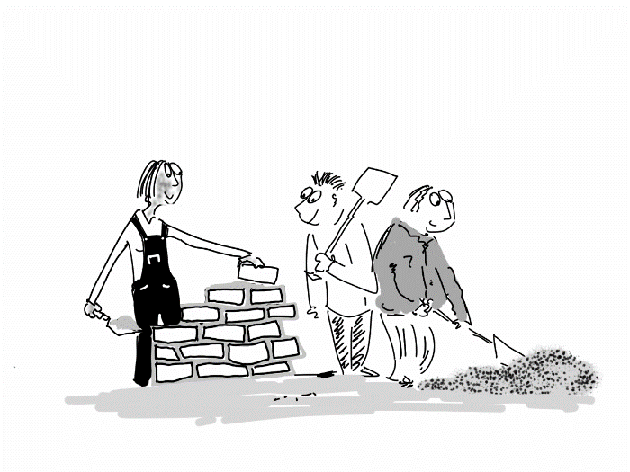
(Add name of particular one if appropriate)
We thank you for communities which
have improved their lives
through working together to share resources.

We pray that many will be empowered to create
a better future for their communities.
Lord, provide riches of every kind
to counter the challenge of poverty.

We bring to you those who work with communities
to explore creative ways to thrive .
Lord, provide riches of relationships
to counter the challenge of harsh locations.

We bring to you those who work with communities
struggling with loneliness and isolation of all kinds .
Lord, provide riches of care and compassion
to counter the challenge of vulnerability. Amen

Prisons

We pray for the work of Mothers’ Union
to help those in prison and their families:

Bless our efforts to support the families
to cope with the challenges they face.
Give us favour with authority
for access to those who need our care.

We pray for prisoners and their families
as they cope with the challenges of being apart.
Please give them hope when life gets tough.

We pray for those who run parenting courses in prison.
May they help parents to strengthen their family relationships
in the present and for the future. Amen
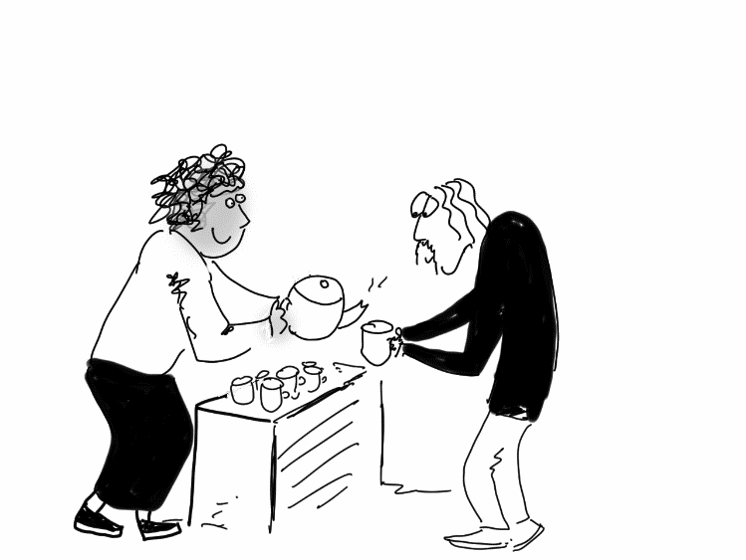

Hospitality

Loving Lord,
we thank you for the ministry of hospitality
shown by Mothers’ Union throughout the world.

Whether in catering for social gatherings,
providing essential food for the hungry,
or welcoming all with tea and love.

We pray that on every occasion
we will nourish both body and soul
by providing sustenance
with God’s love and grace. Amen

Practical provision

Loving Lord,
we thank you for the provision for personal needs
supplied by Mothers’ Union throughout the world.
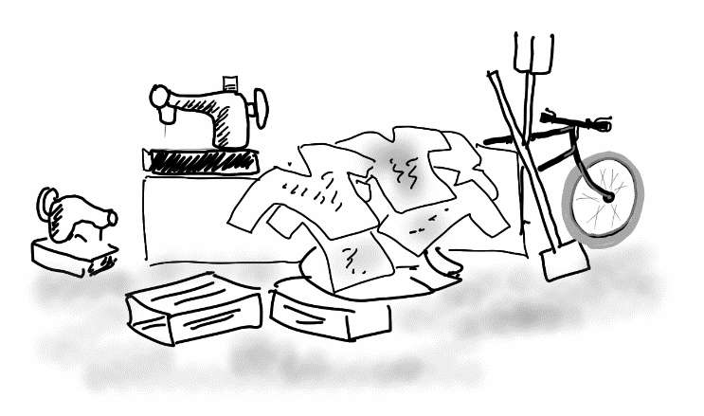
Whether these have occurred through poverty,
Health issues, as a result of conflict,
or broken relationships.

We pray that each gift of practical supplies
will clothe each recipient with dignity
and be accepted as a token of God’s grace. Amen

