Praying with Purpose:

Bible verses and quotes on prayer (1)

As we pray with purpose for the mission of Mothers’ Union, let us take encouragement from God’s word. As you reflect on these verses ask the Holy Spirit to increase faith and insight into the value of our prayers

Pray with faith

I call on you, my God, for you will answer me;
turn your ear to me and hear my prayer.
Psalm 17:6

The Lord is near to all who call on him,
to all who call on him in truth.
Psalm 145:18

If you remain in me and my words remain in you,
ask whatever you wish, and it will be done for you.
John 15:7

You help us by your prayers. Then many will give thanks on our behalf for the gracious favour granted us in answer to the prayers of many.
2 Corinthians 1:11

And I will do whatever you ask in my name,
so that the Father may be glorified in the Son.
John 14:13

I urge that petitions (specific requests), prayers, intercessions (prayers for others) and thanksgivings be offered on behalf of all people,
1 Timothy 2:1 (AMP)



Pray with determination

In my distress I called to the Lord;
I cried to my God for help.
From his temple he heard my voice;
my cry came before him, into his ears.
Psalm 18:6

Devote yourselves to prayer, being watchful and thankful.
Colossians 4:2

Then Jesus told his disciples a parable to show them
that they should always pray and not give up.
Luke 18:1
Answer me when I call to you,
my righteous God.
Give me relief from my distress;
have mercy on me and hear my prayer.
Psalm 4:1

Ask and keep on asking and it will be given to you; seek and keep on seeking and you will find; knock and keep on knocking and the door will be opened to you. For everyone who keeps on asking receives, and he who keeps on seeking finds, and to him who keeps on knocking, it will be opened.
Matthew 7:7-8 (AMP)



Pray with power
The prayer of a righteous person is powerful and effective.
James 5:16

When a believing person prays, great things happen.
James 5:16 (NCV)



Pray with confidence

This is the confidence we have in approaching God:
that if we ask anything according to his will, he hears us.
1 John 5:14

Let us then approach God’s throne of grace with confidence,
so that we may receive mercy and find grace to help us in our time of need.
Hebrews 4:16



Pray continually

And pray in the Spirit on all occasions with all kinds of prayers and requests.
With this in mind, be alert and always keep on praying for all the Lord’s people.
Ephesians 6:18

Rejoice always, pray continually, give thanks in all circumstances;
for this is God’s will for you in Christ Jesus.
1 Thessalonians 5:16-17


Pray with God’s help

If two of you on earth agree about anything they ask for, it will be done for them by my Father in heaven. Where two or three come together in my name, I am there with them.
Matthew 18:19-20

The Spirit is here to help us... when we don’t know what to pray for, the Spirit prays for us in ways that cannot be put into words.
Romans 8:26 (CEV)

At all times, pray by the power of the Spirit. Pray all kinds of prayers. Be watchful, so that you can pray. Always keep on praying for all the Lord’s people.
Ephesians 6:18 (NIRV)



Pray with thanksgiving

Take delight in the Lord, and he will give you the desires of your heart.
Psalm 37:4

Praise be to God,
who has not rejected my prayer
or withheld his love from me!
Psalm 66:20

Glory in his holy name; let the hearts of those who seek the Lord rejoice.
Psalm 105:3

Do not be anxious about anything, but in every situation, by prayer and petition, with thanksgiving, present your requests to God. And the peace of God, which transcends all understanding, will guard your hearts and your minds in Christ Jesus.
Philippians 4:6-7


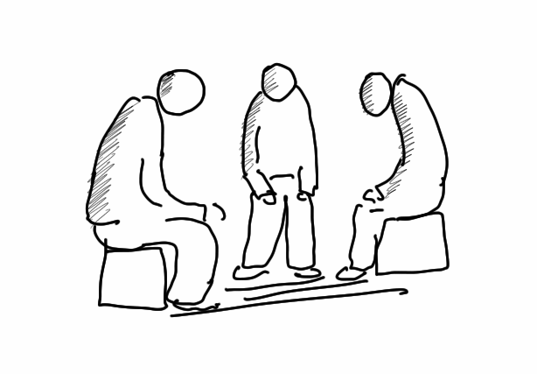

Pray in unity

If two of you on earth agree about anything they ask for, it will be done for them by my Father in heaven. Where two or three come together in my name, I am there with them. Matthew 18:19-20

May the God who gives endurance and encouragement give you the same attitude of mind toward each other that Christ Jesus had, so that with one mind and one voice you may glorify the God and Father of our Lord Jesus Christ.
Romans 15:5-6

These quotes are great encouragement to pray! You might like to focus on a different one each time you gather for prayer. Also, look out for other quotes and build your own collection

This is our Lord's will... that our prayer and our trust be, alike, large.
Julian of Norwich

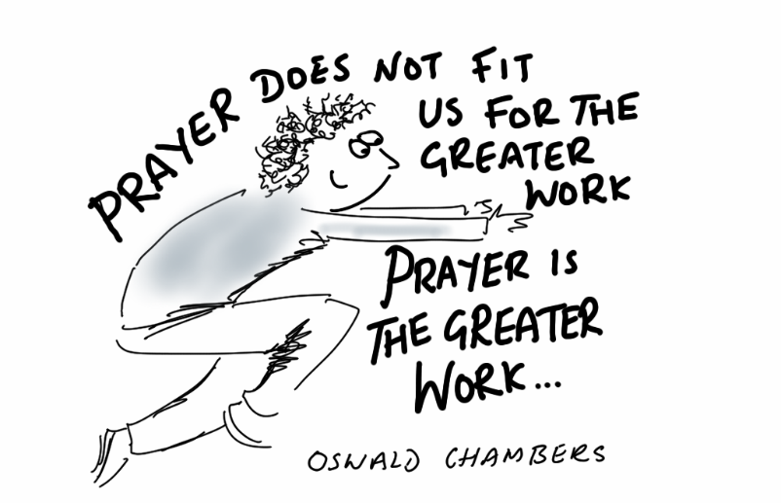
Our prayers may be awkward. Our attempts may be feeble. But since the power of prayer is in the one who hears it and not in the one who says it, our prayers do make a difference. Max Lucado

We have to pray with our eyes on God, not on the difficulties. Oswald Chambers

Prayer is the exercise of drawing on the grace of God. Oswald Chambers

True prayer is neither a mere mental exercise nor a vocal performance. It is far deeper than that - it is spiritual transaction with the Creator of Heaven and Earth. Charles Spurgeon

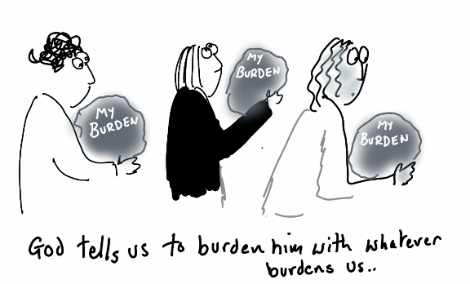
Prayer is where the action is. John Wesley

Prayer is not overcoming God's reluctance, but laying hold of His willingness.
Martin Luther
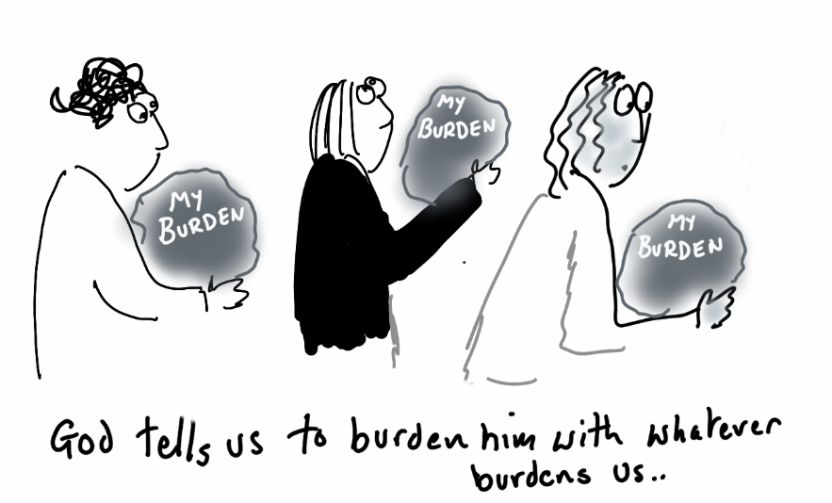

Prayer is not monologue, but dialogue; God’s voice is its most essential part. Listening to God’s voice is the secret of the assurance that He will listen to mine. Andrew Murray

The greatest thing anyone can do for God and man is pray. It is not the only thing; but it is the chief thing. The great people of the earth today are the people who pray. I do not mean those who talk about prayer; nor those who say they believe in prayer; nor yet those who can explain about prayer; but I mean those people who take time to pray. S.D. Gordon

