Praying with Purpose: Creative ideas for prayer (3)

Try using creative ways of prayer as part of your group prayer times. These are both general ideas and some for specific projects and

activities which can be adapted for various contexts. Also, use and develop your own ideas.

Prison work or modern day slavery

Write prayer requests on strips of paper and link to make a paper chain of prayer. Where possible display the paper chain as a reminder to pray.

As prayers are answered, the chains could be broken in a symbolic action

Family life

Use a game played by families as a way of praying e.g. stand in a circle and throw a ball. Whoever catches it calls out an issue for prayer. You can adapt this as a way to give thanks for answered payer etc.

Local community initiatives
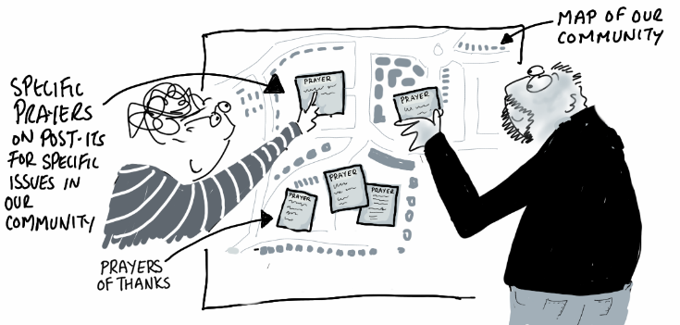
Have a map of your local area. Write your prayers on post-it notes and stick these on the appropriate part of the map. If possible display the map as a reminder to pray. As a prayer is answered replace that post it note prayer with one of thanks. If you use a different colour note for requests and answers the reasons for thanks will be even more noticeable!

Go for a prayer walk in pairs or groups around your local area. Stop at relevant points and pray for people, situations, initiatives and needs, as appropriate.

Refugee work or any worldwide initiatives

Use the praying with a ball idea but with an inflatable globe as the ball.
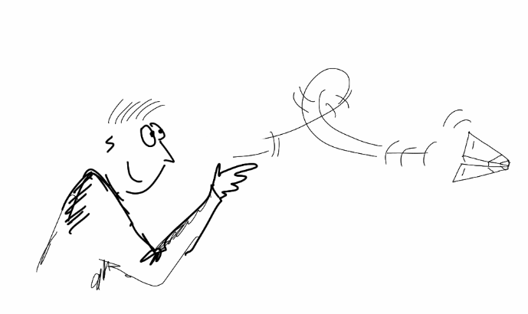

Provide each of the group with an A5 piece of paper. On it, write one prayer for the initiative

and then fold the paper into a paper aeroplane. Standing in a circle all throw their aeroplanes, and then each pick up an aeroplane that is not theirs. Unfold the paper and then go round the group reading out their aeroplane prayer. The papers can be taken home for everyone to continue praying their specific prayer.

This idea can be used for any initiative

General creative prayer ideas

Write prayer requests on paper images of fruit. Hang on a prayer tree and offer all prayers to God with one prayer asking for good fruit to grow from the project

When praying for volunteers for an initiative, explain the qualities and skills needed for each role. Then place a glass pebble on a large plate containing unlit tea lights, to represent each person needed. Light the candles as a symbol of God’s light, which both highlights the task to those he is calling and enhances human qualities and skills. Have a short time of silent prayer focussed on the lit display.

Where the initiative includes craft activities use the craft to pray for their use….
e.g. When knitting pray at the end of each row.

The Bible teaches that our prayers are like sweet smelling incense:
See psalm 141:1-2; Revelation 5:6-8; Revelation 8:3-4
Write prayers on pieces of paper, then read them out and place in a bowl. As you do so release some sort of sweet fragrance e.g. incense; scented candle; home fragrance.
Spend some time in silent prayer as the fragrance fills the room.

Creative prayer responses

Read out each need and use a response after each e.g.

- Lord, in your mercy, hear our prayer
- Lord hear us: Lord, graciously hear us
- In faith we pray: we pray to you, our God
- We come trusting not in the strength of our prayers,
but in your power to answer

You may like to use a response linked to the initiative being prayed for e.g.
- Parenting/ family work: Father of all: hear your children’s prayer
- Prison work: Lord break the chains which hamper this work, and bring freedom to do your will
- Campaigning: Righteous God hear our prayers for a better world where justice and peace may flourish

You could create your own responses to fit your particular focus for prayer

Praying through God’s Word

Choose an appropriate Bible passage, reflect on it for a short time then use the thoughts God highlights to you as pointers for prayer e.g.

Away From It All
Come to me, all you who are weary and burdened, and I will give you rest. Take my yoke upon you and learn from me, for I am gentle and humble in heart, and you will find rest for your souls. Matthew 11:28-29

The apostles gathered around Jesus and reported to him all they had done and taught. Then, because so many people were coming and going that they did not even have a chance to eat, he said to them, “Come with me by yourselves to a quiet place and get some rest.” So they went away by themselves in a boat to a solitary place.
Mark 6:30-32

Family life
People were bringing little children to Jesus for him to place his hands on them, but the disciples rebuked them. When Jesus saw this, he was indignant. He said to them, ‘Let the little children come to me, and do not hinder them, for the kingdom of God belongs to such as these. Truly I tell you, anyone who will not receive the kingdom of God like a little child will never enter it.’ And he took the children in his arms, placed his hands on them and blessed them. Mark 10:13-16
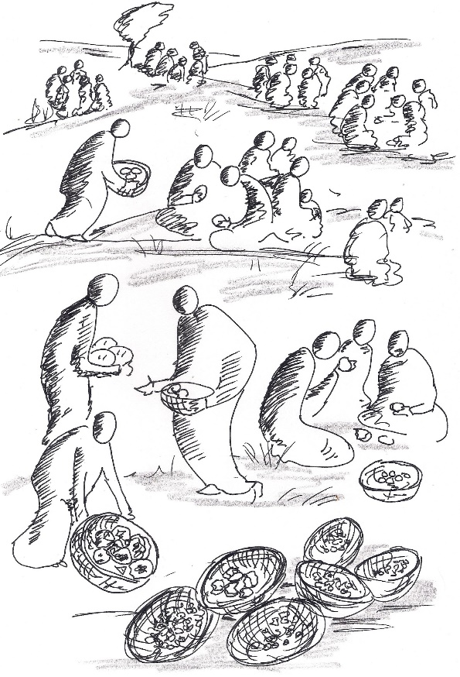

Hospitality/practical provision
By this time it was late in the day, so his disciples came to him. ‘This is a remote place,’ they said, ‘and it’s already very late. ³⁶ Send the people away so that they can go to the surrounding countryside and villages and buy themselves something to eat.’
³⁷ But he answered, ‘You give them something to eat.’
They said to him, ‘That would take more than half a year’s wages! Are we to go and spend that much on bread and give it to them to eat?’
³⁸ ‘How many loaves do you have?’ he asked. ‘Go and see.’
When they found out, they said, ‘Five – and two fish.’
³⁹ Then Jesus told them to make all the people sit down in groups on the green grass. ⁴⁰ So they sat down in groups of hundreds and fifties. ⁴¹ Taking the five loaves and the two fish and looking up to heaven, he gave thanks and broke the loaves. Then he gave them to his disciples to distribute to the people. He also divided the two fish among them all. ⁴² They all ate and were satisfied, ⁴³ and the disciples picked up twelve basketfuls of broken pieces of bread and fish. ⁴⁴ The number of the men who had eaten was five thousand. Mark 6:35-44

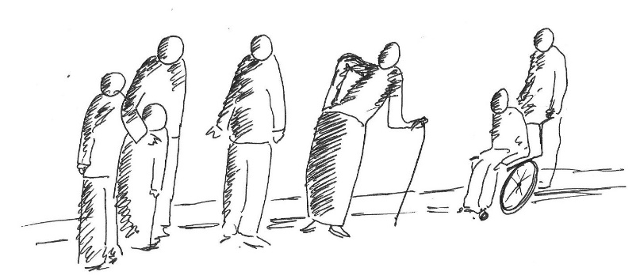
Flourishing relationships
Dear friends, let us love one another, for love comes from God. Everyone who loves has been born of God and knows God. Whoever does not love does not know God, because God is love. This is how God showed his love among us: he sent his one and only Son into the world that we might live through him. This is love: not that we loved God, but that he loved us and sent his Son as an atoning sacrifice for our sins. Dear friends, since God so loved us, we also ought to love one another. No one has ever seen God; but if we love one another, God lives in us and his love is made complete in us. 1 John 4:7-12

Crafting
Moses said to the Israelites, ‘See, the Lord has chosen Bezalel son of Uri, the son of Hur, of the tribe of Judah, ³¹ and he has filled him with the Spirit of God, with wisdom, with understanding, with knowledge and with all kinds of skills – ³² to make artistic designs for work in gold, silver and bronze, ³³ to cut and set stones, to work in wood and to engage in all kinds of artistic crafts. ³⁴ And he has given both him and Oholiab son of Ahisamak, of the tribe of Dan, the ability to teach others. ³⁵ He has filled them with skill to do all kinds of work as engravers, designers, embroiderers in blue, purple and scarlet yarn and fine linen, and weavers – all of them skilled workers and designers. 36 ¹ So Bezalel, Oholiab and every skilled person to whom the Lord has given skill and ability to know how to carry out all the work of constructing the sanctuary are to do the work just as the Lord has commanded.’
Exodus 35:30-36:1

Support for one another
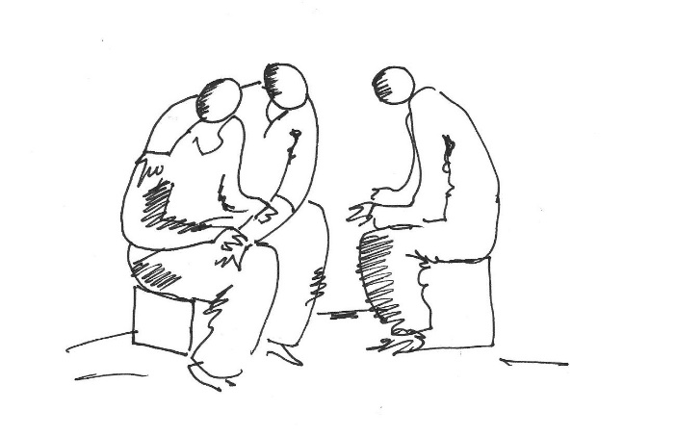
Above all, love each other deeply, because love covers over a multitude of sins. ⁹ Offer hospitality to one another without grumbling. ¹⁰ Each of you should use whatever gift you have received to serve others, as faithful stewards of God’s grace in its various forms. ¹¹ If anyone speaks, they should do so as one who speaks the very words of God. If anyone serves, they should do so with the strength God provides, so that in all things God may be praised through Jesus Christ. To him be the glory and the power for ever and ever. 1 Peter 4:8-11

Renewing strength and vision
Do you not know?
Have you not heard?
The Lord is the everlasting God,
the Creator of the ends of the earth.
He will not grow tired or weary,
and his understanding no one can fathom.
²⁹ He gives strength to the weary
and increases the power of the weak.
³⁰ Even youths grow tired and weary,
and young men stumble and fall;
³¹ but those who hope in the Lord
will renew their strength.
They will soar on wings like eagles;
they will run and not grow weary,
they will walk and not be faint.
Isaiah 40:28-31

