Praying with Purpose: Blessings (4)

When we pray for God’s blessing for a project, let’s do so in faith; embracing and exploring the whole spectrum of what God’s blessing means – God’s divine help; favour; mercy; benefit; gift; approval

Base your prayers on blessings in the Bible:

Use different Bible versions to bring new understanding and inspiration.

You may like to expand the blessing to reflect the specific work for which you have been praying: see below for example*
The Lord bless you
and keep you;
the Lord make his face shine on you
and be gracious to you;
the Lord turn his face towards you
and give you peace
Numbers 6:24-27



May the Lord answer you when you are in distress;
may the name of the God of Jacob protect you.
May he send you help from the sanctuary
and grant you support from Zion.
May he remember all your sacrifices
and accept your burnt offerings.
May he give you the desire of your heart
and make all your plans succeed.
May we shout for joy over your victory
and lift up our banners in the name of our God.
May the Lord grant all your requests.
Psalm 20:1-5



May the God of hope fill you with all joy and peace as you trust in him,
so that you may overflow with hope by the power of the Holy Spirit.
Romans 15:13



May the grace of the Lord Jesus Christ, and the love of God,
and the fellowship of the Holy Spirit be with you all
2 Corinthians 13:14



Now to him who is able to do immeasurably more than all we ask or imagine, according to his power that is at work within us, to him be glory in the church
and in Christ Jesus throughout all generations, for ever and ever! Amen
Ephesians 3:20-21


Do not be anxious about anything, but in every situation, by prayer and petition, with thanksgiving, present your requests to God. And the peace of God, which transcends all understanding, will guard your hearts and your minds in Christ Jesus.
Philippians 4:6-8



We always thank God for all of you and continually mention you in our prayers.
We remember before our God and Father your work produced by faith, your labour prompted by love, and your endurance inspired by hope in our Lord Jesus Christ.
1 Thessalonians 1:2-3



May our Lord Jesus Christ himself and God our Father, who loved us and by his grace gave us eternal encouragement and good hope, encourage your hearts and strengthen you in every good deed and word.
2 Thessalonians 2:16-17



May the Lord direct your hearts into God’s love and Christ’s perseverance.
Now may the Lord of peace himself give you peace at all times and in every way.
The Lord be with all of you.
2 Thessalonians 3:5, 16



Now to the King eternal, immortal, invisible, the only God, be honour and glory
for ever and ever. Amen
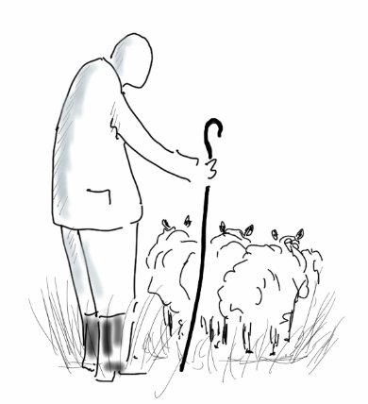
1 Timothy 1:17



Now may the God of peace, who through the blood of the eternal covenant brought back from the dead our Lord Jesus, that great Shepherd of the sheep, equip you with everything good for doing his will, and may he work in us what is pleasing to him, through Jesus Christ,
to whom be glory for ever and ever. Amen
Hebrews 13:20-21



Grace, mercy and peace from God the Father and from Jesus Christ,
the Father’s Son, will be with us in truth and love.
2 John 3



To him who is able to keep you from stumbling and to present you before his glorious presence without fault and with great joy – to the only God our Saviour be glory, majesty, power and authority, through Jesus Christ our Lord, before all ages, now and for evermore! Amen
Jude 24-25



* Numbers 6:24-27

The Lord bless you
and keep you;

We pray God’s blessing on those who are working to make this project (mention by name) succeed. May they be sustained in all they do and protected from discouragement

We pray God’s blessing on those whom the project (mention by name) seeks to support. May their lives be enriched through this practical expression of the love of Christ

The Lord make his face shine on you
and be gracious to you;

We pray for God’s light to shine on the project (mention by name) bringing clarity to plans and purposes

We pray for God’s grace and loving kindness to encircle both those who serve and those who are served
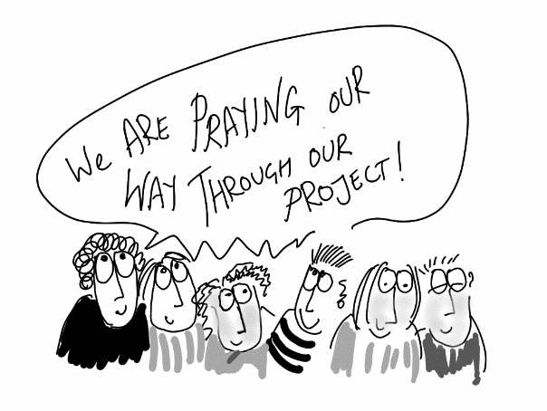
The Lord turn his face towards you
and give you peace.

We pray for God’s divine favour upon this project

(mention by name - or specific aspects)

We pray for God’s peace that surpasses all understanding

to fill the lives of all involved

Amen

