Praying with Purpose: Template for prayer

A template which can be adapted for specific contexts and initiatives
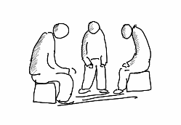
Prayer is not overcoming God's reluctance,
but laying hold of His willingness.
Martin Luther

3 Then move into praying for specific aspects of the initiative. There are various ways of structuring your prayer time. You may like to choose different ones each time you meet or use your own ideas –

See Praying with Purpose resources for suggestions

Write down any particular themes that emerge as you pray and pass them on to those involved in the project if they are not there with you

2 Open your time in prayer -

See Praying with Purpose resources for prayer suggestions

Share any answers to prayer so far, reiterate needs still to be met and any new prayer requests

Loving Lord, thank you for being close to us now as we agree together

on our requests and petitions.

Thank you that the Holy Spirit is here to help us put our needs into words,

and to plead our case before you.

We commit this time to you, for the growth of your Kingdom

and the glory of Christ. Amen

1 At the start of your prayer time, encourage each other with a reminder of God’s willingness to hear and answer prayer –

See Praying with Purpose resources for suggestions of quotes

and Bible verses

4 Finish by using a Biblical acclamation or blessing to ask God to bless the work. You may like to expand this to reflect the specific work for which you’ve been praying –

See Praying with Purpose resources for examples of blessings

