Praying with Purpose: Using the Lord’s Prayer

Lord, teach us to pray. Luke 11:1

As you pray for each other, your projects and initiatives, try basing your intercessions on the prayer Jesus taught his disciples when they asked him how they should pray

Pray each of the stanzas of the prayer as divided below, pausing to reflect on the words before praying and sharing as indicated

Our Father in heaven,
hallowed be your name,

Begin by using prayer and Bible verses to bring praise

and worship to God, our holy, heavenly Father
your kingdom come,
your will be done,
on earth as in heaven.

Share news, answers to prayer of the initiative which you are

bringing to God - which is a particular practical example of God’s kingdom on earth
Give us today our daily bread.

Bring before God ongoing and new prayer needs on behalf of the initiative and those who are involved in running it
Forgive us our sins
as we forgive those who sin against us.

Admit our need for God’s forgiveness for our own shortcomings as a precursor to showing any forgiveness needed e.g. for those who have made the initiative necessary in the first place; or those who may be obstructing it. If these aren’t appropriate in your particular case, you may wish to include more general prayers for/of forgiveness for the way we fail to follow the values of Christ…
Lead us not into temptation
but deliver us from evil.

Pray for perseverance when initial enthusiasm wanes; or opposition is proving to be difficult; when answers to prayer seem slow….
For the kingdom, the power,
and the glory are yours
now and for ever. Amen

Finish with praise and an acknowledgement of God’s power and majesty etc….

In subsequent gatherings you may like to use alternative versions of the Lord’s Prayer to encourage fresh reflection and prayer e.g.

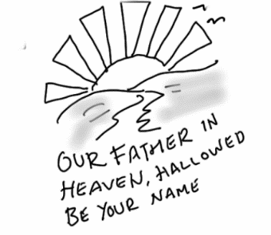
Our Father, who is in heaven,
Hallowed be Your name.
Your kingdom come,
Your will be done
On earth as it is in heaven.
Give us this day our daily bread.
And forgive us our debts, as we have forgiven our debtors [letting go of both the wrong and the resentment].
And do not lead us into temptation, but deliver us from evil.
For Yours is the kingdom and the power and the glory forever. Amen.
Amplified Bible

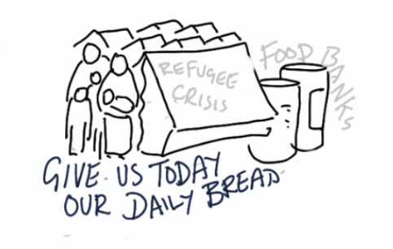
Our Father in heaven,
we pray that your name will always be kept holy.
We pray that your kingdom will come.
We pray that what you want will be done,
here on earth as it is in heaven.
Give us the food we need for each day.
Forgive the sins we have done,
just as we have forgiven those who did wrong to us.
And do not cause us to be tested;
but save us from the Evil One.’
The kingdom, the power, and the glory are yours forever. Amen.
International Children’s Bible

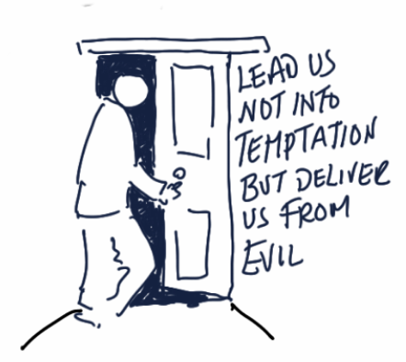
Our Father in heaven,
Reveal who you are.
Set the world right;
Do what’s best—
as above, so below.
Keep us alive with three square meals.
Keep us forgiven with you and forgiving others.
Keep us safe from ourselves and the Devil.
You’re in charge!
You can do anything you want!
You’re ablaze in beauty!
Yes. Yes. Yes.
The Message

