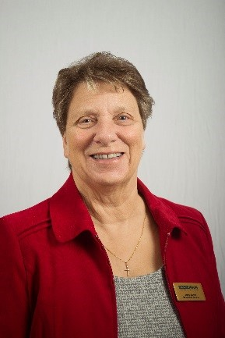
Reflection February 2023
My Dear Friends, As I write this the sun is at last shining after so many days of torrential rain. So much rain that I have been reminded of Noah and the flood. I do hope that you have all been keeping safe and warm and that you and your families have not been too badly affected. Many people in the world are suffering right now because of climate change, government unrest and war and as members of the body of Christ as well as the Mothers’ Union we are called upon to pray and to stand beside our brothers and sisters. We have just come through the season of Epiphany when we remembered that Jesus was the light of the world, but, entering into the pre-Lent period does not change that and we need to shine as lights in this dark world, showing that light by being cheerful and sharing a smile or laughter with those we meet in our daily lives. I don’t know if you remember the saying ‘laugh and the world laughs with you, cry and you cry alone’. During my life I have often found that to be true, however, it doesn’t stop me from sharing other peoples’ sorrow. I believe that one of the best things we can do is listen, really listen and if we do Jesus will help us share His love and we will be able to say “God loves us; not because we are loveable but because He is love, not because He needs to receive but because He delights to give”. If we are able to do that then whatever the weather outside the sun will always shine around us and will be visible for all to see. As we continue into a new MU working year, please will you be a shining light in the darkness for Sheran, our Worldwide President, and the members of the Trustee Board, who, together with CEO Bev Jullien, the Senior Leadership Team and MU members of staff will be working through difficult times to encourage all members to keep smiling and continuing the important work needed to enable us to flourish and grow. I have daffodil bulbs which will soon be flowering which, despite the weather, have made it through all the rain, sleet and snow and will soon be making me smile once again. May God bless you all, I can see you are all smiling because I can sense the love of God in the air.
Love and Prayers
Jenny
Let us pray
Mary Sumner’s Personal Prayer
All this day, O Lord, let me touch as many lives as possible for thee; and every life I touch, do thou by thy spirit quicken, whether though the word I speak, the prayer I breathe, or the life I live. AMEN
Father, we thank you that you have given us kind hearts and the ability to smile through difficult times. Help us to remember that you are love, and love is the greatest gift we can share. We are reminded of the Graham Kendrick hymn……
Jesus put this song into our hearts, Jesus put this song into our hearts. It’s a song of joy no one can take away, Jesus put this song, into our hearts.
Jesus taught us how to live in harmony, Jesus taught us how to live in harmony. Different faces, different races, He made us one, Jesus taught us how to live, in harmony.
Jesus taught us how to be a family, Jesus taught us how to be a family. Loving one another with a love that He gives, Jesus taught us how to be, a family.
Jesus turned our sorrow into dancing, Jesus turned our sorrow into dancing. Turned our tears of sadness into rivers of joy, Jesus turned our sorrow, into a dance.
May we live forever in your love and may our voices be raised to you in everlasting song. In Jesus name. AMEN

